DEI Growth Matrix: A Biopsychosocial & Differentiation Framework
Purpose: This template is designed to help individuals integrate DEI principles into their professional lives by identifying and committing to personal growth areas aligned with Systems and Bowen Theory.
Instructions:
Step 1: Inspiration: Examine the bio-psycho-social assessment and identify areas to improve your ability to contribute to a DEI-focused work environment.  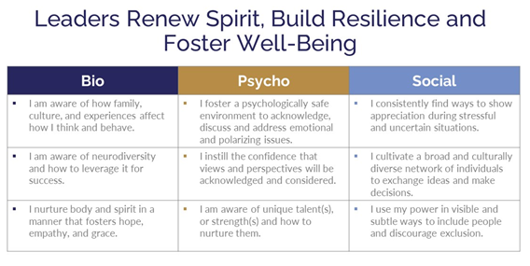 |  | Step 2: Goal: Choose attributes from the 'Differentiation of Self' framework that will support your role in fostering a DEI culture at work.  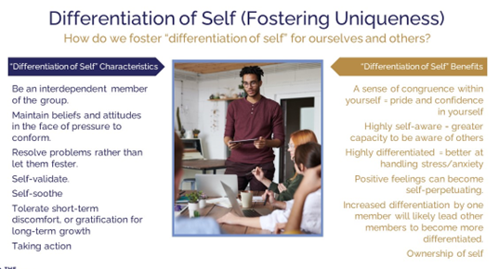
Step 3: Daily Commitment: Define specific, daily actions to help you work towards your well-being and differentiation goals, ultimately enhancing DEI implementation in your job.
Bio | Psycho |  | Social
In the 'Bio' category, actions could include self-care practices that enable one to be an effective DEI advocate even under stress. | 'Psycho' actions may involve education and reflection on one's cultural competencies and biases. |  | 'Social' commitments could be activities that promote inclusion and equity within one's immediate professional sphere.
Examples include:  - Practice mindfulness to maintain resilience when discussing DEI topics in polarized settings.  - Engage in physical activities that improve mental clarity to approach DEI work with a non-anxious presence. | Examples include:  - Reflect daily on personal biases to foster a mindset open to DEI learning and transformation.  - Write a journal about DEI progress to reinforce learning and personal growth in DEI competencies. |  | Examples include:  - Initiate conversations about DEI with colleagues to understand diverse perspectives.  - Lead by example in inclusive behaviors, ensuring all team members feel valued and heard.
Two-Week Reflection & Follow

Daily Biopsychosocial Commitment Table
Action / The Day Action was Taken Over 4 weeks | Monday | Tuesday | Wednesday | Thursday | Friday | Saturday | Sunday
Bio
- Engage in 16-8 intermitted fasting to address GERD |  |  |  |  |  |  | 2/10
- Complete 28-day body-weight strength training
- Incorporate daily Natto into daily diet
Psycho
- Complete night Neurofeedback digital sleeping pill to improve sleep and understand Neurofeedback coaching
- Incorporate Insight Dialogue into client sessions
- Complete daily morning box-breathing
Social
- Join and participate in the Vancouver Jazz Meet-Up
- Plan 2-annual guys trip with Keith
- Plan the annual couples’ trip with Keith & Denise

