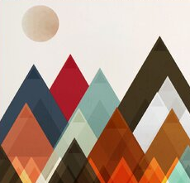 Mountain Inspiration

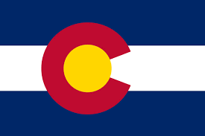 Color palate inpriation

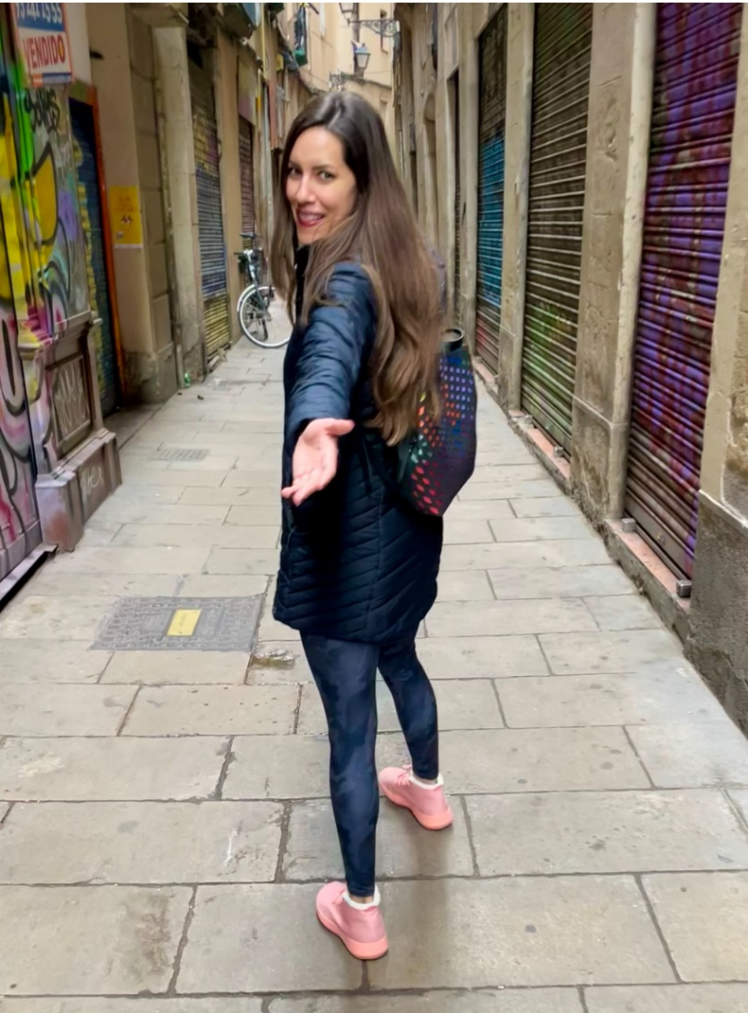 Our owner inspiration (Long brown hair, hand reaching out) – Logo image doesn’t have to be an actual presentation of her…just inspiration, but would like brown hair and hand outreaching to be included.

