Understanding CalAIM
California Advancing and Innovating Medi-Cal — more commonly known as CalAIM — is a far-reaching, multiyear plan to transform California’s Medi-Cal program and enable it to work more seamlessly with other social services. Led by the California Department of Health Care Services (DHCS), the goal of CalAIM is to improve outcomes for the millions of Californians covered by Medi-Cal, including those with the most complex needs.
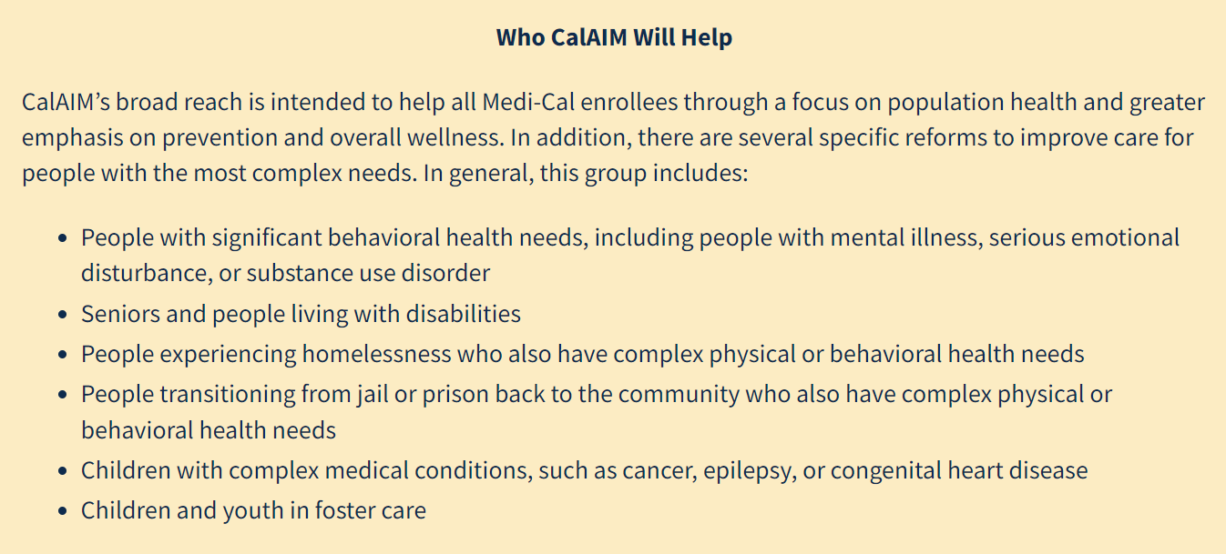
Programs at Rooted Life
Enhanced Care Management
Today, Medi-Cal is highly fragmented, with some enrollees needing to access care paid for by six or more delivery systems, which can make it difficult for people to navigate across providers and services. In response, a new ECM benefit would provide a high-touch care coordinator for Medi-Cal managed care enrollees with multiple complex needs. If successfully implemented, this benefit would ensure that enrollees with complex needs are identified and engaged by someone who understands their goals, develops a plan in partnership with them and their providers, and actively connects them with the clinical and nonclinical services and resources that help them meet those goals.
Community Supports (or “In Lieu of Services)
Medi-Cal’s coverage may be comprehensive when it comes to health care services like doctor’s visits, hospital or nursing home stays, or medications and equipment. There are, however, situations where traditional health care services on their own are not enough to support well-being. Traditionally, Medi-Cal has not covered that safe place to recuperate, instead only covering a nursing home or hospital, which is more than what is needed. In response, DHCS is proposing to give managed care plans the option to substitute new clinical and nonclinical services for traditionally covered services like care in a nursing home or hospital.
Housing supports:
  - Housing transition navigation services (e.g., assistance applying for and finding housing, signing a lease, securing resources for setup, utilities, moving in)
  - Housing deposits – up to $6000
- Security deposits can be used to obtain a lease on an apartment or home.
- First month’s and last month’s rent as required by landlord
- Set-up fees/deposits for utilities
- First-month coverage of utilities
- Services necessary for the individual’s health and safety, such as pest eradication and onetime cleaning prior to occupancy
- Goods such as an air conditioner or heater, and other medically-necessary adaptive aids and services
  - Housing tenancy and sustaining services (e.g., early intervention around behaviors that might jeopardize housing, dispute resolution with landlords and neighbors, recertification support)

Short-term recovery supports:
- Short-term, posthospitalization housing - provides members who do not have a residence and who have high medical or behavioral health needs the opportunity to continue their medical, psychiatric or substance use disorder recovery immediately after exiting an inpatient hospital, residential treatment facility, correctional facility, nursing facility, or recuperative care and avoid further preventable utilization of state plan services.

- Recuperative care (medical respite) —provides member with room, board and medical care coordination is a post-acute care setting.
- Eligible Individuals are those who meet the Housing and Urban Development (HUD) definition of homeless and who are receiving enhanced care management, or who have one or more serious chronic conditions and/or serious mental illness and/or is at risk of institutionalization or requiring residential services as a result of a substance use disorder. For the purpose of this service, qualifying institutions include hospitals, correctional facilities, mental health residential treatment facility, substance use disorder residential treatment facility, recovery residences, Institution for Mental Disease and State Hospitals.
- Recuperative care programs also provide room, board, and medical care coordination in a post-acute care setting for people experiencing homelessness who are too ill or frail to recover from a physical illness or injury on the streets or in shelter, but who are not ill enough to be in a hospital.

