Page 1 of 2
Hello. I am open to different ideas but here is some info to start.
This logo will be a circle about 2 ¼” - 2 3/8” wide patch going on a hat. The hat color will be either Navy Blue, Black, or Dark Gray. Open to color suggestions for the logo colors like red, blue, white, gray, etc. Maybe a white or gray background. Anything that will contrast well on the hat.
Something like these circle images as examples of what I would like to do with colors and design changes. Remove that Stay and Play text.

Don’t need the double circle but maybe that would work. Open to ideas. Include a border around the circle kind of like what is shown.
Keep the golf clubs crossing. Keep the golf flag pin. Flag red, flagpole white or gray, horizontal line on the bottom of the flagpole green.
Replace the golf ball with the letters TNG in Eras Bold Itc in Bold font. Open to what color maybe red or other colors.
Replace the airplane with something like this Owl. The owl does not have to be blue and does not have to have a golf club in is hand. Probably a typical brown Owl but open to suggestions.I kind of like the Owl facing a little to the right and a fierce looking owl.
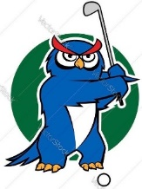
Replace the bed with something like this running Jackalope. The Jackalope should face to the Left. Same colors as the owl. Again, maybe a brown Jackalope but open to

Page 2 of 2

suggestions on color. Fierce Jackalope eyes like the Owl would be nice. No circle around the Jackalope.
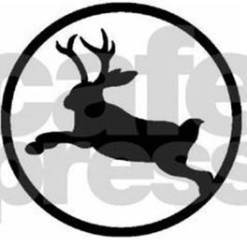

Thanks! Excited to see the options! Contact me with questions.
Scott LaLoggia
scottlalo@aol.com

