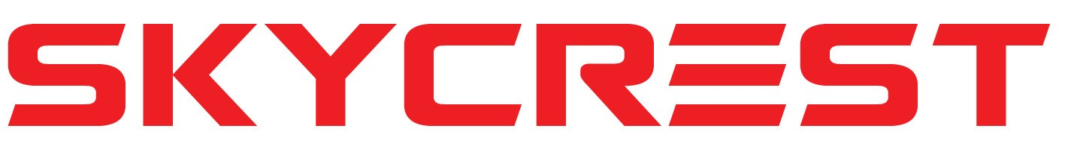

Page 1 –
Skycrest Services: Delivering safe, reliable aerial access and maintenance services to Oil&Gas, Construction, Utility, & Renewable energy industries.
Our Vision:
To be the leading provider of aerial access, geotechnical drilling, and service solutions, setting the standard for excellence in safety, efficiency, and environmental stewardship.

Mission Statement:
At Skycrest, our mission is to deliver unparalleled aerial access, geotechnical drilling, and service and maintenance solutions, consistently exceeding our clients' expectations. We strive to achieve this by investing in cutting-edge technology, fostering a culture of safety and continuous improvement, and prioritizing environmental sustainability. Through collaboration, integrity, and dedication, we aim to contribute to the success of our clients while maintaining the highest standards of quality and professionalism.

Select Division:
Aerial Access
Geotechnical Drilling
Renewable Energy Services

Notes * Don’t use wind energy as the center stage on this page use graphics that combine generation, Geotech, utility oil and gas, construction and renewables

Division 1 –
Renewable Energy Services
Tabs:
- About: Skycrest is a full-service wind energy service provider specializing in blade access and repair, service and maintenance, and trouble shooting on most wind turbine platforms.
    - Our leadership:
  - Michael Guttridge :
        - Michael Guttridge is the President and co-founder of two successful private organizations in the construction and technology consulting industries. He has over 30 years’ experience, ranging from hands on direct involvement up to executive level management and operations. Michael is currently focusing on expanding Skycrest operations, with the goal of increasing the footprint in Canada as well as establishing a presence in the US. Michael’s background in construction and consulting has enabled Skycrest to bring professionalism and level of detail to the industry, which sets us apart from our competition. Through rigorous planning, risk management, attention to detail, and hiring exceptional talent, Michael has worked hard to drive double-digit growth and profitability year over year in both organizations. Michael has spent many years leading teams nationally across Canada and the US, to provide great value and exceptional service for clients. Michael has also completed his Bachelor’s Degree in Computer Information Systems, graduating with Summa Cum Laude honors.
  - Cory Buckmaster:
Cory Buckmaster is the Vice President of Skycrest Services and brings a wealth of business operations and executive-level management experience to the company. He holds a bachelor's degree in Information Systems and has a strong technical background, having worked in the IT operations industry for over a decade. Prior to joining Skycrest Services, Cory was part of a startup that built a national technology services company with offices across Canada. In his current role, Cory is responsible for the resourcing operations, strategic direction, and technology decisions for Skycrest Services. He is passionate about technology, knowledge management, and the renewable industry in Canada and is committed to operational excellence.
  - Randy Folland:
Randy Folland is a highly experienced drilling professional with 29 years of field
operations experience in locations throughout Canada, the United States, and Far Eastern Russia. He has a strong background in geotechnical and environmental drilling, but also has experience in a range of other areas within the drilling industry. Folland began his career in 1993 as a driller's assistant with Bertram Drilling Corp, where he worked on various drill rigs and assisted with drilling operations for geotechnical, environmental, oil and gas exploration, seismic, geothermal, mineral coring, sonic direct push, test wells, and other specialized projects. Over the course of his career, he has installed thousands of monitoring wells and drilled hundreds of programs, working with a variety of track machines and top drive rotary rigs. In addition, he has been employed by the Alberta Government to plug artesian flowing holes in hundreds of locations throughout Western Canada. Folland has a proven track record of maintaining clean, well maintained equipment and work sites, and is committed to safeguarding the public and environment.
  - John Holmes
        - John Holmes is the VP of Operations and a dynamic professional with a diverse background, started as a Journeyman Machinist before earning degrees in Electrical Engineering and Business Management. Over 15 years, he rose through the ranks, notably as a Regional Manager at Vestas Wind Technologies, overseeing transactional operations.
At Orbis Engineering and Field Services, John optimized operations in the utility industry and led a team of 500 technicians, project managers, and engineers, enhancing the company's regional presence.
Currently at Skycrest Services, John guides initiatives in blade repairs, turbine maintenance, and aerial work platforms across North America. His strategic vision and hands-on approach have been pivotal in expanding our customer base and ensuring future success.
With a multi-faceted background from hands-on machining to executive leadership, John's commitment to continuous learning and innovation positions him as a dynamic leader shaping the future of the energy and utility industries.

Services:
Skycrest – Your Partner in Wind Turbine Performance!
At Skycrest, we understand that the key to harnessing the full potential of wind energy lies in the meticulous maintenance of your wind turbines. Our commitment to excellence and unwavering focus on routine maintenance positions us as your dedicated partner in ensuring optimal turbine performance and longevity.
Skycrest Value:
Safety First – Compliance Guaranteed: Safety is our top priority. Our teams are trained to adhere to the highest industry standards and safety regulations. By partnering with us, you can rest assured that your wind turbines are not only efficient but also compliant with all safety requirements.
Maximizing Efficiency for Peak Performance: Our team of skilled technicians is dedicated to maximizing the efficiency of every component in your wind turbines. From blade inspections to fluids analysis, we work with you to ensure that your turbines operate at their peak, delivering the maximum power output.
Ensuring Reliability and Longevity: Your wind turbines are significant investments, and we are here to protect that investment. We cater our maintenance services meet and exceed all recommended manufacturers recommendations and are designed to identify and address potential issues before they escalate, minimizing downtime and extending the lifespan of your equipment. We will service and maintain additional hardware and systems as well including Lidar, CMS, oil particle monitoring systems and more.
Cost-Effective Solutions: We understand the importance of managing operational costs. Our proactive maintenance approach helps you control expenses by identifying and addressing issues early on, preventing major breakdowns that can result in expensive repairs or replacements.
Optimizing Energy Production: Your turbines are designed to generate clean, sustainable energy. Through our comprehensive maintenance services, we ensure that your wind turbines consistently operate at their designed capacity, optimizing energy production and contributing to your overall environmental goals.
Stay Technologically Advanced: The wind energy industry is evolving, and so are we. Our team stays abreast of the latest technological advancements, providing you with opportunities to upgrade or incorporate new technologies into your existing turbines, enhancing their performance and aligning them with the latest industry standards.
Skycrest is your dedicated partner in maximizing the potential of your wind turbines. Contact us today to discuss how we can help elevate the performance of your wind turbines and contribute to the long-term success of your renewable energy initiatives. Together, let's harness the power of the wind for a cleaner, greener future!

  - Services Portfolio – with many years experience in providing full scope services for the customer Skycrest is here to support all of your turbine maintenance and repair needs. (articles or videos of work done)
    - Annual/semi annual service and maintenance -> link to new page
    - Troubleshooting a variety of different wind turbine platforms -> link to new page(see below for linked pages)
    - Torque and Tension-> link to new page(see below for linked pages)
    - Major corrective support -> Coming soon
    - Blade/Composite Services-> link to new page(see below for linked pages)
    - Onsite Safety Services -> link to new page (see below for linked pages)
  - Contact for a Quote

- Safety: Safety is at the forefront of everything we do. Our mission is to create a safe work place through the following steps:
  - Sefe work processes and procedures
    - ISO certifications :ISO 9001, 14001, and 45001
    - Online/ app based safety reporting platform

  - Company culture
    - We achieve our mission by incorporating safety into the very fabric of our company culture. Our approach includes ongoing training programs, rigorous safety protocols, and the empowerment of every team member to prioritize safety in their daily tasks. We invest in state-of-the-art safety technology, regularly review and update safety procedures, and foster a workplace environment where open communication about safety concerns is encouraged.
Through collaboration, integrity, and dedication, we aim to contribute to the success of our clients while maintaining the highest standards of quality and professionalism. Our commitment to safety is unwavering, ensuring that each project is executed with the utmost care, protecting both our workforce and the environments in which we operate. By upholding these principles, we not only meet industry standards but set new benchmarks for safety excellence in our field.

  - Training and development
    - Regular training modules:
      - All team members are required to undergo regular training modules covering a wide range of safety topics. These modules are designed to keep our workforce up-to-date on the latest safety standards, protocols, and industry best practices.
    - GWO certification and platform specific training
      - This ensures that our team possesses the specialized knowledge and skills necessary for working in challenging and dynamic environments.
    - ART and First Aid for All Field Techs: Our commitment to safety extends to providing Advanced Rescue Training (ART) and First Aid certifications for all field technicians. This not only equips them with life-saving skills but also enhances their ability to respond effectively to any emergency situations that may arise during project operations.
  - Work gear:
    - Company provided state of the art gear to ensure employees have access to gear appropriate to the tasks and climate they are working in

- Careers: We are always looking for skilled blade technicians, wind turbine maintenance technicians to join our team. Email us with your resume describing your specific area of expertise – careers@skycrest.com

- Contact: Contact requests Provide Physical address – 403 Main Street Three Hills AB T0M-2A0
  - Info@Skycrestservices.com

Linked Pages:
  - Annual/Semi annual services – Let us help keep the annual and semi annual services on track. We have technicians capable of performing services on most platforms and can help prevent reliability issues due to late or inadequate service and maintenance on your assets.
  - Troubleshooting – Efficiently resolve turbine issues with our Troubleshooting expertise. Our technicians can swiftly identify and restore reliability, ensuring peak performance. Connect with us to discuss your platforms and discover tailored support capabilities for seamless operations. Elevate your reliability standards with our committed team.
  - Torque and Tension – We have crews that specialize specifically in torque and tensioning and are able to provide timely and economical solutions to ensure the safety of your critical turbine hardware.
  - Blade/composite service – we provide the full scope of services surrounding blade maintenance upgrades and repairs. All of our blade services are complemented by our engineering assessments from quote to delivery from our senior composite engineers to ensure you receive the best care available throughout the process. We excel in the following areas:
    - Advanced composite repair fiberglass and balsa core
    - LEP – Honteck, Polytech ELLE and more
    - Aerodynamic upgrades/power curve upgrades
    - Leading edge restoration
    - Minor repairs
    - Impact damage
    - Lighting damage
  - Onsite safety services
    - Safety Supervision
    - Site safety walks – documentation checks
    - Onsite safety inspections/audits
    - Site orientation, ground disturbance training and other job site training facilitation
    - Reporting and compilation of documentation.

Division 2 –
Aerial Access
Tabs:
- About: Skycrest is a full-service wind energy service provider specializing in blade access and repair, service and maintenance, and trouble shooting on most wind turbine platforms.
  - Our leadership:
    - Michael Guttridge :
      - Bio
    - Cory Buckmaster:
Cory Buckmaster is the Vice President of Skycrest Services and brings a wealth of business operations and executive-level management experience to the company. He holds a bachelor's degree in Information Systems and has a strong technical background, having worked in the IT operations industry for over a decade. Prior to joining Skycrest Services, Cory was part of a startup that built a national technology services company with offices across Canada. In his current role, Cory is responsible for the resourcing operations, strategic direction, and technology decisions for Skycrest Services. He is passionate about technology, knowledge management, and the renewable industry in Canada and is committed to operational excellence.
    - Randy Folland:
      - Bio
    - John Holmes
John Holmes is the VP of Operations and a dynamic professional with a diverse background, started as a Journeyman Machinist before earning degrees in Electrical Engineering and Business Management. Over 15 years, he rose through the ranks, notably as a Regional Manager at Vestas Wind Technologies, overseeing transactional operations.
At Orbis Engineering and Field Services, John optimized operations in the utility industry and led a team of 500 technicians, project managers, and engineers, enhancing the company's regional presence
Currently at Skycrest Services, John guides initiatives in blade repairs, turbine maintenance, and aerial work platforms across North America. His strategic vision and hands-on approach have been pivotal in expanding our customer base and ensuring future success.
With a multi-faceted background from hands-on machining to executive leadership, John's commitment to continuous learning and innovation positions him as a dynamic leader shaping the future of the energy and utility industries.

- Services:
  - Blade basket
  - Truck mounted aerial work platforms
    - We own and maintain a fleet of truck mounted aerial work platforms:
      - Effective industries :
        - Utilities
        - TV/Film/photography
        - Construction
        - Oil and Gas/ Petroleum
        - Rescue services
        - Renewable energy
        - Cellular/communications
        - Glazing
        - Window/building washing
        - Ship yards
    - Highlights: Mobility and Accessibility:
      - Advantage of Reach: Truck-mounted units provide greater reach and accessibility to elevated work areas, allowing operators to navigate and position the platform with precision. This flexibility is particularly advantageous when working on complex structures or in challenging environments.
      - Quick Setup and Deployment:
      - Time Efficiency: Truck-mounted units are known for their quick setup and deployment. They can be easily driven to the work site, and once on location, the platform can be raised or extended rapidly. This saves valuable time compared to the time-consuming setup associated with traditional methods.
      - Enhanced Safety Features:
      - Stability and Security: Truck-mounted units are designed with stability in mind, providing a secure platform for operators to work at heights. These units often come equipped with advanced safety features such as stabilizers, interlocks, and emergency controls, minimizing the risk of accidents.
      - Versatility and Adaptability:
      - Multi-Functional: Truck-mounted aerial access units are versatile and can be adapted for various tasks. They often come with interchangeable attachments or platforms, making them suitable for a wide range of applications, from maintenance and construction to emergency response.
      - Increased Productivity:
      - Efficiency and Throughput: The efficiency of truck-mounted units can lead to increased productivity. Operators can move swiftly between different work areas without the need for dismantling and reassembling equipment. This streamlined process translates into higher throughput and faster project completion.
      - Weather Considerations:
      - Reduced Weather Dependency: Unlike suspended baskets or rope access, truck-mounted units are less affected by adverse weather conditions. They offer a more stable working platform in windy conditions, allowing for continuous operations in a wider range of weather scenarios.
      - Cost-Effective Solution:
      - Operational Cost Savings: Truck-mounted units can often be a more cost-effective solution over the long term. Their versatility reduces the need for multiple specialized access methods, and the speed of setup and operation can lead to overall cost savings in labor and project timelines.
      - Increased Operator Comfort:
      - Operator Ergonomics: Truck-mounted units provide a stable and comfortable working platform for operators, reducing fatigue and improving overall efficiency. The ergonomic design of the platform enhances the operator's ability to focus on the task at hand without the discomfort associated with other methods.
      - While each method has its own set of advantages, truck-mounted aerial access units stand out for their efficiency, mobility, and safety features, making them a preferred choice for a variety of tasks requiring access to elevated work areas.
    - Contact for a Quote
  - Our fleet:
    - SI 178HDT 54m
      - 500kv insulated boom
      - Basket safe work load 1000lbs
      - Max wind speed 12.5m/s
      - 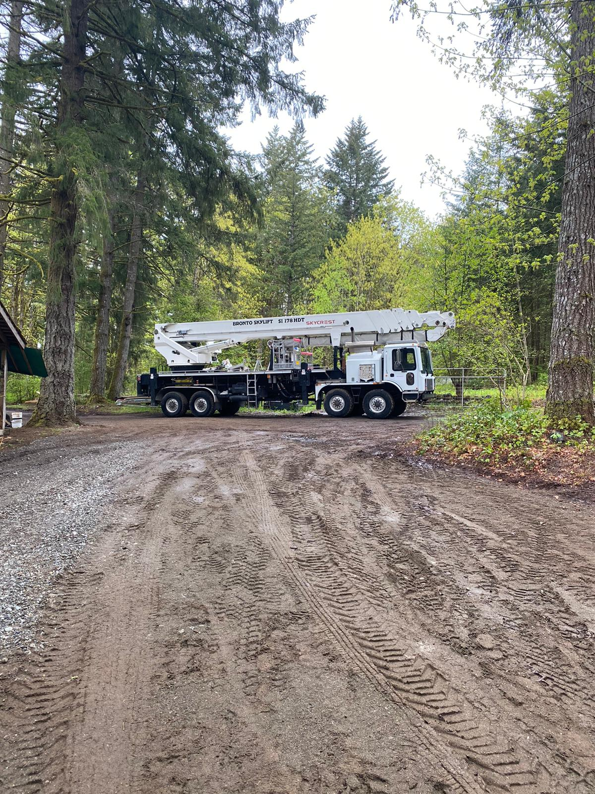
    - S 230 XR 70m
      - 500kv insulated boom
      - Basket safe work load 1300lbs
      - Max wind speed 12.5m/s
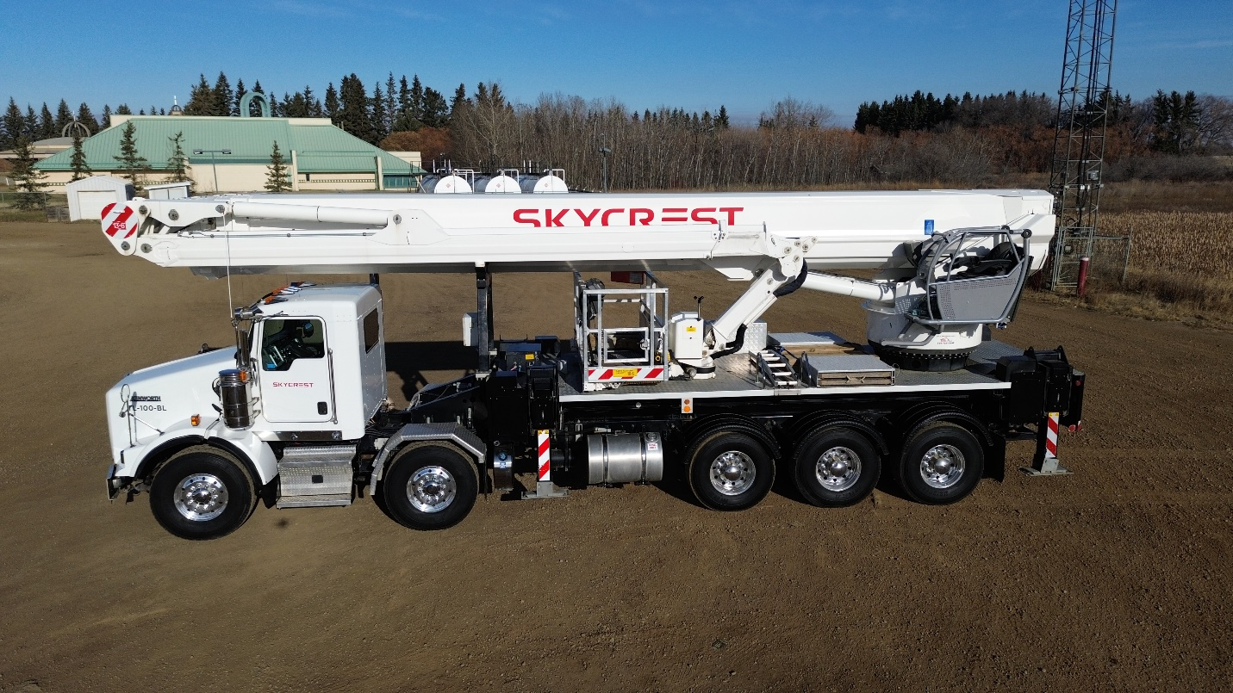

- Safety: Safety is at the forefront of everything we do. Our mission is to create a safe work place through the following steps:
  - Sefe work processes and procedures
    - ISO certifications :ISO 9001, 14001, and 45001
    - Online/ app based safety reporting platform

  - Company culture
  - Training and development
    - We have regular training modules that all of our team is required to complete covering a wide range of safety topics.
    - Platform specific training
    - Firstaid for all field techs
  - Work gear
    - Company provided state of the art gear to ensure employees have access to gear that will fit the climate they are working in

- Careers: We are always looking for skilled operators to join our team.
  - Email career@skycrestservices.com

- Contact: Contact request

Division 3 see brochure attached in submission

