
6750 Finnerty Sideroad
Caledon, Ontario L7K 1C7
www.pommies.com orders@pommies.com Tel: 416 919 5001

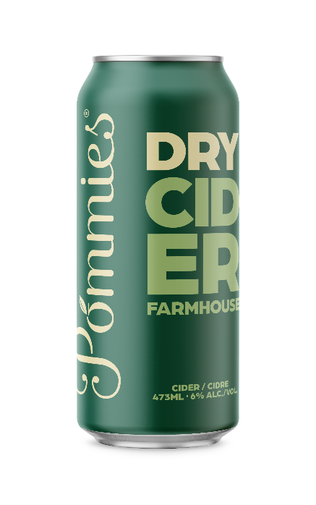
LCBO#: 418582

Pommies Farmhouse (6% alc.) is a traditional cider that appeals to a sophisticated palate. Made with fresh pressed juice of Ontario apples, Farmhouse is dry, medium-bodied and complex. It is a crisp tangy cider, rustic in nature and refreshing to the core. Pommies Farmhouse is richly carbonated with a fresh apple aroma and a dry finish.

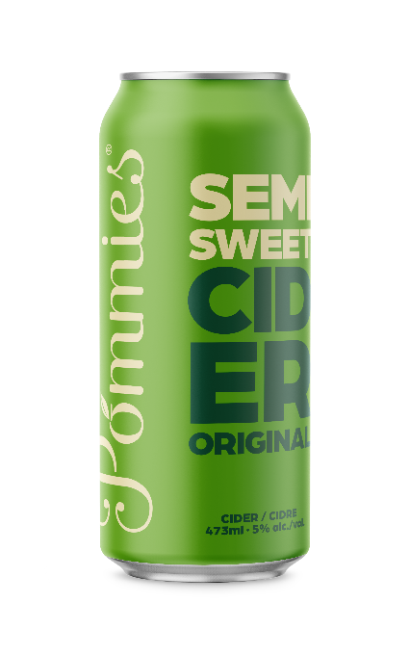
LCBO#: 453118

Pommies Original (5% alc.) is a classic, Ontario style semi-sweet cider. Made from the fresh pressed juice of five varieties of Ontario apples, Pommies Original is clean, crisp and refreshing. Pommies Original is a light-bodied, easy-drinking cider with a balanced finish.

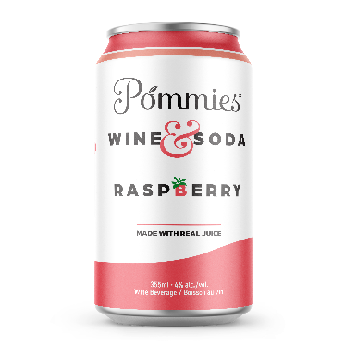
LCBO#: 123456

Pommies Wine & Soda (4% alc.) is the perfect sipper for all occasions. With hints of fruits and wine, Wine & Soda is made with white wine, carbonated water and real raspberry juice…that’s it. No preservatives, no artificial anything and no sugar.

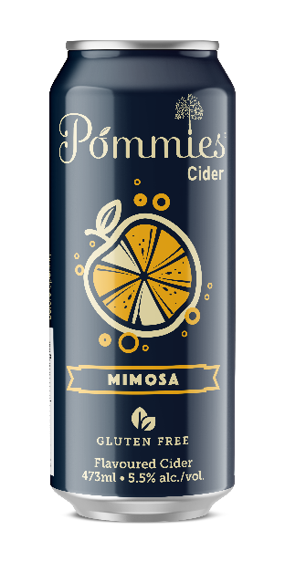
LCBO#: 015153

Pommies Mimosa (5.5%) is a refreshing blend of Ontario cider and orange juice. A fun twist to the brunch classic, celebrate every day with this light and lively cocktail.

