Border Aggregates

Border Aggregates at Carnforth.

This system benefits from 154 JA 500w panels and a 50kw Solis Inverter.

This system has an installed capacity of 77.00 kWp and will produce over 63,000 kw’s of electricity per year.

The company will benefit from a saving of over 38% on their annual electricity bill and the system will pay for itself in 2.5 years.

Go Green Solar Group handle every aspect of the project from the design to installation and everything in between.

Design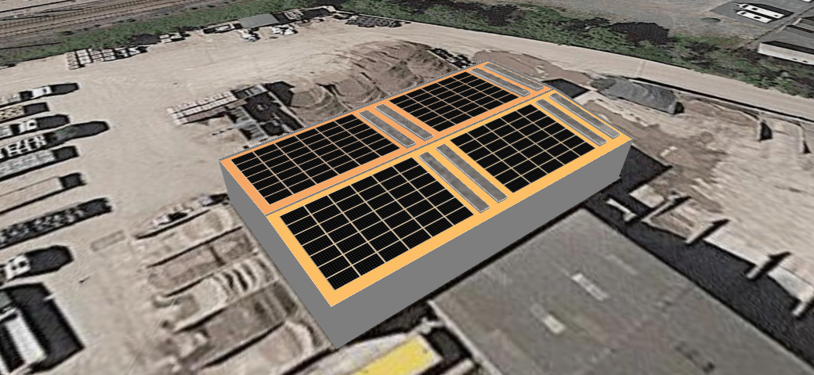
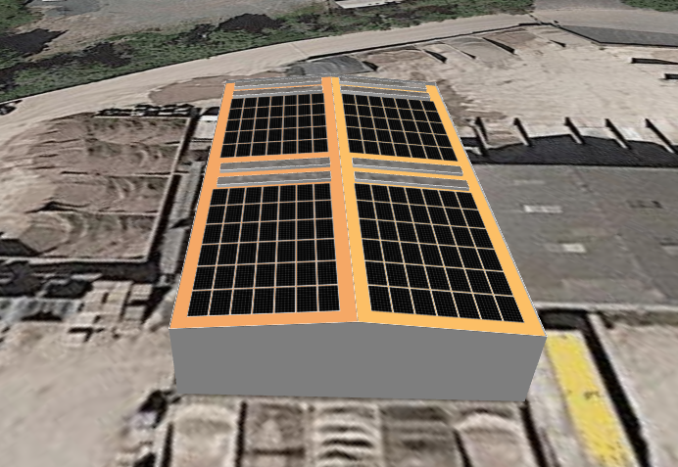

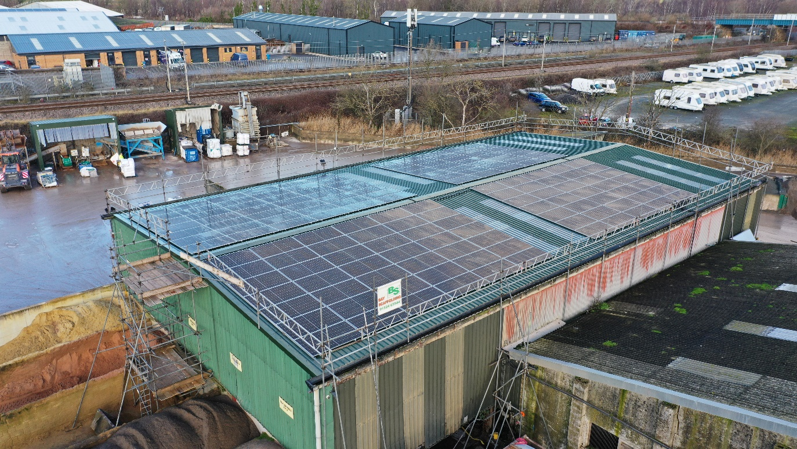
Finished project. 