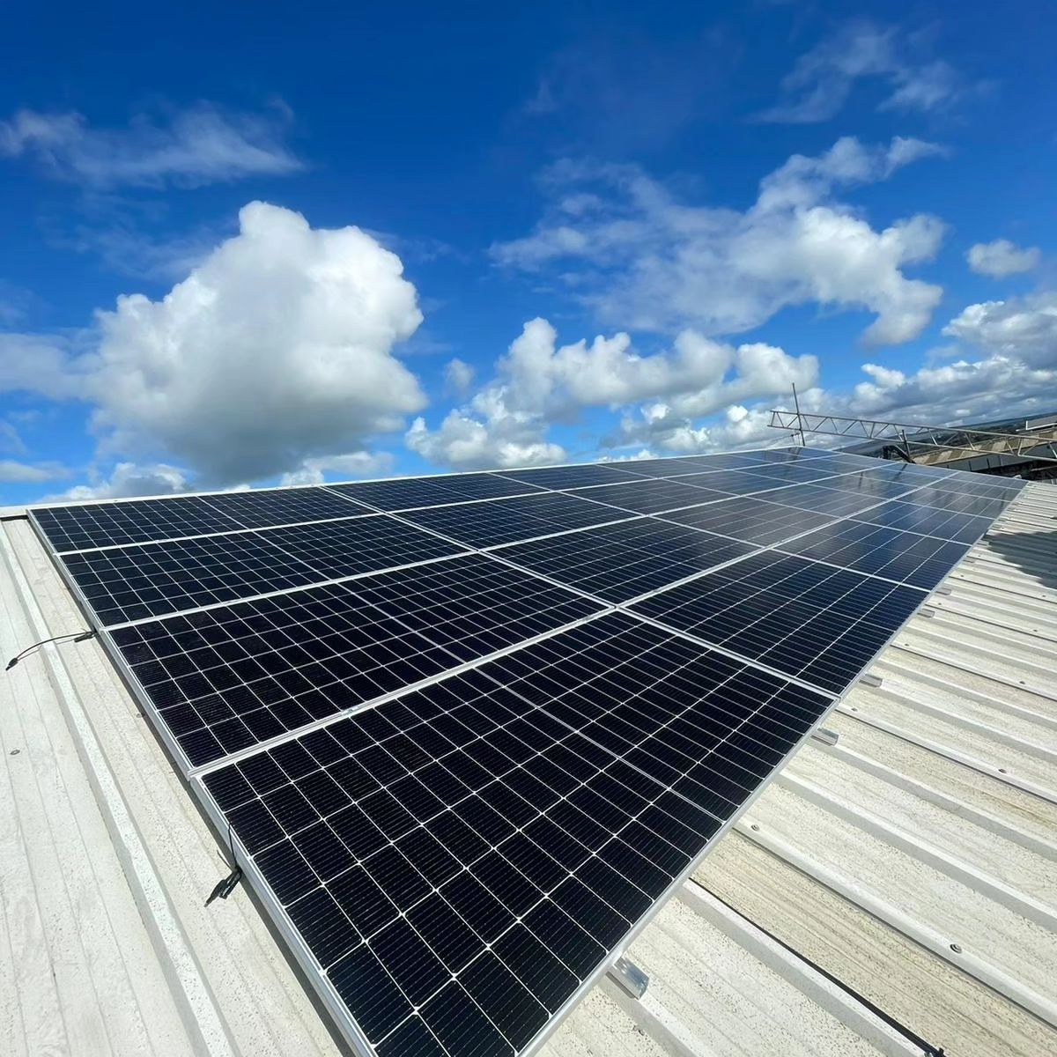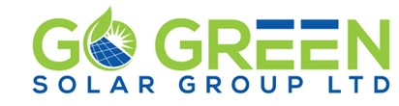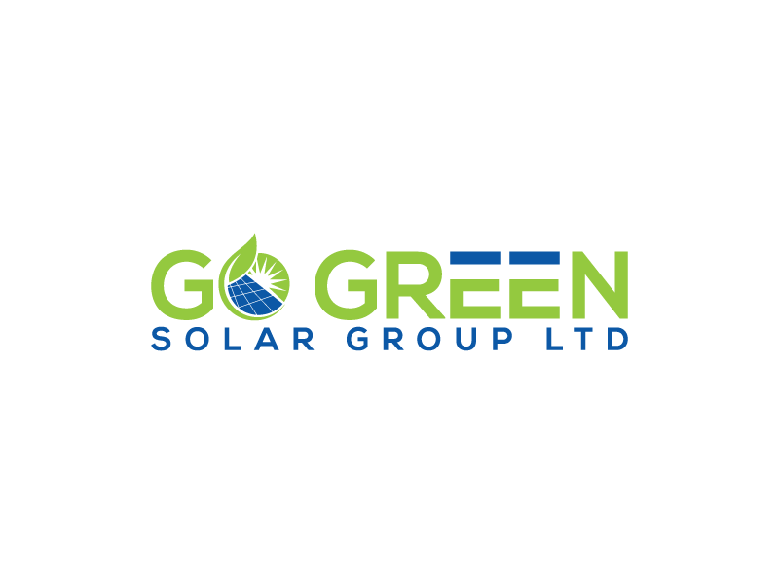

Go Green Solar Group Ltd specialise in providing high quality commercial solar energy systems. We work across a range of business sectors including owner/operators, corporates, landlords, new builds and the public sector.

Go Green Solar Group Ltd deliver premium solar PV energy systems allowing companies to control their electricity generation at substantially reduced costs and deliver environmental benefits and increase their energy security.

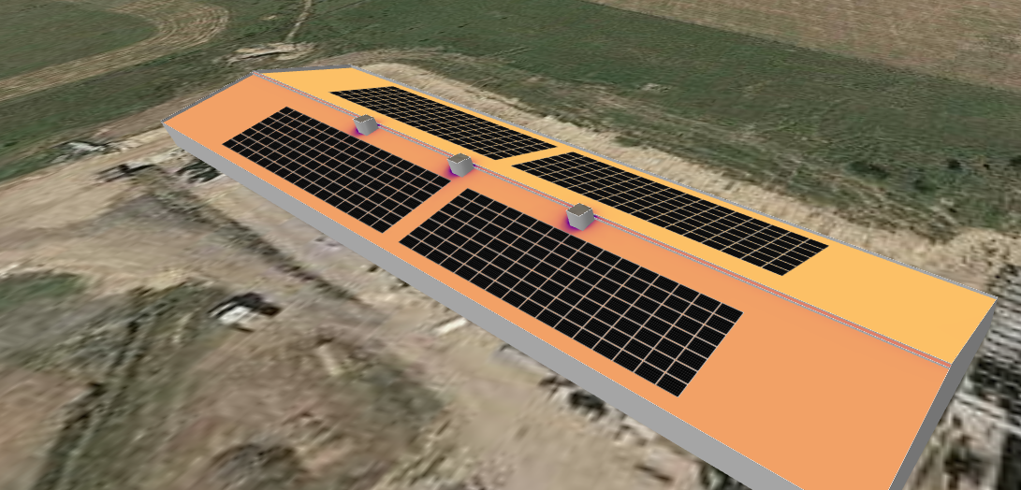
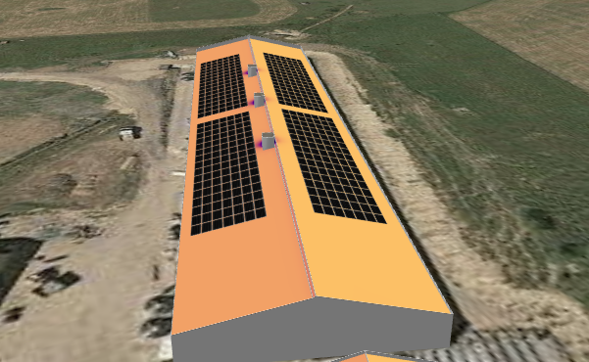
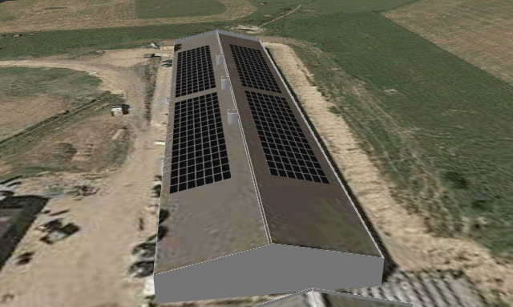
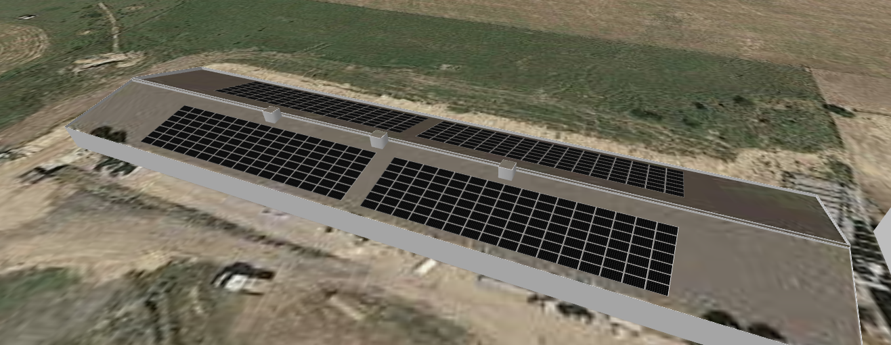

Case Study:
Chicken farm Egg producing facility. North West.

Farm usage
Total power used on site 264,990 kw per year
Total cost of electricity £108,680

Solar installed 224 kW system
448 X 500w panels
2 X 80kW Solis inverters
Full remote managment system

System production
Yearly saving of £66,457
Payback time 2.4 years
Bill offset 61.15%
ROI 47.76%
Finance is available and project is cash positive in the first year.

Project Management
All aspects of work are undertaken in house by the Go Green Solar Team to include:
- Design
- Grid relations (DNO application)
- Project management
- Scaffolding
- After sales care
Get Your free feasibility study by contacting 01524 965050
Or enquiries@gogreensolargroup.co.uk
Website: www.gogreensolargroup.co.uk
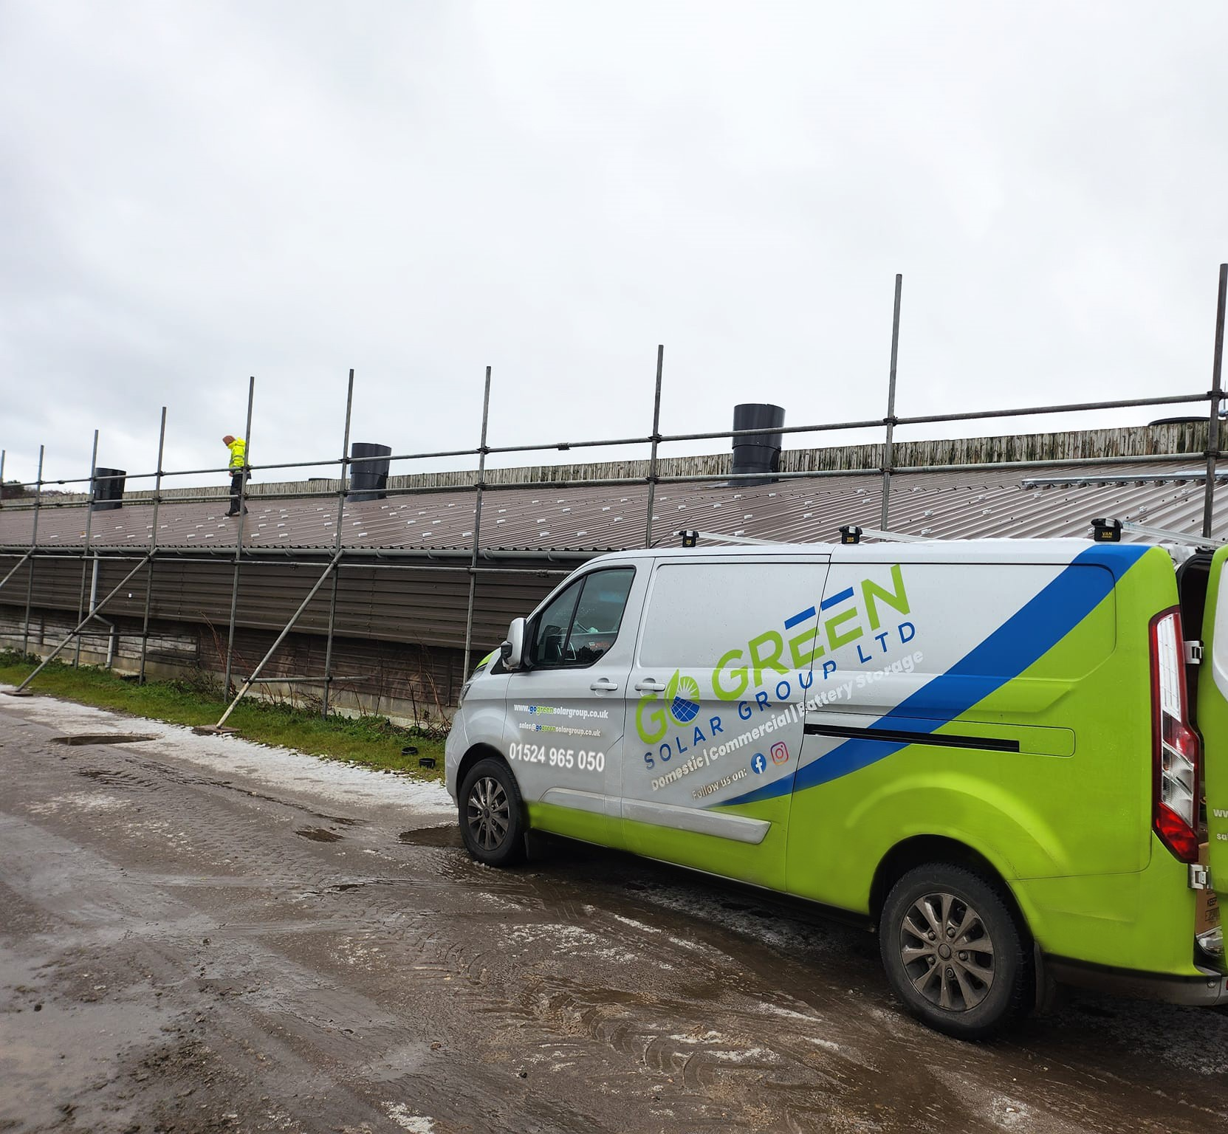
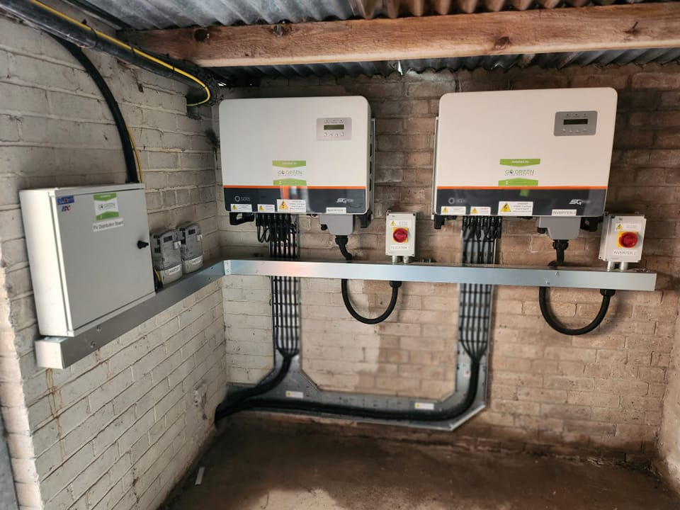

Accreditations

