Content
page 1

Logo Pixel technology I Logo UNIT BOX

Automated Dispensing Cabinet (ADC) – an effective way to control costs and efficiently manage the drug administration in hospitals.
www.pixeltechnology.com I www.unitbox.info

page 2
How does ADC - Unit Box enhance the daily functioning of the hospitals?
UnitBox is more than just a solution for modern pharmacotherapy challenges; it's a significant advancement in ensuring top-level patient care. This system boosts hospitals' daily operations through a complete automation and digitalization of drug circulation, a crucial process for efficient healthcare management.
According to the State of Pharmacy Automation report, a substantial number of medical facilities globally are already benefiting from such improvements. Notably, automated ward pharmacy cabinets are highly regarded by the medical staff, with research indicating an impressive 98% satisfaction rate, and 84% of hospital pharmacy managers rating them as ‘’good’’ or ‘’excellent’’.
What problems does UnitBOX solve?
- Too long preparation time for patient medications - nurses spend up to 57% of their working time preparing medications for patients and dealing with bureaucracy.¹
- Medication administration mistakes - between 8% and 25% of medications in hospitals are administered incorrectly, which can result in extended hospital stays and complications.²
- Inefficient medication management - difficulties in verifying medication stocks, theft, and wastage of medications.
- Unauthorized access to medications - lack of control over access to medications and lack of monitoring.

Numbers:
30% Cost savings ³
17% Error reduction⁴
57% Time savings⁵

Case study - own material*
Implementation of the UnitBox system in hospital wards resulted in:
Up to 70% - reduction in inventory levels *
20% - reduction in the number of items in the ward pharmacy inventory *
Up to 2 hours - daily time savings for staff in the preparation of medication sets (for 35 beds in the ward).*

page 3

Improve the medication distribution system – the capabilities of the UnitBox Automated Dispensing Cabinet.

- Real-time automation of medication inventory management minimizes the risk of errors and enhances patient safety.
- ‘’Access control’’ prevents unauthorized use of medications, with the access granted through identifiers, access codes, and video recording.
- Precise tracking of medication ‘’expiration dates’’ through report generation and statistical data reduces the number of expired medications and minimizes the medication losses.
- Reporting and data analysis enable a better understanding of medication usage patterns, optimization of orders, and staff workflow.
- UnitBox technology allows for centralized management of medication processes in hospitals.
- Integration with the hospital's HIS system streamlines the patient data management and automates processes.
- UnitBox features built-in educational modules to support the staff in utilizing the pharmacy's capabilities efficiently.
- The UnitBox system is scalable and can be tailored to the specific needs of hospital units, with fully configurable modules and drawer sizes.
- It includes a built-in label printer and EAN and QR code scanner, eliminating the issue of unlabeled medications.
- Implementing the UnitBox system in hospitals provides 100% control over medications.
- The device maintains constant temperature and humidity monitoring for each drawer and includes a built-in refrigerator to ensure the recommended storage conditions for medical products, including narcotics, vaccines, and other therapeutic items.
- The device operates in emergency mode, ensuring uninterrupted service in case of unexpected situations.
- Interoperability with EHR (Electronic Health Record) facilitates the management of procedures and legal regulations related to medication circulation in the hospital.

Why is it beneficial for hospitals to use an Automated Dispensing Cabinet (ADC)?
- Automation and digitization of activities in hospital logistics
Improving the communication between the hospital pharmacy and the wards regarding medication distribution to the units and hospital pharmacy stock.
- Enhancing patient safety during medication dispensing.
Full patient identification and integration with the Hospital Information System (HIS) reduce the risk of human mistakes that may occur during manual medication preparation and dispensing.
3. Boosting the efficiency of medical staff.
Automatic control of inventory levels, orders, and medication distribution to hospital units and patients.
4. Accelerating the digital transformation of healthcare facilities and generating savings.
UnitBox automated dispensing cabinets generate large amounts of data that can be analyzed to optimize processes, improve procurement planning, and manage the inventory efficiently.

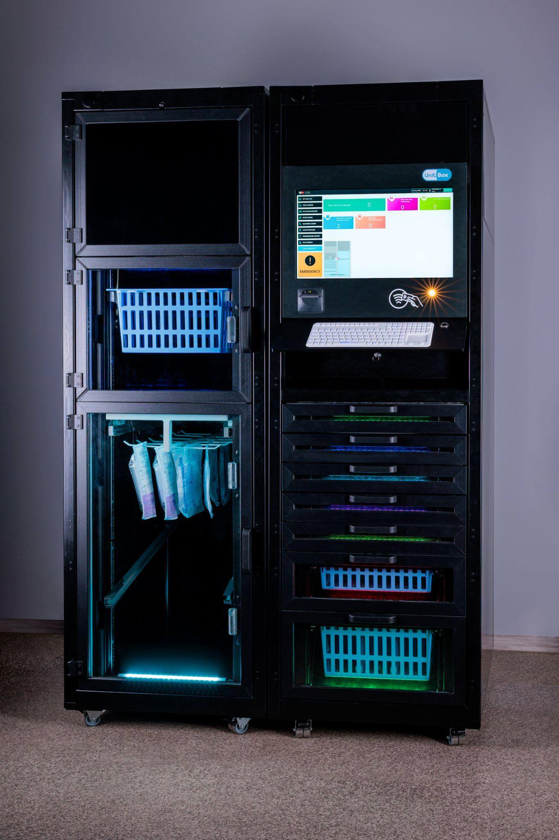
- 22-inch touchscreen display
- Video camera
- RFID card reader
- Drawers with ISO baskets
- Integrated keyboard
- Label printer
- 2D and 1D barcode scanner
- Built-in refrigerator

Dimensions (height x width x length)
2000 x 1300 x 820 mm

- https://www.ncbi.nlm.nih.gov/pmc/articles/PMC6371290/
- https://www.ncbi.nlm.nih.gov/pmc/articles/PMC7362775/
- www.eahp.eu/sites/default/files/dd-007.pdf
- ejhp.bmj.com/content/20/Suppl_1/A85.2.abstract
- hospitalpharmacyeurope.com/reviews-research/implementing-an-automated-dispensing-system-for-the-safe-management-of-controlled-drugs/

page 4

Please delete: trusted us

more photos

Need more information? Schedule a non-binding presentation!

QR - unitbox.info

email: team@pixel.com.pl
phone: +48 609 601 608
Piękna 1, 93-558 Lodz, Poland

