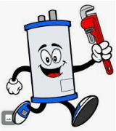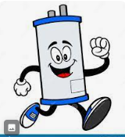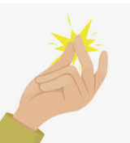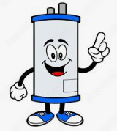

These are just some examples of what I am thinking…a running, happy, dancing water heater. Snapping his fingers on one hand to refer to our name: Snappy Water Heater.
These are just from googling an image. Not intended to be used and I don’t have permission to use them.

