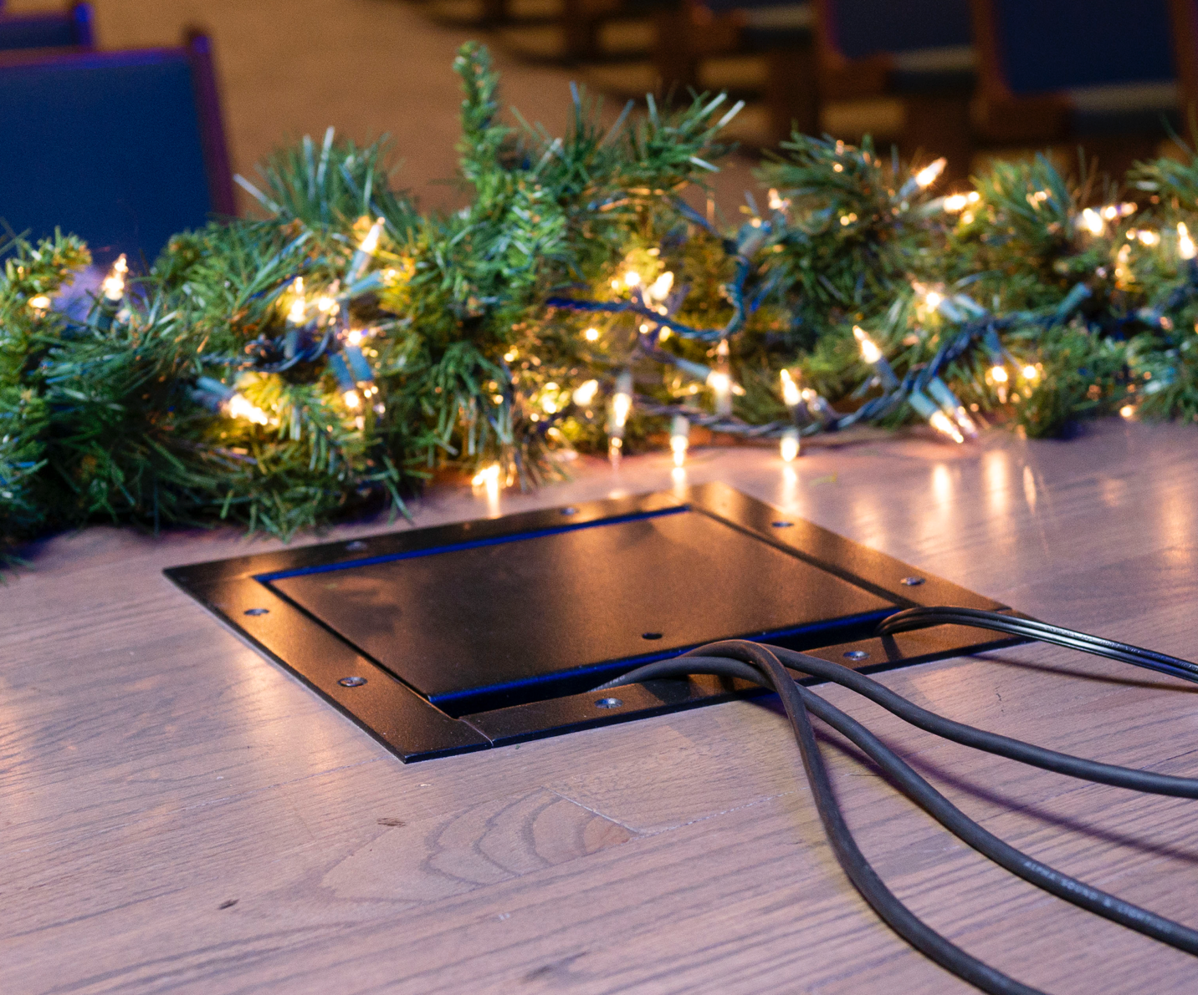

Total Print Ad Size: 5” x 5”

Logo: 

#1 Text: Protect and Conceal High and Low Voltage Connectivity
#2 Text: Become a Dealer (click here)

