Overview
When a potential customer visits our site, they will be driven to this page where they can see how our product works. The goal of this page is to allow a potential customer to picture how heyLibby, our product, fits into their business processes and tools. We will do this by using an example customer, which is Taylor the owner of a small painting business and how he uses heyLibby.

The page will have the following components:
- An image of a Taylor the painter and text that says “I’m Taylor, owner of a small painting business. I use heyLibby as my AI sales assistant in the following ways”…
- The five areas that heyLibby is used
  - Chat
    - Text that says “I embed the heyLibby chat on my website and add it as my link in bio on social media.”
    - An Image showing his website with the embedded chatbot in the bottom right corner (put a placeholder for a chat icon and we can edit with our actual icon later) and shows how heylibby.ai/taylorspainting is his link in bio on instagram or facebook (your choice which).
    - Button to ‘try out chat’
  - Phone Calls
    - Text that says “Libby answers my phone calls”
    - An image that shows a phone number somewhere a small business would display it…on a billboard, on a company car/truck
    - Clickable image/button that says ‘Listen to an example call’ or something similar. This could be a button or a cool image that denotes its clickable and is a sample phone call
  - Text
    - Text that says “Libby responds to my text messages”
    - An image that relates to this such as: text message conversation between Libby and a customer on a mobile phone, the phone number on another place a small business would display it like the previous but different image, phone number in an email signature of the small business owner or on a business card.
    - Text that says “Text 206-555-5555 to try it out” or something similar
  - Email
    - Text that says “Libby responds to my emails”
    - An image of the email address on the website contact me, or a business card, or truck, etc. Something that relates to where the small business owner would put the email address for potential customers to email.
    - Text that says “Email testemail@email.com to try it out” or something similar.
  - Manage My Leads: A section showing how the example customer Manages their leads through heyLibby.
    - Spot for an embedded video.
    - Text that says “I manage my leads through heyLibby to ensure that I always follow up with the most qualified leads as quickly as possible.”
- A button to ‘Set up your own Libby” or if you need the text shorter “Sign up now”/”Sign up”

Other notes and options to spark creativity
- You could try including the Phone calls and text messages section together since phone numbers will be both called and texted.
- Page could show all of the components above on scrollable view OR it could have a component where they could select each option (Chat, Phone Calls, Text, Email, Manage Leads) and then it displays the related information when one item is selected.
- I have included an image below of the various sections we’re imaging that align to the 3 sections above, but the placements are just examples so be creative of course! It also includes the Header/Footer of the site. I’ve also included an image below of the mobile header and footer since mobile designs are very important for this page.
- I included some libby png/gifs that you could use. Libby is our brand character so you could create different images or gifs of Libby doing different things. Libby represents the AI assistant that our customers set up through heyLibby so Libby will be their AI assistant that answers calls, texts, emails, and chats for them.
- We have a current site heylibby.ai that we are currently rebuilding with just slightly different designs. You can go to heylibby.ai to get an idea of our brand. It looks mostly the same but we’re using Material UI for the components so I’ve included an image below of part of the new home page, which you’ll see the similarities and differences.

Scope
- Create the UI/UX designs
- Create the images needed for the page, providing the original editable files.
- Desktop and responsive (including mobile)

Image examples below:
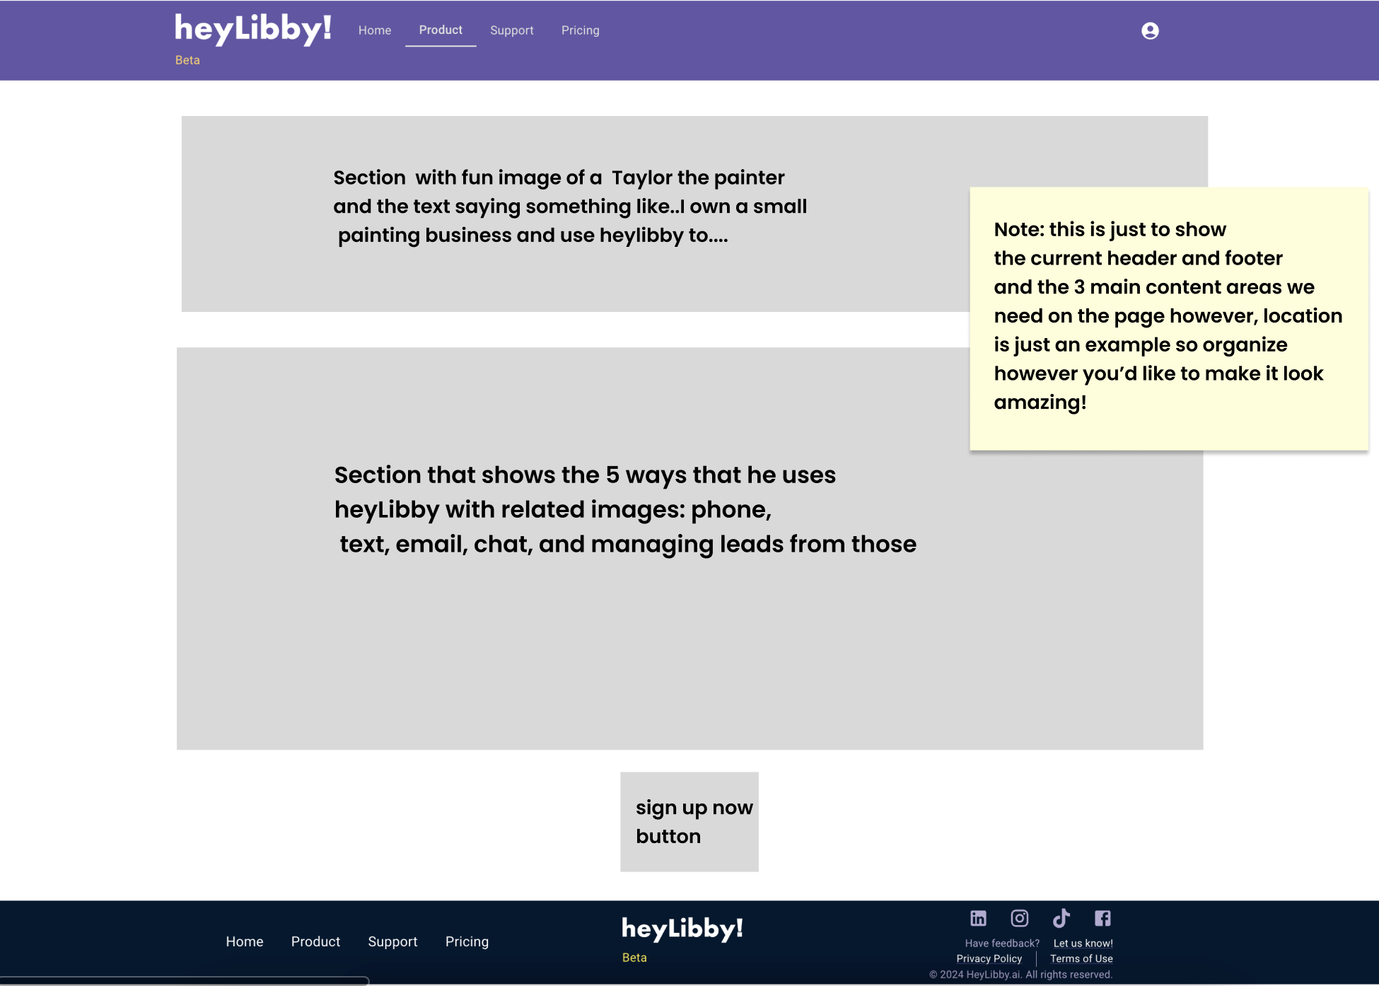

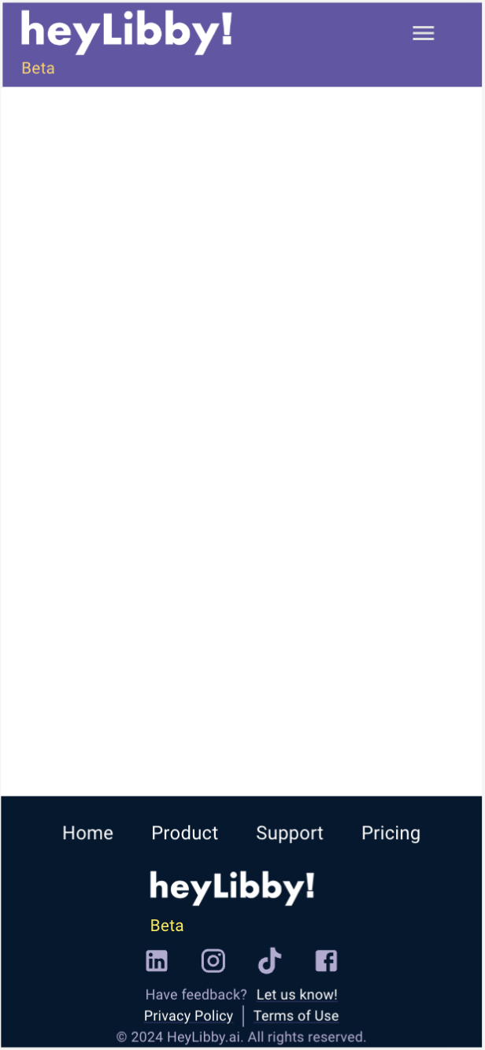
Screenshot of new home page just to show the style of our site. You can also visit heylibby.ai, and you’ll get a good idea of our brand.
