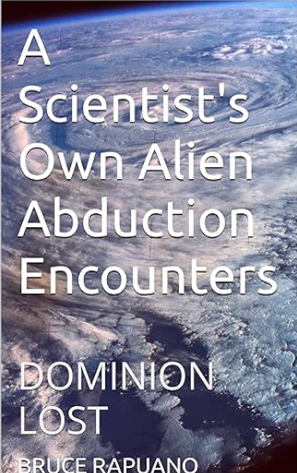

This bombshell nonfiction book, recently discussed by the author with George Knapp on Coast to Coast AM, is the only first-person account to date of UFO alien abductions authored by a mainstream American scientist. The author, who has multiple degrees in neuroscience, goes on the record regarding his incredible and fascinating experiences with multiple UFO close encounters, including a very close encounter during which he was abducted from a group of eight other witnesses, interactions with alien beings and an unexplained nasal implant of specific structure all of which were recalled without regressive hypnosis. Also riveting are the author's experiences with short humanoid beings that are described in captivating detail to reveal all the ways that aliens control human behavior during the abduction process.
Even more amazing is the fact that this book is the first to explain :
- how the implants that are frequently reported by abductees work to analyze and influence the activity of the human brain.
- exactly how the “grey aliens” were genetically reengineered from our early hominin ancestors.
- precisely how the UFO propulsion system creates gravitational wave energy.
At the same time, relying on his professional background, insight from his personal abduction experiences and numerous cited scientific articles from peer-reviewed journals, the author demonstrates that the ultrasophisticated technical capabilities exhibited by the alien visitors to our planet are more than plausible. They represent a logical extrapolation of current human theoretical and applied science.
Moreover, the powerful evidence of such technology which has existed for more than 60 years, especially with respect to incredibly advanced propulsion systems for interstellar space travel and implanted devices that are likely instruments of mind control, proves that the aliens are here. Potentially breakthrough scientific innovations underlying these highly advanced alien capabilities are revealed that make the book a de facto whistleblower report on the subject of UFO’s and alien abduction. More importantly, this book is a wake-up call to our species to finally accept the reality that we are now sharing our world with technologically superior alien beings. This new reality must be addressed immediately.

