On front doors each side:

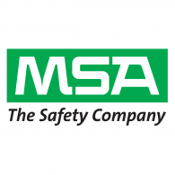

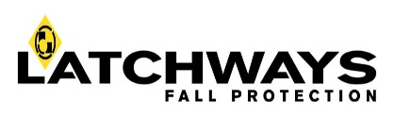

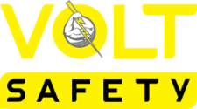

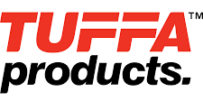

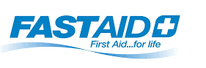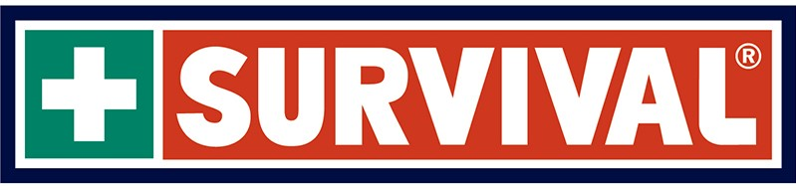

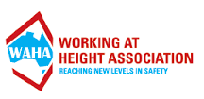

On Sides:

Similar to vehicle but play with design a little so its not just an identical layout as it will be towed by the vehicle.

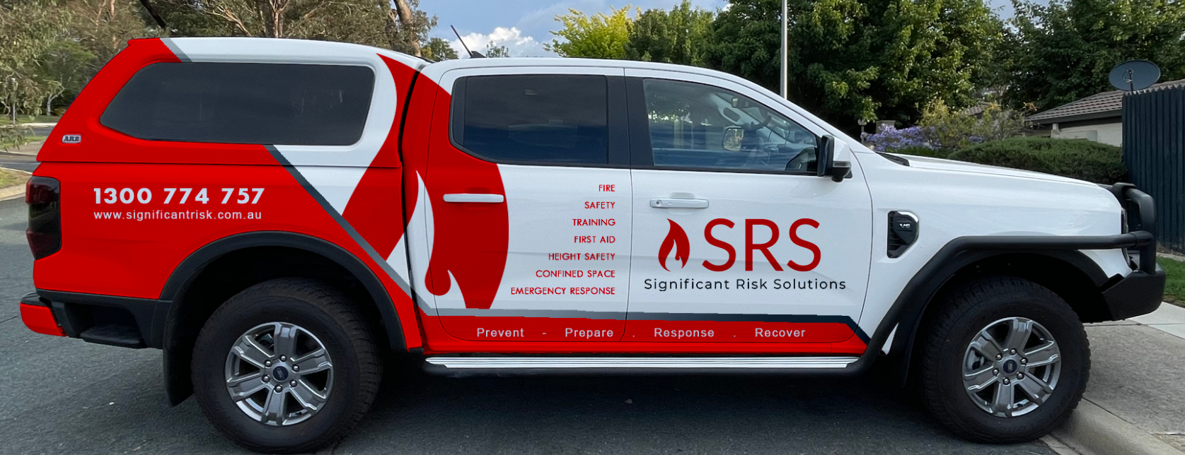

SRS Brand, Logo
Website address
Email Address
Phone number
prevent prepare, respond, recover.
List of services (As shown above)
On-Site Training

On Front:

SRS Brand, Logo
Website address
Email Address
Phone number

On Rear:

SRS Brand, Logo, Website address, Email Address, Phone number
Follow us on (Social Media links, Facebook, Instagram, LinkedIn)

Summary of courses:

Confined Space Courses:
- Enter and work in confined spaces
- Confined space sentry / stand-by person
- Confined space permit issuer
- Breathing apparatus
- Confined space rescue
- Gas test atmospheres

Height Safety Courses:
- Safe work at heights
- Heights safety supervisor
- Heights safety permit issuer
- Suspended worker retrieval
- Vertical rescue

Fire and Safety Courses:
- Respond to workplace emergencies (Fire extinguisher)
- Emergency / fire warden
- Chief emergency / fire warden
- Facility fire safety advisor
- Conduct fire team operations
- Fire Fighting and Emergency Response
- Low Voltage Rescue and CPR

Plus, First Aid, Workplace Safety, White Card, Forklift, EWP and Much More……

Need training – We have the solution!

