Affirmation colour-in story book

Looking for someone to develop the front cover for a colour-in children's story book.

Needs to feature 4 cartoon animal characters (monkey, elephant, tiger, flamingo) and general jungle foliage (detailed brief attached).

The book is a colour-in story based on positive affirmations (I am strong / I am brave / I am loved etc), targeted at 4-6 year olds. It should feel bright, bold, positive and fun. Potential to continue working together to develop internal pages which will be colour-in line drawings echoing the front cover, with short pieces of copy added.

Format
- 20x20 cm (8x8 in)
- Design/words printed on right hand side (flat page) only to allow for colour bleed / free drawing
- Covers are the only bits with colour – rest is for kids to colour in (outline only)
- Words will need space around them – can be in one block or split in two

Design brief (select pages only)

Page | Copy | Visual
Cover | Mia’s Magic Words  A colouring in affirmation adventure | Top – jungle foliage, not too dense. Love the long branches with small green leaves on the left.  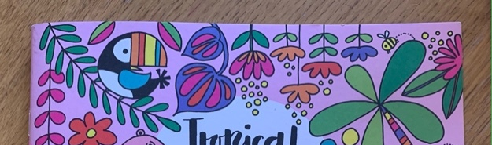  Monkey hanging/swinging on one side – from the top foliage into the mid section (alongside the title).  Image 1 for a sense of positioning, but character should feel closer to the sloth in image 2.  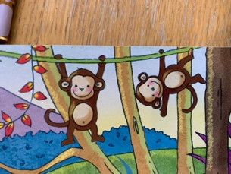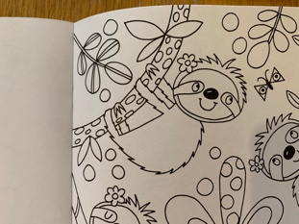  Title (I don’t love the font on the colouring book, the No Other Love is closer but would ideally be a bit softer)  - Mia’s [less focus]  - Magic Words [main focus]  3 characters across the centre/bottom third  Elephant / Tiger / Flamingo (any order)  Elephant – see colouring book back cover. Don’t love the spots on the elephant’s ears. Could incorporate something else for colour – some flowers?  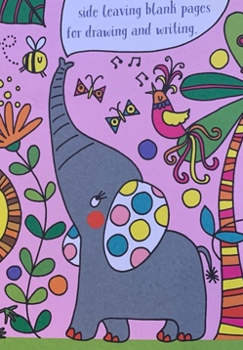  Tiger – something a little rougher than the colouring book tiger – more of this tiger cub  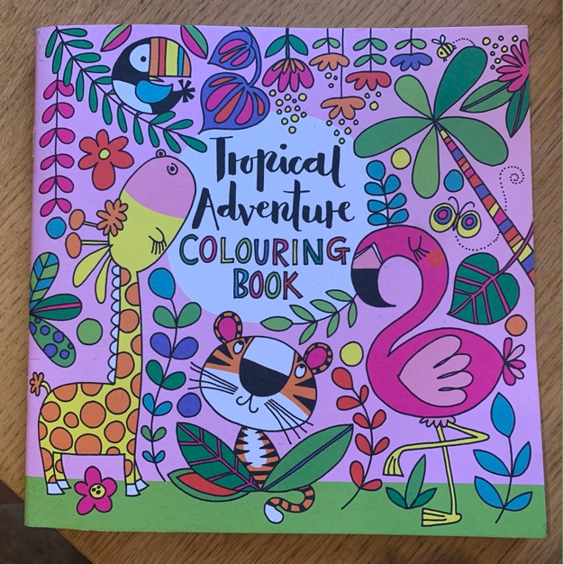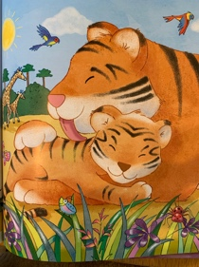  Flamingo – ref the colouring book version.  Bottom  A colouring in affirmation adventure in a ‘banner’ (like The purr-fect tale bit on There’s No Other Love’)  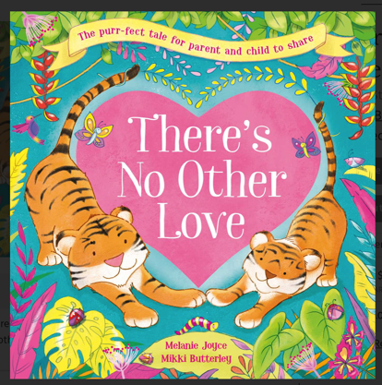  Colour – very bright and loud. Like the light pink background from the colouring book. Foliage & a few bugs/butterflies throughout.  Bottom right not coloured in to show it is a colouring in book (maybe a swipes of not-coloured in – as if shading in white? But nothing to fine/small/detailed)

General design references
