  Contact:  Geoffroy Van Humbeeck (Founder & CEO)  geoffroy@asmartworld.be +32 476 06 74 09  Funding:  Current Seeking  $750k in equity $10M in equity  Use of Proceeds:  First 12 months after funding:  - X People - $XM  - xx (3)  - xx (4)  - xx (1)  - $Xk Technological innovation  - $Xk Market expansion  - $Xk Operational optimization  - $Xk Infrastructure & Technology  - $Xk Intellectual property protection  - $Xk Sustainability and ESG impact  12 to 24 months after funding:  - $Xk Market expansion and consolidation  - $Xk Product and service enhancement  - $Xk Strategic partnerships and brand visibility  - $Xk ESG initiatives  Output:  - International expansion to 5 new territories (4 in EU + US 50x bigger than our current market)  - Operational breakeven after 24 months  - Increase 25x of revenue compared to our 2023 figures.  - Series A: Springboard for Series B  Unique Ecosystem & Competitive Edge:  Our scalable ecosystem uniquely blends software, services, and impact, delivering unparalleled market advantage and transformative user experiences.  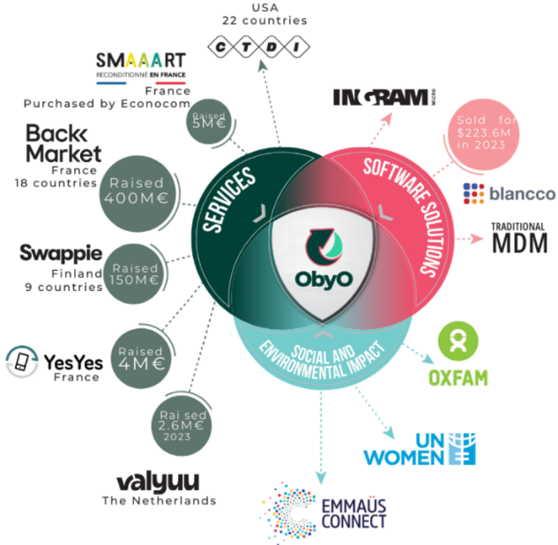  Team  CEO, COO & CTO | Elevator Pitch  We're turning environmental challenges into economic opportunities. We blend cutting-edge SaaS with strong ESG values, laying the foundation for a global expansion to supply the growing demand for refurbished smartphones. Join us to forge a profitable, sustainable future in tech, where innovation meets global responsibility.
Problem
aSmartWorld tackles the global issue of smartphone underutilization, where billions of devices lay unused, 70% of which are suitable for reconditioning. The frequent 2–3 year smartphone upgrade cycle indicates a vast, ever-renewing market for refurbished phones.

Tapping into this multi-billion-dollars market, we confront not only the environmental issue of electronic waste but also unlock substantial economic potential. This represents not just a market opportunity, but a significant step towards sustainable technology consumption.
Solution
aSmartWorld uniquely blends advanced technology with eco-responsibility, demonstrating profitable solutions to environmental challenges.

With a product market fit validated in Belgium, we're set for global expansion with our scalable ecosystem integrating tech, services, and social impact.

Our versatile SaaS platform, initially crafted for B2C, is now adapting to meet the increasing B2B demand from major telecom operators and enterprises. This strategic adaptation of our SaaS platform not only carves a unique market position but also catalyzes opportunities for strategic partnerships and scalable growth, maximizing the impact of our software on a larger scale.
Technology
Our solution is the culmination of 24 months of R&D and over 12 months of proven B2C market testing. Built with a robust tech stack using Flutter, Dart, and Python, and prioritizing security with Firebase, we're set to transform the refurbished smartphone industry. Our EU-protected ObyO brand is a testament to our market readiness and legal solidity.

Offering complete device lifecycle management, scalable branding for global expansion, and enhanced operational efficiency, our solution not only promises substantial revenue growth but also positions our partners as leaders in sustainability and innovation. This is more than an investment; it's a leap into the future of telecom.
Market Opportunity
At the forefront of the sustainable tech market, our software-centric strategy harnesses the vast potential of billions of underutilized smartphones worldwide. The ObyO SaaS platform, our flagship product, is engineered to meet the increasing demands of telecom giants, major corporations, and the growing B2C market, offering solutions that are environmentally sound without compromising economic value. Our unique approach, aligned with ESG principles, sets us apart, positioning us as innovators redefining standards in sustainable technology. We're leading the way in this market, steering toward a future where technology is sustainably leveraged.
Statuts
Having achieved a validated product-market fit in Belgium, we've established a proven track record, laying a solid foundation for expansion. Our solution, honed through 24 months of rigorous R&D and over 12 months of successful B2C market testing, positions us at the cusp of significant growth and innovation.

