Hello Designers!

I am hoping you can help us w/ a great logo design and look forward to seeing everyone's work!

Thought a quick brief background on our business and with some our logo ideas would be helpful.
A. Glamping Industry Background --
- What is glamping?
Glamping combines the words “Glamping” and “Camping” resulting in the combined word of “Glamping”

- How is glamping different than glamping?
In camping you purchase and pack your own gear. Where in glamping everything there including bed, furniture and in luxury glamping there are bathrooms

- In glamping a number of different structures are used not only “soft structures” called tents and yurts but also “hard structures”, like small cabins, trailers, A-Frames, etc.

B. Posh Outdoors Model

- See video on our first location called Wilderness River in the Canadian Rockies -- https://www.youtube.com/watch?v=4W5WeyPUtUU&t=210s

- Our primary glamping is a glass tube called a “Tubbo” and is manufactured in Spain. Here is the website www.Tubbocom. Here is there video -- tbb0 -- https://www.youtube.com/watch?v=XEWdJI09O-I

C. Our Logo Ideas, Concepts & Potential Ideas

Logo Idea #1 --

6. This is our manufacturers Tubbo’s logo



One logo concept we would like to explore is similar to Tubbo, i.e. – w/ circles BUT with more color and boldness.

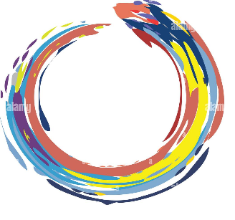
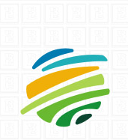

Logo Idea 2 --

Tubbo has the circular logo image to the right of their name
One more logo we add to make the “letter “O” on our company name Posh Outdoors a circular image rather than the font “O”

Logo Idea 3 –

One more idea we had and would to have some concepts is the below logo which utilizes Leafs into the logo


Hope the above helps!
Pleas email if any questions
Look forward to seeing great logos!

Thanks!
Kevin

