Example Brands & Design Notes (All the titles are links to products)

OUR BIGGEST COMPETITOR – KIPERIN:
This is the biggest brand in Turkey right now.
It’s design is not even that good, BUT IT HAS A VERY DISTINCT CHARACTER. YOU CAN RECOGNIZE IT FROM MILES AWAY. WE WANT TO CATCH A SIMILIAR FEELING.
This product is very very important. They also use emboss techniques very frequently etc.
We want these types of similar to the 2nd product (Applied Nutrition Marine Collagen one with Platinum strokes and very neat looking product information – 11g protein, 12g collagen, 0g sugar etc.). You can just copy the same section to the bottom aswell. We love it.
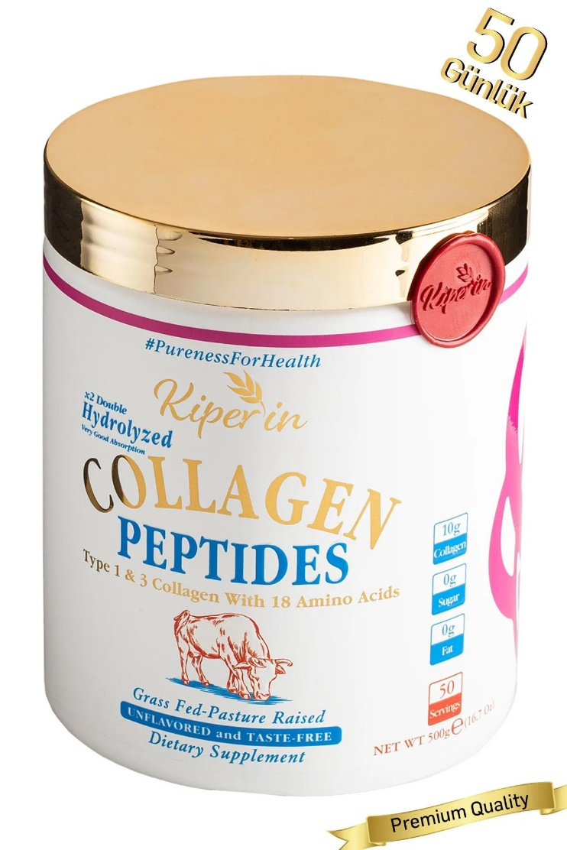

Applied Nutrition Marine Collagen Powder
THIS IS PROBABLY THE CLOSEST TO WHAT FEELING WE WANT TO EVOKE.
You can try adding a similar embossed strokes to the headline aswell. Deep blue with platinium gray stroke (which feels very nice)

Also I really like the bottom of this design aswell. The font is great aswell. I just love it.
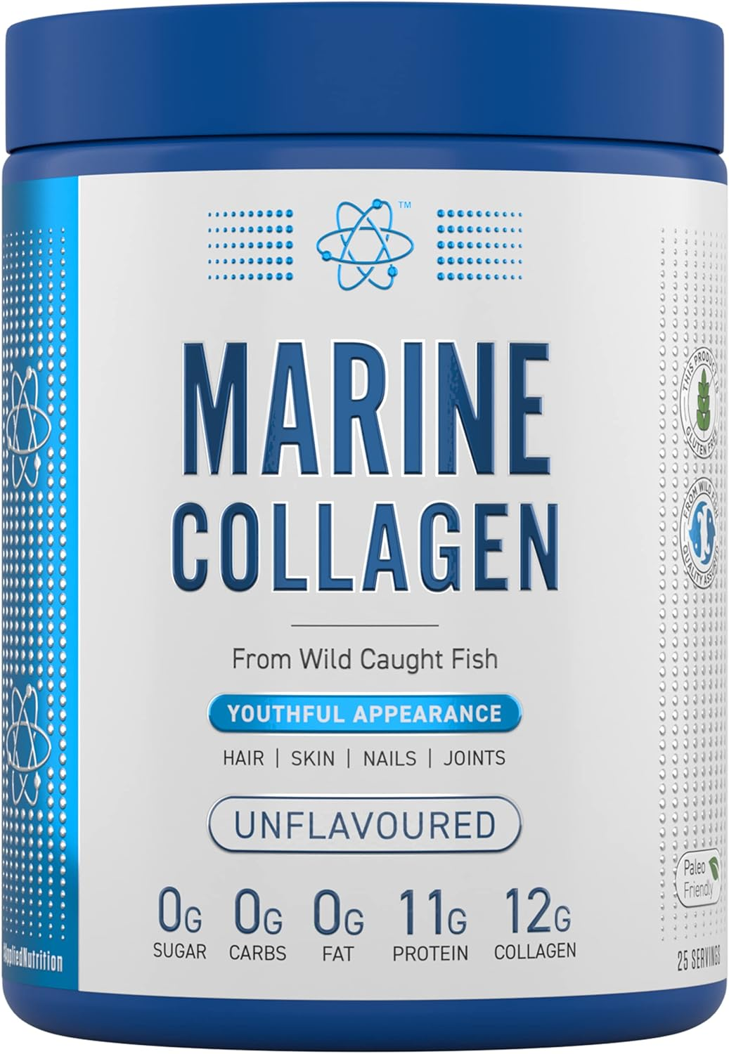

Sports Research Organic Collagen Peptides
The thing that I like about this design is that it feels very clean & established/trustworthy.
But it lacks the feeling that we seek. I mean it’s not very distict to look at it. It doesn’t evoke any feelings in me.
BUT IT’S VERY CLEAN AND I LIKE THE CLEANNESS OF IT.
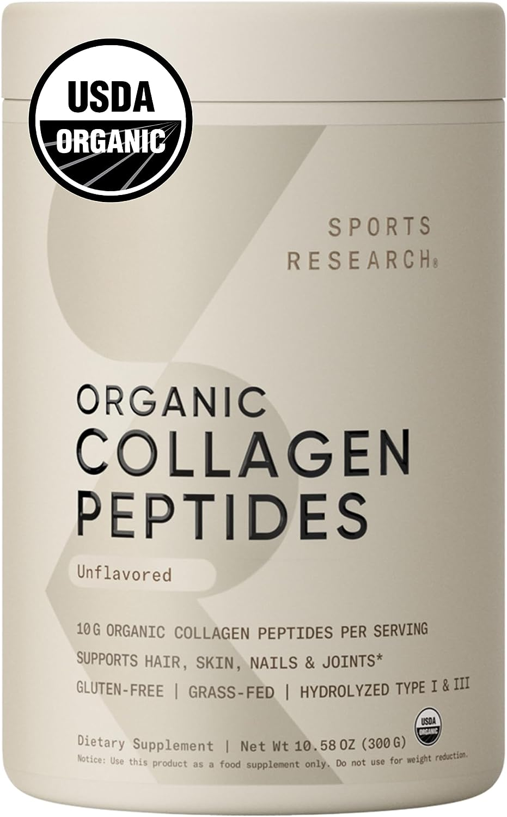

Vital Proteins Collagen Peptides Powder,
So this is not the perfect one aswell, BUT IT HAS A CHARACTER & IT’S CLEAN.
It’s just that the icons are very details & it’s a VERY BUSY design.
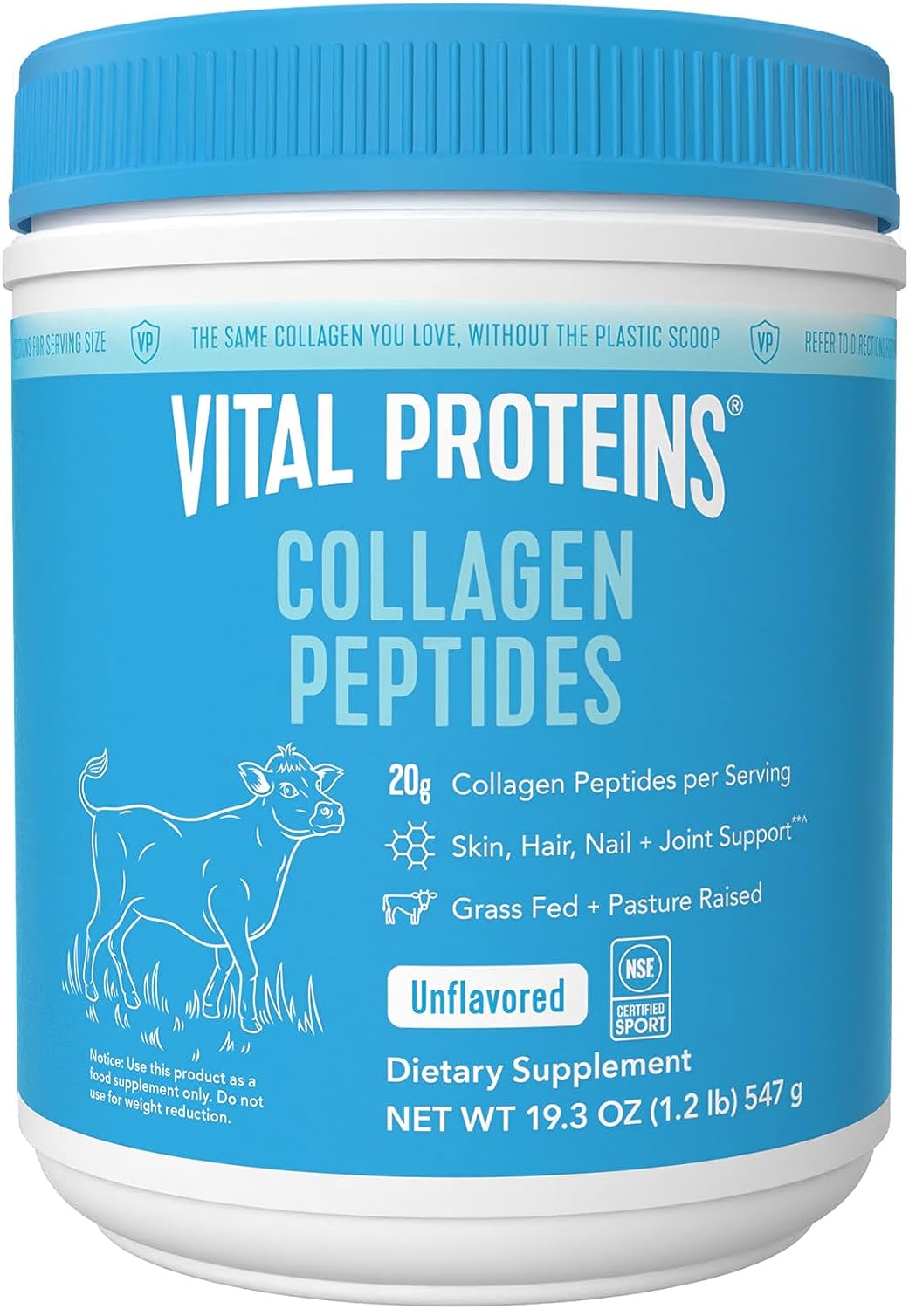
But other than that, the cow, the benefits are really good.

Bulletproof Unflavored Collagen
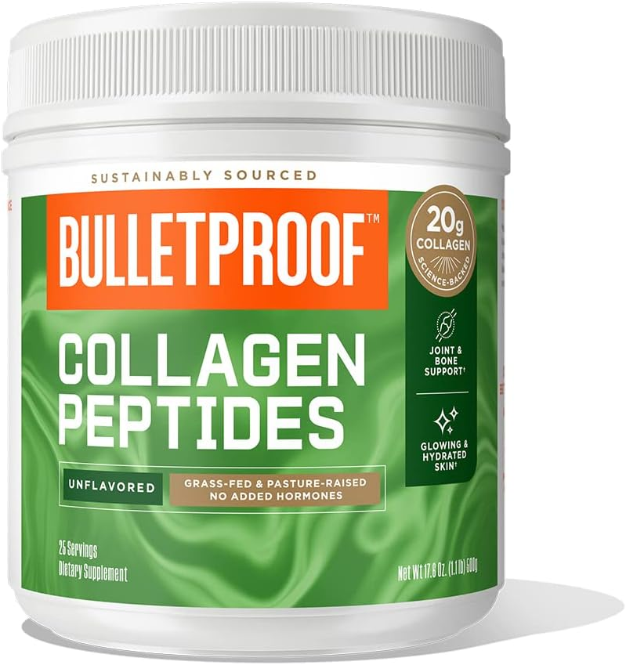
This is a BAD example of what we don’t want. It’s very cluttered and busy… We don’t want it.

Great Lakes Wellness Collagen Peptides
The thing that I like about this design is that it has a CHARACTERISTIC.
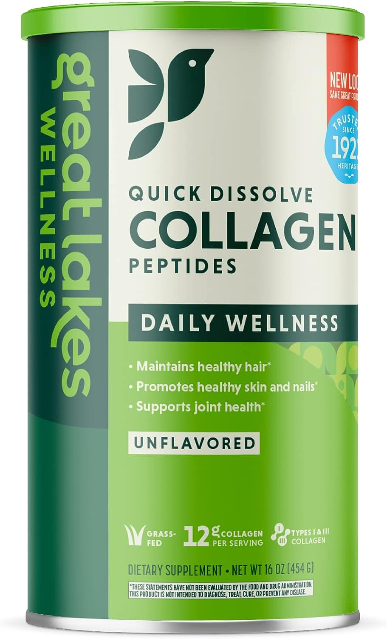
It’s not exactly what we want, but this evokes a feeling inside me and that’s a sign of good design for us.

Collagen Powder Protein by Ancient Nutrition
Same thing with this, it’s busy but it evokes a certain feeling.
It feels ancient, elegant, premium (those fractals also support that color scheme & fonts aswell).
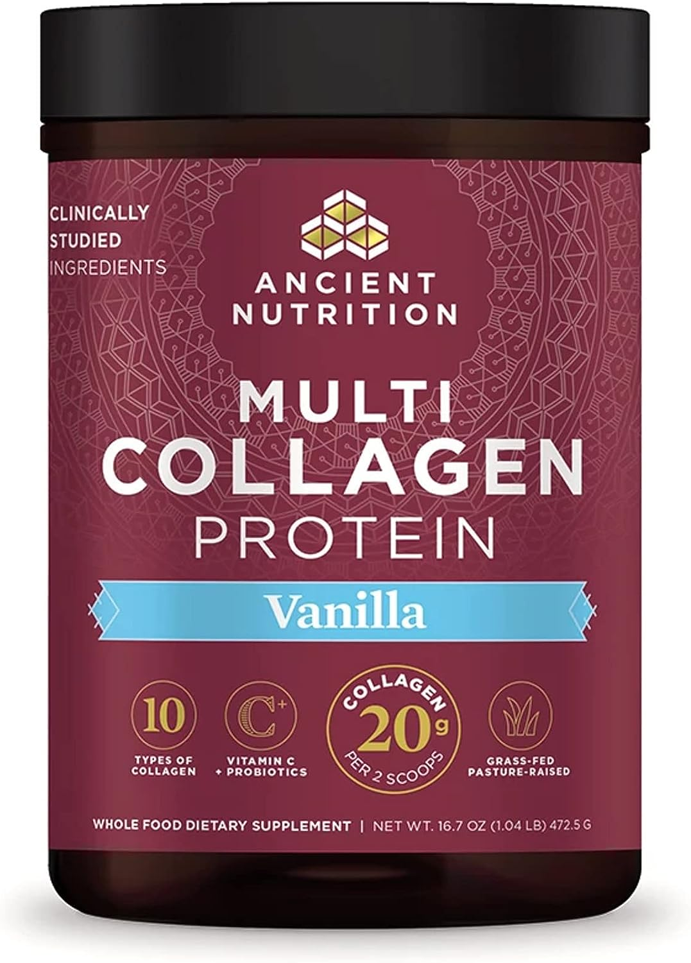
Including just to explain what we want better.

Naturagen Pro Kolajen Powder 330gr
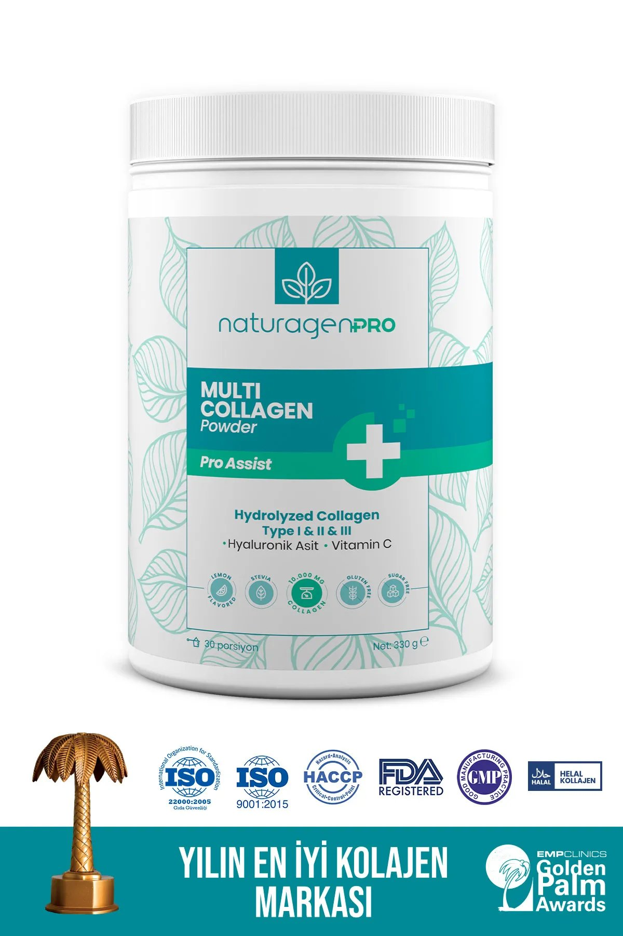
This is not something we very much like, but it has a characteristic aswell. That’s why I endorse these types of designs.

Last Notes
This list is not exhaustive and NOT TO limit your creativity, just to give as much information as we can about the product, market, what we are looking for etc.

Feel free to be creative.

As long as we evoke the feelings I’ve mentioned throughout these documents, it’s all good.

We are looking forward to working together.
Best.

