12(h) x 15(w) Mailer ideas
SIDE A:
WHAT HAPPENS IN BURBANK (SHOULD) STAY IN BURBANK (Create a blend of image A and Image B {below} into one unique image)
COPY: Arranged as you see fit
You’ve got a neighbor in the direct mail business.
For 75 years, American Direct Mail has been serving our community- from large studios to small mom-and-pop stores.
We live here, too!
As a local family, we ascribe to the values that make our community special- that small town feel with big city services- focused on keeping us all connected.

WHAT WE DO:
Direct Mail/Marketing
Mailing for Union Pension, Insurance, and Healthcare Notices & Membership Voting Materials
Nonprofit Mailing
Political and Community Campaign Mailing
City and Government Mailing
Fulfillment Services
*Green and Union options available
Mention this mailer and get a $50 Gift Card to Porto’s or Romancing the Bean on your first Order of $2500 or more; Get a $100 Gift Card to Porto’s or Handy Market on your first order of $5,000 or more.

SIDE B:
COPY: Arranged as you see fit.
Remember great customer service? We do. (Example images C, D)
We don’t provide a cookie-cutter mail service. We focus on helping clients by doing one thing really well—and that’s direct mail. Our team of experts goes through every phase of the direct mail cycle to provide you with better results, higher-value customers, and direct mailing success for years to come. We can design, print, mail, and provide targeted lists, tracking, and analytics. We’re more than a direct mail service provider, we’re your marketing partner!
When you take these values and wrap them around our commitment to customer satisfaction, you get good old-fashioned customer service that is, sadly, rare these days.
At American Direct Mail, we view it as an obligation to our customers to go above and beyond to provide them with services that not only meet their needs but exceed their expectations. Our “Make it Right” mentality extends beyond our products and services.
Whether it be the timely response to an inquiry, a human answering your call or following-up to ensure your ongoing satisfaction, you can trust that working with ADM will be a rewarding, enjoyable experience on top of an excellent return on your investment.

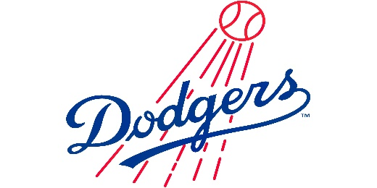
Clients include: (small banner across bottom of page; 7 IMAGES could be page one or page 2; image size will need to be reduced)
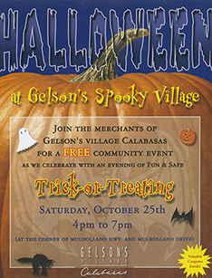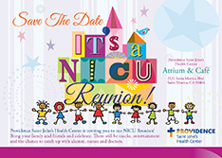
Gelsons LA Dodgers; Providence Health Center
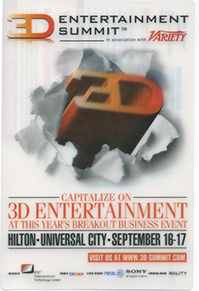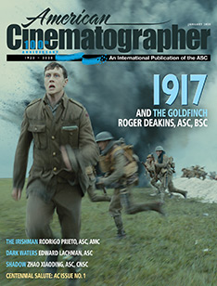
Variety American Cinematographer
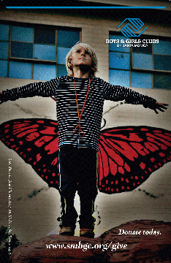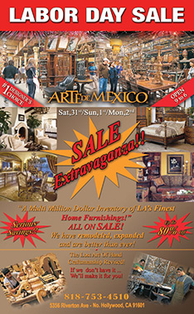
Boys and Girls Club Arte de Mexico

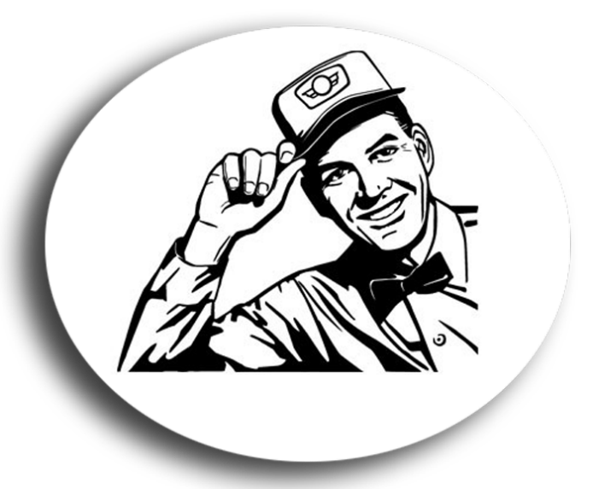
IMAGE C
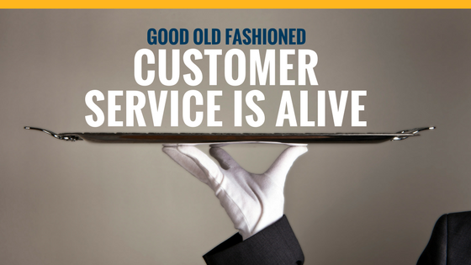
IMAGE D

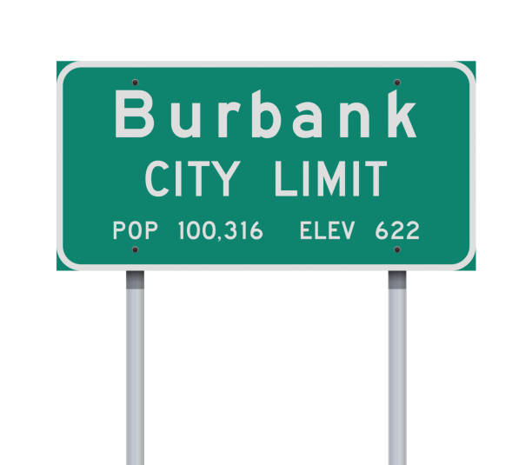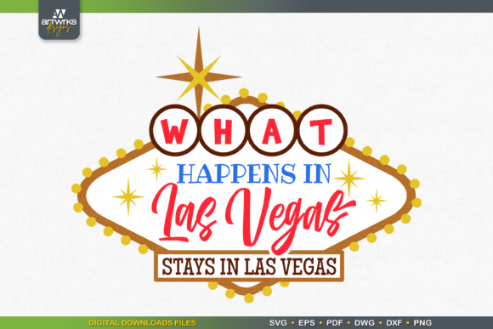
IMAGE A IMAGE B (blend these 2 images)

