Glutathione

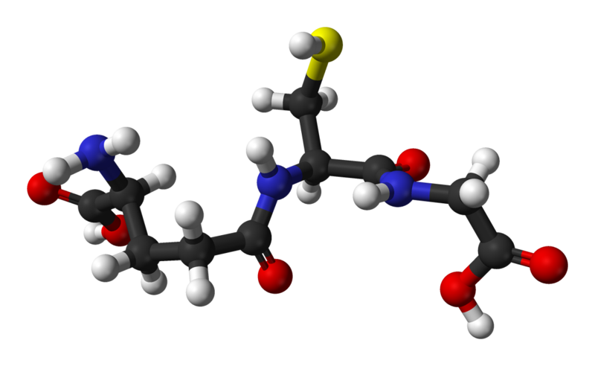
You know about antioxidant research, so you drink antioxidant packed beverages, you search for foods with antioxidants, and you do everything you can to smash those free radicals. This is the next step. There’s a reason The Mayo Clinic loves Glutathione. It’s the gold standard of antioxidants, believed by the medical press to slow the progress of Parkinson’s, reverse liver damage, combat cancers, and many more. Nobody can definitively say to what extent, if any, these may occur, but antioxidants are a health gold mine, can’t hurt, and may produce amazing effects over time.

Contains:

Ringer’s Lactate 1L (Potassium Chloride 0.3 g/L, Sodium Chloride 6 g/L, Sodium Lactate 3.1 g/L, Calcium chloride 0.2 g/L)

Magnesium 1g
Folic Acid (a B vitamin) 1mg
Glutathione 1g

$150

