Directions/ideas for the front side of a 6 x 9” horizontal display mailer (use your own judgment for design)….

The template we need to use to print 4 color on the front and the back is attached with job order files.

I would like to keep the front side completely about the promotion of Super Joints Plus™, with emphasis on “Made with ParActin®”.

Eye-catching headlines can be (these are suggestions)…
Try it for 90 days on us - We guarantee you will feel better!
90-Day Moneyback Guarantee! Proven Clinical Results!
Use a nice big picture of the bottle (see attached file).
Make sure the phone number is big and easy to read… (877) 606-3195
Make sure to list the price like this… Only $29.95 a bottle (case price).

The following statements were taken off of this video, at the .50-1.09 second mark…
https://www.youtube.com/watch?v=glYCLPX6n3c

There are multiple human clinical studies which allow for the following claims:
Supports Healthy Inflammatory Response.
Support Healthy Joint Function.
Supports Strengthen Joints.
Eases Joint Flare-Ups.
Improve Flexibility and Mobility.
Maintains Bone Mass and Strength.
Supports Muscle Health.
Supports Healthy Immune Response.
Promotes Healthy Mobility.

In the video, I like the way they separated the first word in cursive, like you see below…
(it does not need to be displayed exactly like this, just want to show some creative ways of displaying benefits)
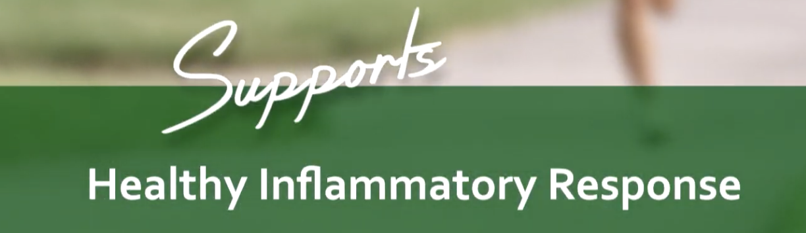

I think the nine health benefits mentioned above are so important, that all 9 of them should be on the front of this mailing piece. More in-depth explanation of each highlighted health benefit is on this page (see link) if you’re able to use it and make it fit without making the page look cluttered, then do so. But if it doesn’t fit, we’ll just stick to the top 9 health benefits that I listed above. Here’s the link… https://paractin.com

We also need to have an FDA disclaimer somewhere on the bottom of the front page…
These statements have not been evaluated by the Food and Drug Administration. This product is not intended to diagnose, treat, cure or prevent any disease.

See Super Joints Plus™ bottle shot below (but see attached files for high quality image)…
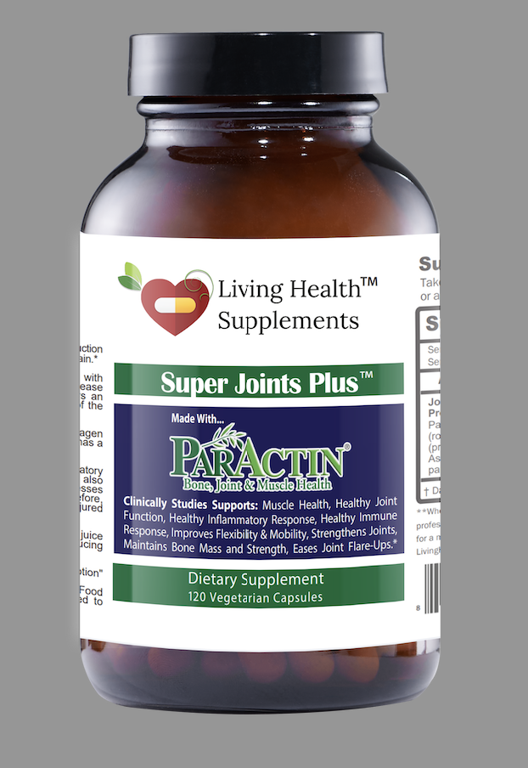

On the back of the mailing piece, we need to of course leave room for the postage and a white open space for the mailing address (see attached 6 x 9 template), but we’re allowed to print everywhere else (they just don’t want anything with numbers or that could possibly be mistaken as an address below the bottom half of the page, as automatic address scanners may pick it up by accident).

The highlight of this backpage will be…
Call and Claim Your Free Product Today!
(Just pay shipping and handling)
(877) 606-3195

And then I would like to display these additional three bottles shots (the three different products)…
And also find images here, though I don’t think the quality will be good enough to copy… https://livinghealthsupplements.com/collections/shop So attached are the originals in the job order files.

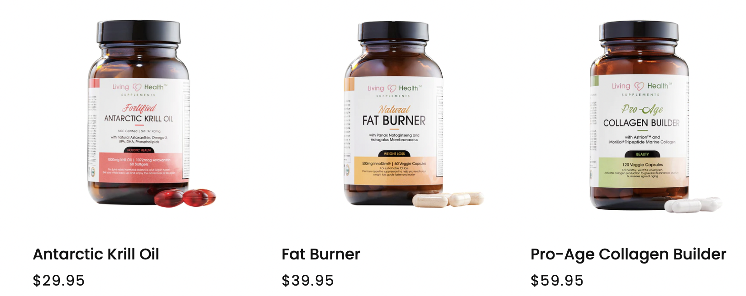

Below the picture will have a an explanation, that reads like this….

As an extra bonus just for you today, we’re giving away 1 to 4 bottles of the above shown product for FREE with every order of Super Joint Plus™ made with ParActin®. Call today to see what you qualify for (877) 606-3195.

Website and phone number should also be displayed on the bottom of the backside, which is…

www.Living HealthSupplements.com / or Call (877) 606-3195

That about covers the ideas that I have, if you want to explore the product even more so to see if you can come up with some eye-catching comments and details, feel free to do sell and shoot proof are way.

