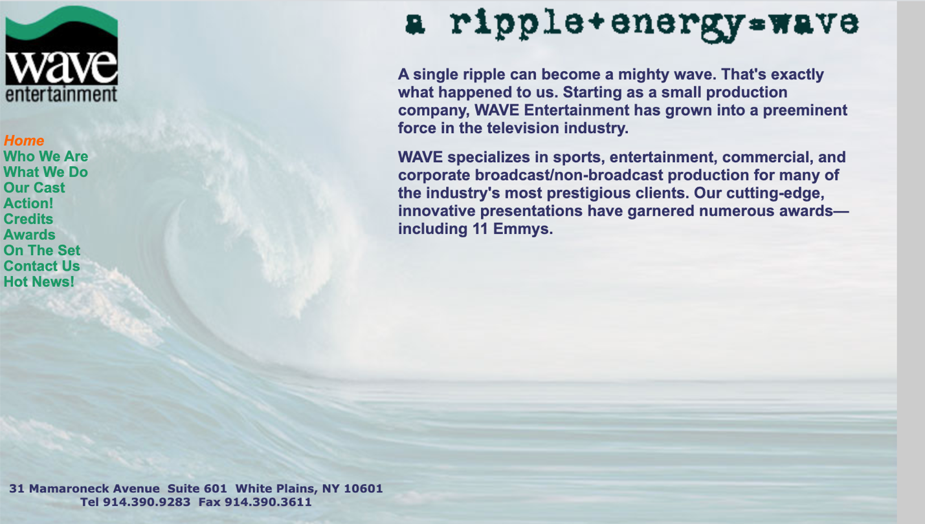

Our DBA is WAVE Media. So want the logo to say that.
There are SOOOOO many companies with a similar name.
WAVE is actually an acronym for Warren’s Audio Visual Endeavors but no need to spell that out anywhere. Like the idea still relating it to a graphic water wave and maybe even creating a motion graphic for it for a website. I do like the tagline still “A ripple + energy = WAVE”

A link to some ideas.
https://99designs.com/inspiration/logos/wave
REALLY LIKE this. Not sure if it’s already a company’s logo or not.
