Sowcoco Copyright

Instructions:
  - Hydrate your coconut coir block by adding ~200ml water directly into your coconut planter
  - Leave for a minute or two to expand, then give it a fluff-up with your spade.
  - Sprinkle your seeds over the coir and stir gently.

Leave somewhere sunny and watch your chickpea microgreens sprout in under a week. Ensure the coir stays damp, but never overwater as this can drown your precious seedlings!
Include the following icons above or to the left of each step:
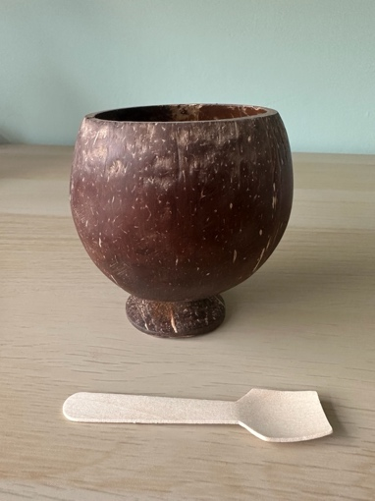
Icon 1: Simple icon of jug pouring water into the coconut planter – with 200ml on it
Icon 2: Icon of ‘spade’ stirring the planter
Icon 3: Icon of a seed packet sprinkling seeds (They will be small pale circles)

Could also include an icon showing the herb having grown under the sun / in a windowsill

For reference, here is a real image of the planter and the spade. The seed packet would just be a simple rectangle.

(Tip – Write what you’re growing on the spade handle first – it doubles as a great plant marker!)

Could include this line but it’s not essential^

QR Code:
Your tasty shoots will be ready to harvest in 2-3 weeks. Stuck for ideas? Scan the QR code for Sowcoco’s top tips and recipes!

Recycling/Hazard warning:

Box and seed packet – recycle with paper
WARNING: Choking hazard – potential for small parts. Do not eat the seeds.

Add this in plain text at the bottom of one side with the symbol in black, white or green. You could make the ‘Recycle with paper’ stand out more, as this is a selling point.

Social media and contact details:

We want to see your SowCoco grow!
Share your #CocoShoot pics with us - @HelloSowcoco
(Add TikTok and Instagram icons)

Email – hello@sowcoco.com
Website – www.Sowcoco.com

Present this how you like but try to draw attention to the hashtag!

Everything else written below is non-essential but could be included, especially the selling points. It would be good to have at least one or two of the selling points on the front of the box.

Selling points
  - Real coconut shell planter
  - Grow microgreens from coconuts
  - Complete kit – Just add water
  - Zero Waste, Zero Mess
  - Grows protein-rich chickpea shoots in 2-3 weeks
  - Made from coconut by-products
  - Eco-friendly

Kit includes:
  - Coconut shell planter
  - Coconut coir soil (expands in water)
  - Cicer arietinum Seeds (Micro Chickpea)
  - Mini spade

