Date
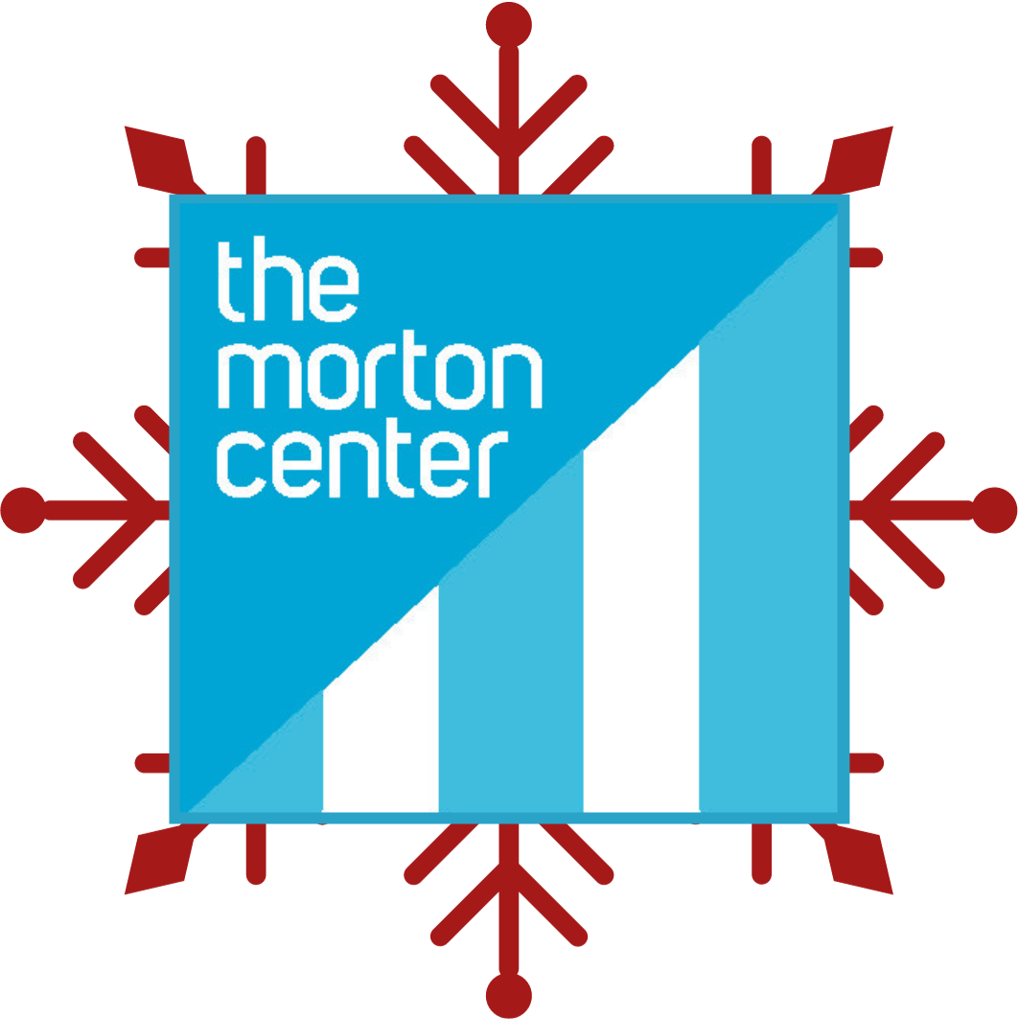

<<First_Name>> <<Last_Name>>
<<Address1>>
<<Address2>>
<<City_State_Zip>>

You can give the gift of love and support this holiday season and brighten
the lives of children who come to the Hope Group. Just $50 will provide
one session for a child in need.

Dear <<Salutation>>,

It started with a phone call to Melanie and Allen. “These kids need to go somewhere. Would you take them for just 30 days to prevent foster care?”

Kamie and Lizzie, two sisters aged 9 and 5, needed a place to stay. Their parents were struggling. Addiction. Domestic violence. Self-harm. And neglect of the girls. The details were hard to hear.

Melanie and Allen first came to know Kamie and Lizzie by offering respite care one week every month for the girls and their parents. The program helped kids from entering foster care.

Now they were being asked to take the girls for 30 days while Mom went to rehab and Dad was in jail. (Sadly, it’s been nearly a year because Mom kept putting it off.)

How could they say no? Melanie and Allen said yes, hoping to give these two young girls a break from the chaos. “We loved them. We had to keep them.”

I'm reaching out to you today, not only to share their story, but to offer you a chance to be part of a beautiful journey. Kamie and Lizzie are two bright, beautiful girls who’ve faced more than any child should.

The Morton Center needs caring, compassionate people like you to support
kids like Kamie and Lizzie. People like you who want to be sure that kids affected
by their parents’ addictions can get the support they need. Please, will you send your
These girls really need you!
best donation right now?
Kamie had witnessed the trauma up close, while Lizzie had been relatively shielded. But no matter the extent of their experiences, the impact was deep. From comments about self-harm to intense emotional breakdowns, their young hearts bore scars many of us can't even imagine.

Just 3 weeks after moving in with Melanie and Allen, Kamie was introduced to the Hope Group at The Morton Center. Although the first days were challenging, with Kamie retreating into herself, she soon started to bloom. Because of you, she learned to voice her feelings, articulate her fears, and began a path to healing.

Lizzie wasn't far behind. Under the guidance of Morgan, one of our dedicated play therapists, she too started navigating her emotions. As Melanie, their foster mom fondly recounts, Lizzie has now become an expert at voicing her feelings, saying things like, “you're making me mad and angry and disappointed.”

<<First Name>> stories like these aren’t rare. But the resources, sadly, are. But. just $50 can provide one crucial therapy session for a child in need. Will you send in a gift right now?

As the year closes and the season of giving begins, I’m reaching out to compassionate souls like you. With your generous donation, we can ensure that kids like Kamie and Lizzie can continue to find their voices, confront their traumas, and move toward brighter futures. And these two precious girls can continue on their journey here at The Morton Center.

Our mission at The Morton Center is more than just recovery. It’s about rekindling joy, rebuilding lives, and rejuvenating souls. Will you join us on this journey?
Thank you for being so kind-hearted. It’s only because of people like you that we can help these kids!
In the spirit of hope and healing,


Priscilla McIntosh | CEO

P.S. <<First Name>>, by choosing to donate today, you're not only supporting The
Morton Center but you're also embracing children like Kamie and Lizzie, offering them a brighter, safer, and more hopeful tomorrow. Every dollar you give counts towards a new beginning. Please, send in your most generous gift today.
The Morton Center | 1028 Barret Ave | Louisville, KY 40204 | 502-451-1221 | www.themortoncenter.org

