

When parents struggle with addiction, kids hurt, too. But you have the power to help transform their lives.

YES, Priscilla! I want to give back and help children like Kamie and Lizzie find healing and hope. Here is my generous gift of:

m $50 m $100 m $250 m Other $______________

You may give by check: Make your check payable to The Morton Center and return it along with this form in the enclosed return envelope.

You can RUSH your gift by giving online: www.themortoncenter.org

You may give by credit card: Please provide your information below and return this form in the enclosed return envelope.

Credit Card Number:____________________________________________________

Expiration Date: Month_________ Year_________ Security Code:_____________

Name on Card: _________________________________________________________

Signature:______________________________________________________________

Phone number & email
should we have questions: _______________________________________________
<<First_Name>> <<Last_Name>>
<<Address1>>
<<Address2>>
<<City_State_Zip>>
Thank you!

The Morton Center is a 501(c)(3) nonprofit organization. Aside from the really great feeling you get from helping people find recovery and healing, no goods or service were exchanged in return for your kind donation, which may be deductible under IRS tax laws. Thank you for believing in our mission!

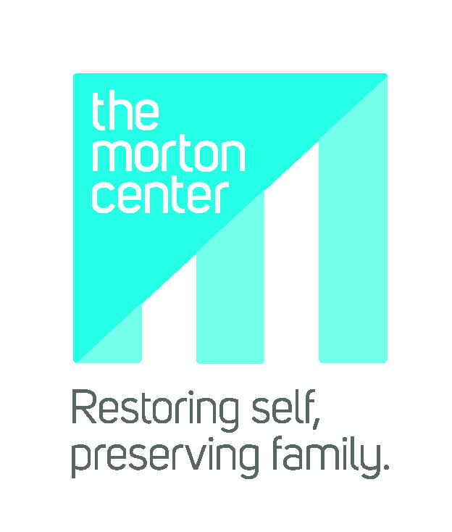
The Morton Center | 1028 Barret Ave | Louisville, KY 40204 | 502-451-1221 | www.themortoncenter.org

