Projects

Inspiration for photo layout: https://westcoastasm.com/portfolio-item/bay-area-parking-structure/
Inspiration for project layout: https://www.isecinc.com/projects/#/view=grid&solution=architectural-woodwork

Click each photo for more info (project highlight)

- SOFI Stadium
  - Scope of Work: Installation of Seismic Expansion Joints Floor: Exterior & Interior and Walls: Exterior & Interior and Ceilings: Interior and Roof Joints: Exterior and Installation of Moisture & Fire Barrier: Exterior & Interior
  - Other Scope of Work: Firestopping and Acoustical Caulking: Electrical & HVAC & Mechanical Piping & Fire Protection (Sprinklers)
  - Building Type: Stadium
  - Location: Los Angeles
  - Completed 2021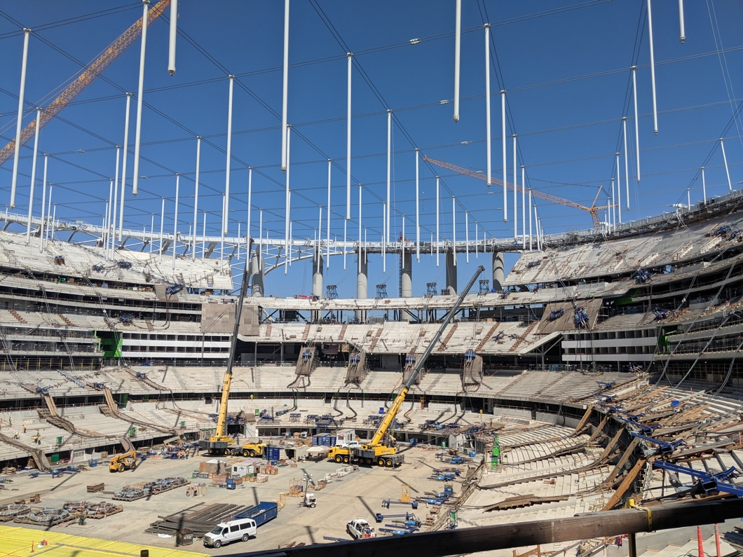
- Gaylord Chula Vista
  - Scope: Expansion Joints, TOW/BOW Firestop, Penetration Firestop and Acoustical sealants on Mechanical duct and pipe and plumbing (Tentatively on Sprinkler pipe)
  - Type of Building: Hotel and Convention Center
  - Location: Chula Vista
  - Under Construction
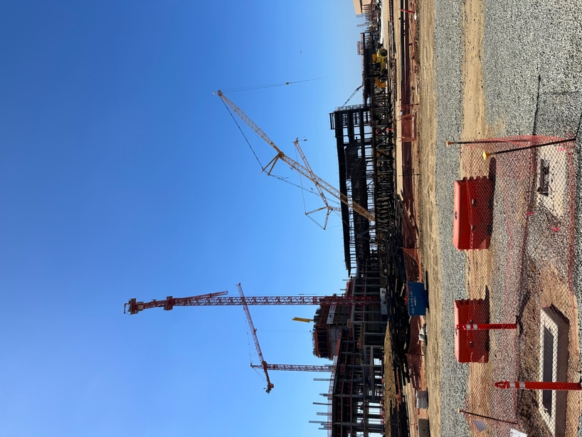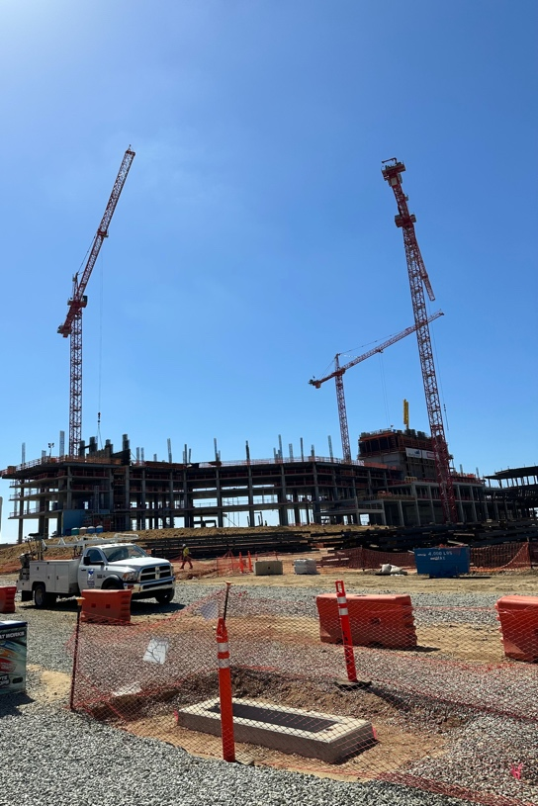

- Intuit Dome
  - Scope: Seismic Expansion Joints, firestopping and sound sealants of electrical penetrations, mechanical and plumbing penetrations, and fire sprinklers
  - Type of Building: Arena
  - Location: Los Angeles
  - Under Construction
