Word template requirements

We require 3 templates as listed below
All Templates
- Include Microsoft Word “styles” with consistent headings and titles etc to provide a similar look between all Templates.
- Include a table style with color-filled header row.
- Provide for second page to have different header than the first page
- Page numbers and report header and reference in the footer.

Template 1
- Memo
  - Provide a version for landscape layout as well as portrait layout.
  - Memo may be used for other things like fee offers
Template 2
- Report
  - Requires header page which could have an image or graphic, needs project title, company logo date and revision.
  - Table of contents
  - Add a document status page, the example below is from a company called BBO
Template 3
- Formal letter
  - Logo at top of first page only
  - Address and contact person field
  - “Our reference” and “your reference” fields
  - Subject line below “Dear XXX”
  - Signature and position title at bottom
General
- Business is in the civil construction industry
- Template to be clean and modern, no images required other than the Logo and the header page for the report which could be a shape\pattern or image.
Font
- Simple and modern, open to suggestions, we use calibri at the moment which works for us.

Example 1 – template 1 – I like this – it is clear and simple
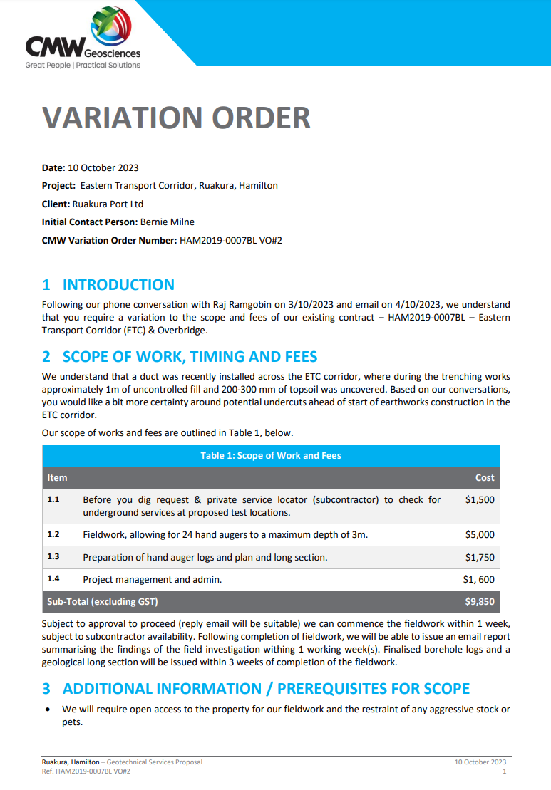
Example 2 – report doc control
