Here is the logo we created in Canva using an icon from Canva elements.
Example of a logo in horizontal form
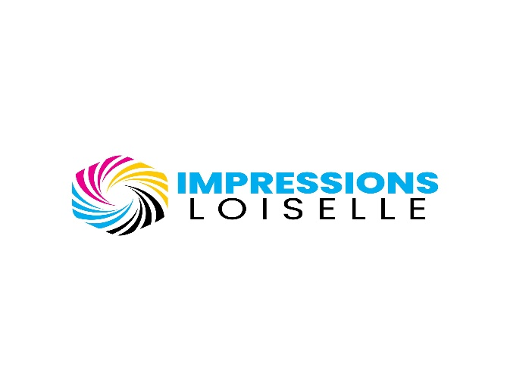
The word: IMPRESSIONS is always in blue using the color # 00adee
Font to use: Poppins Black, must be Capitalize.
This is for when the background is white. Loiselle must be in black. If you include an icon similar to this one or anything else that have the color white in it, please make sure to change it to black to fit the white background.
Fell free to change the icon as a whole just remember that if you include white element to change that element to black for use in a white background scenario. Use cmyk colors for the icon. Pink, blue yellow white/black depending on the background.

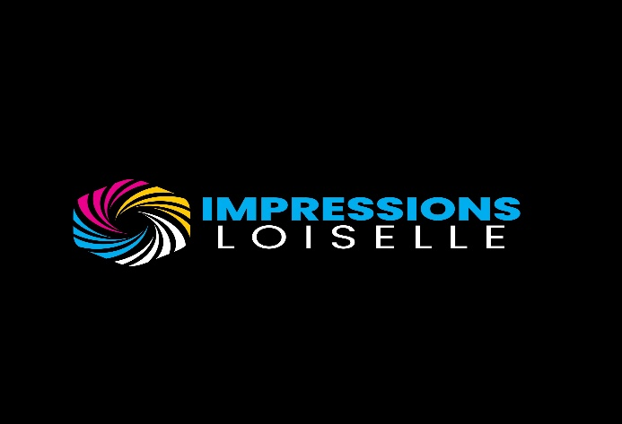
Fell free to change the icon as a whole just remember that if you include a black element to change that element to white for use in a black background scenario. Use cmyk colors for the icon. Pink, blue yellow white/black depending on the background.
The word: IMPRESSIONS is always in blue using the color # 00adee.
Font to use: Poppins Black, must be Capitalize.
This is for when the background is black. Loiselle must be in white. If you include an icon similar to this one or anything else that have the color black in it, please make sure to change it to white to fit the black background.
Important note for page 1.
This is an example of what we created for a logo in a horizontal form.
We created a logo example in a white background scenario and a black scenario to give you an example of what your design should look like.
The only 2 requirement that you absolutely have to follow is this:
- Font for the word: IMPRESSIONS have to be: Poppins Black and must be CAPITALIZE.
- Color for the word: IMPRESSIONS must be: #00adee

As for the word: Loiselle we also used Poppins light but feel free to use another font as you like. Feel free to also experiment with different sizes or add line before and after the word Loiselle.
Feel free to change and create your own version of that logo in horizontal form using your imagination. The element use doesn’t have to be an exact replica for the icon again feel free to let your creativity go.
Here is the logo we created in Canva using an icon from Canva elements.
Example of a logo in vertical form
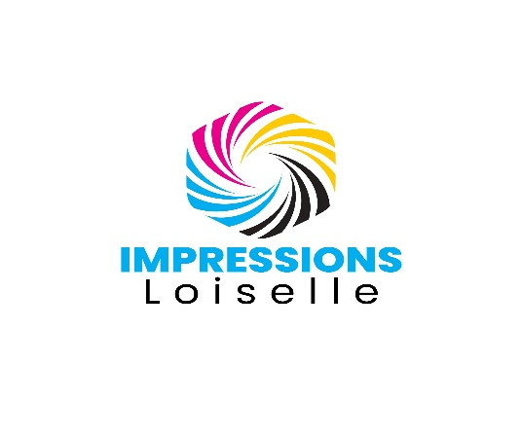
The word: IMPRESSIONS is always in blue using the color # 00adee
Font to use: Poppins Black, must be CAPITALIZE.
The word: Loiselle don’t have any requirement feel free to use anything.
Again, the Icon use doesn’t have to be this one. Feel free to create your own as long as it fit the color background. This example was created as an example for a white background. Remember to use the cmyk colors like pink, blue, yellow and white/black depending on the background.

The word: IMPRESSIONS is always in blue using the color # 00adee
Font to use: Poppins Black, must be CAPITALIZE.
The word: Loiselle don’t have any requirement feel free to use anything.
Again, the Icon use doesn’t have to be this one. Feel free to create your own as long as it fit the color background. This example was created as an example for a black background. Remember to use the cmyk colors like pink, blue, yellow and white/black depending on the background.
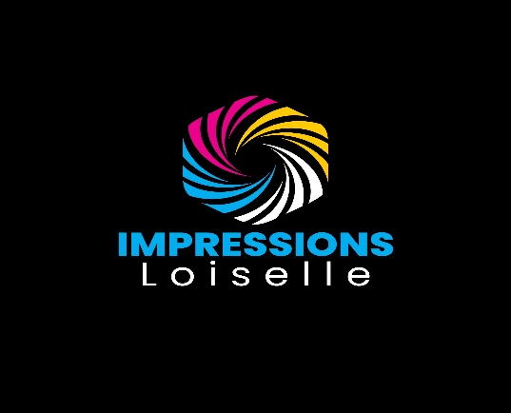
Important note for page 3. (Vertical form logo)
This is an example of what we created for a logo in a vertical form.
We created a logo example in a white background scenario and a black scenario to give you an example of what your design should look like.
The only 2 requirement that you absolutely have to follow is this:
- Font for the word: IMPRESSIONS have to be: Poppins Black and must be CAPITALIZE.
- Color for the word: IMPRESSIONS must be: #00adee

As for the word: Loiselle we also used Poppins light but feel free to use another font as you like. Feel free to also experiment with different sizes or add line before and after the word Loiselle.
Feel free to change and create your own version of that logo in vertical form using your imagination but make sure to at least follow the 2 required rules.
The element use for the icon don’t have to be an exact replica feel free to let your creativity flow as for the icon.

Here is the logo we created in Canva using an icon from Canva elements.
Example of a logo in Icon form

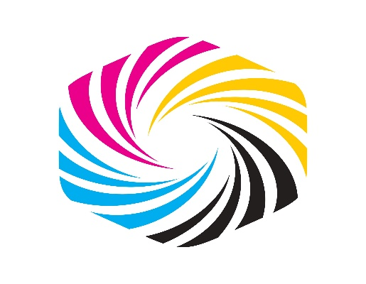
This is the Icon logo we made using an element from Canva.
This is just an idea we made using the cmyk colors that we liked.
This particular icon is for a white background.
Feel free to create your own icon using the cmyk colors as specified. It does not have to be an exact replica of this one.
Use the pink, yellow, blue and white/black depending on the background color.
Let your creativity flow!

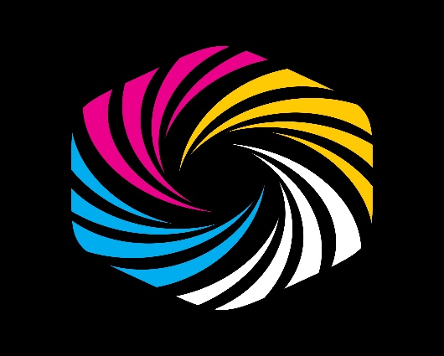
This is the Icon logo we made using an element from Canva.
This is just an idea we made using the cmyk colors that we liked.
This particular icon is for a white background.
Feel free to create your own icon using the cmyk colors as specified. It does not have to be an exact replica of this one.
Use the pink, yellow, blue and white/black depending on the background color.

Things we don’t want as an icon
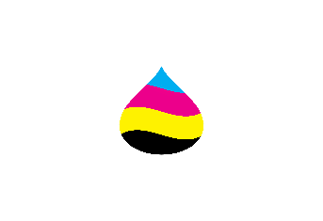
We don’t like the paint droplet. It makes me of a painting logo than a printing logo so please don’t use any.
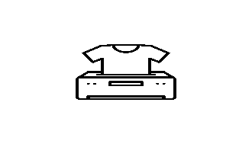
We don’t like printer icon nor the t-shirt icon we feel it doesn’t represent our printing business since we will be using more than a printer to print design.

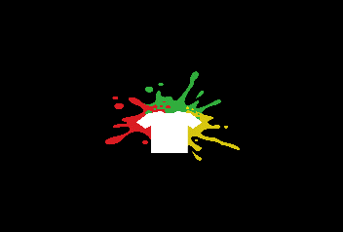
We don’t like t-shirt icon as we feel that it makes the brand feel like it only make t-shirts while we will be doing a lot more than t-shirts. Don’t use any of those either.
Conclusion
As specified thought this task we only have 2 requirements that you must absolutely follow. Here they are again.
- Font for the word: IMPRESSIONS have to be: Poppins Black and must be CAPITALIZE.
- Color for the word: IMPRESSIONS must be: #00adee
We need 3 version of our logo.
Version 1 - Horizontal shape form (Icon on the left and text on the right)
This form should have a version for a white background and a black background. This version will mostly be use for our website and letterheads and our business cards.
Version 2 – Vertical shape form (Icon on the top and text on the bottom)
This form should also have a version for a white background and a black background. This version will mostly be use for Mobile website header, clothing tags, business cards, and invoices.
Version 3 – Icon Form (Only the Icon)
This form should have a version for a white background and a black background since it will be using colors like pink, blue, yellow black or white for the cmyk representation colors. This version will mostly be use for the website emoticon, infographics, Youtube icon and more.
What we need for files
We will need all the necessary files to be able to go back and edit anything later on if we want to. We are using Adobe Illustrator and sometime photoshop but mostly illustrator for vector design. We need all the files to be saved as accordingly so we can go back and edit if we must later on.
.svg, eps, ai, .psd, .pdf, ,png and more are a must.
Why we need a designer
We could have very well used the logo we created using Canva but the problem with that is the element use for the icon cannot be copyrighted and we want a logo that we can have full rights to.
We are curious about what other designers could created for our business and we can’t wait to see what you come up with. We simply want other options beside the things we specified we don’t like.
We thank you for the time you will use to help us find the best logo design for our business.

