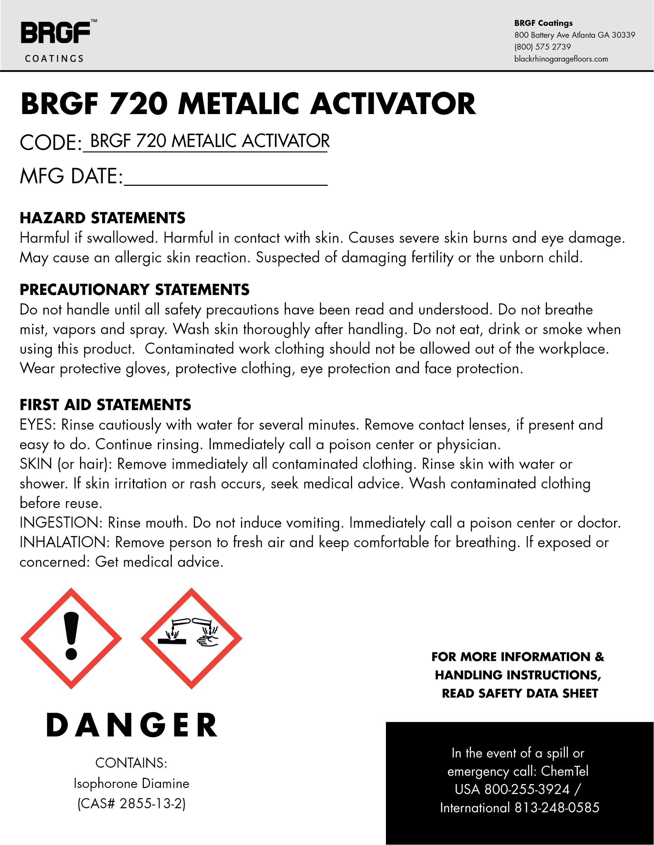
UN1760, Corrosive Liquid, NOS, (Nonyl Phenol), 8, II
06/21/23 123456789

