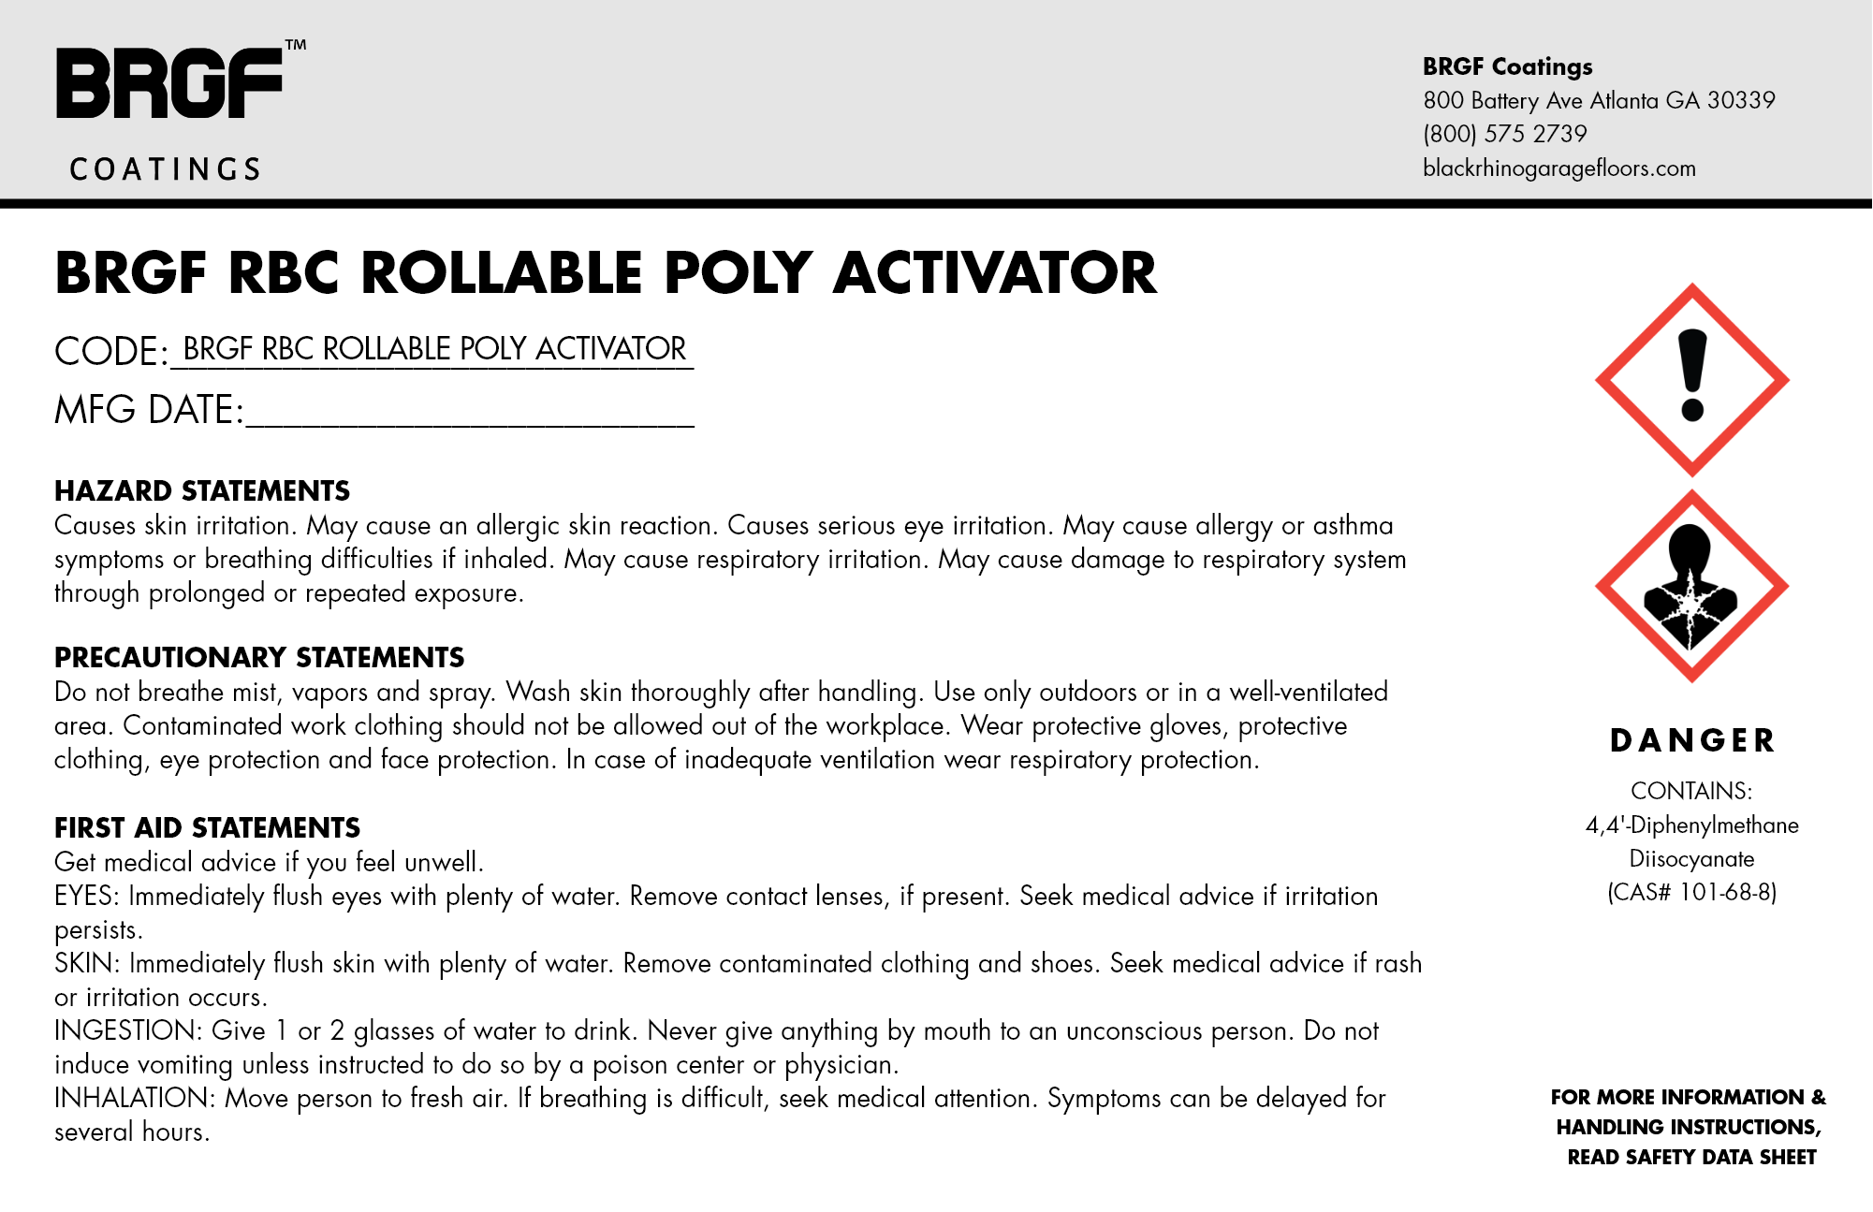
06/21/23 123456789
06/21/23 123456789

