Big Banner
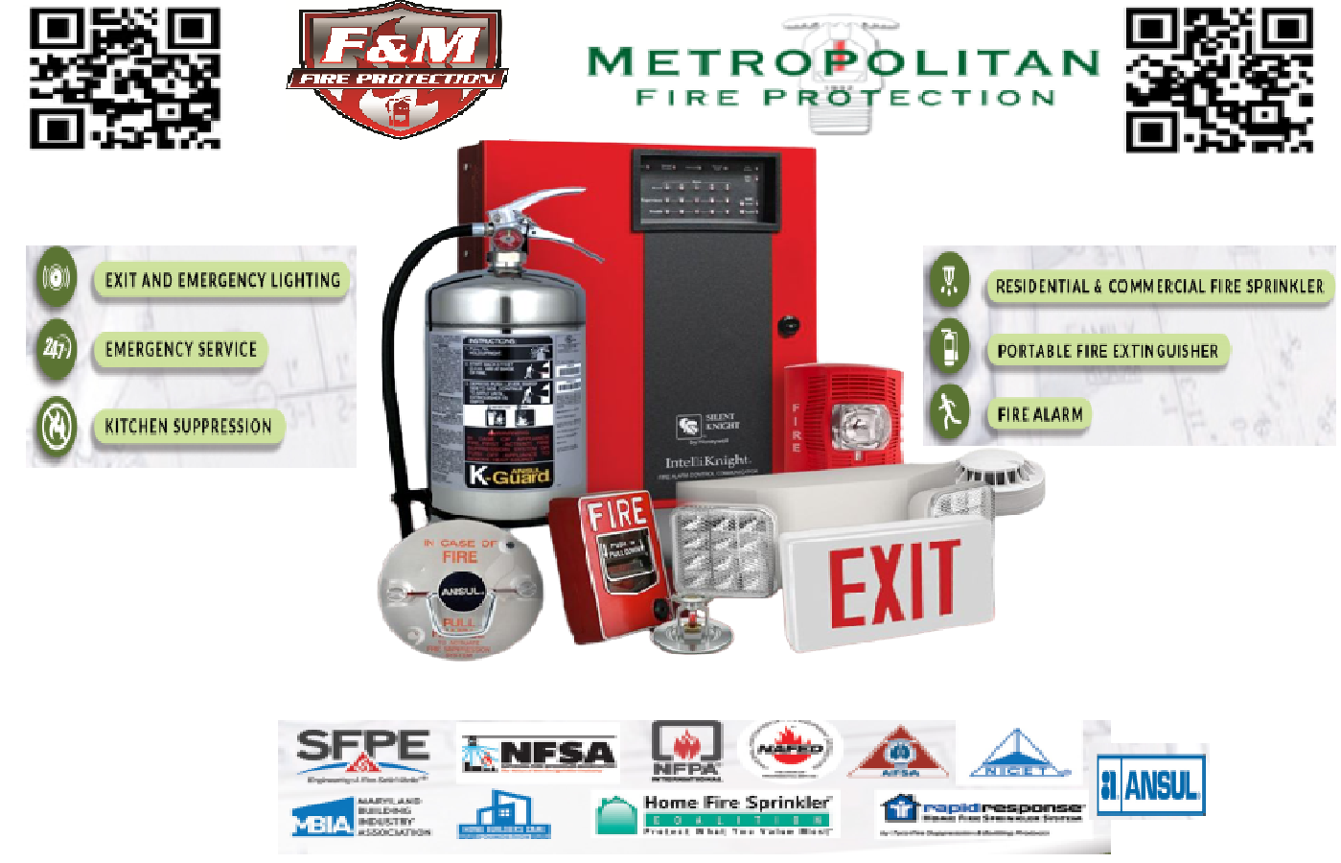
- The main picture bigger
- More room between the pictures in the bottom
- No green bullets
- Metropolitan & FM logo combined at the center of the top, with the QR sides in the top corners.
- Background to be set up in quadrants with grayed out pictures. Each quadrant will be a different item (fire alarm, sprinkler head, extinguisher, and suppression)

Pull Up 1
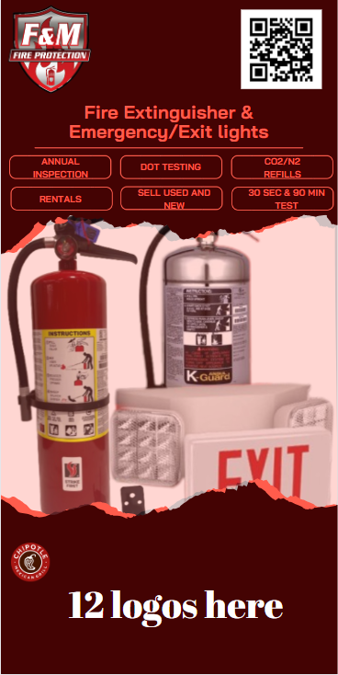
- You can modify the main picture but not from google please.
- 12 logos in the bottom (Round)
- Walmart
- CVS
- JLL
- Starbucks
- Macys
- CBRE
- North Face
- Nike
- Extended Stay America
- Morgan Properties
- Ernst Equities
- Whiting-Turner
… and more

*We might change some of the logos, but you can have the head up what’s the idea of the design*

Pull Up 2
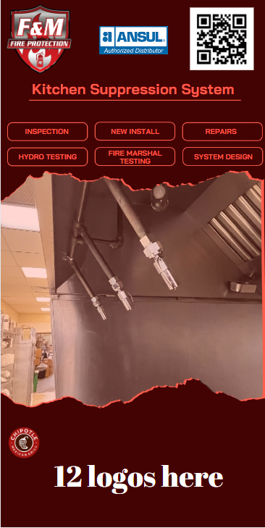
- You can modify the main picture but not from google please.
- 12 logos in the bottom (Round)
- Shake Shack
- PF Chang
- MOD Pizza
- Chipotle
- Burger King
- Cracker Barrel
- North Italia
- Mc Donalds
- Regal Cinemas
- Ruby Tuesday
- The Fresh Market
- Five Guys

*We might change some of the logos, but you can have the head up what’s the idea of the design*

Pull Up 4 & 5
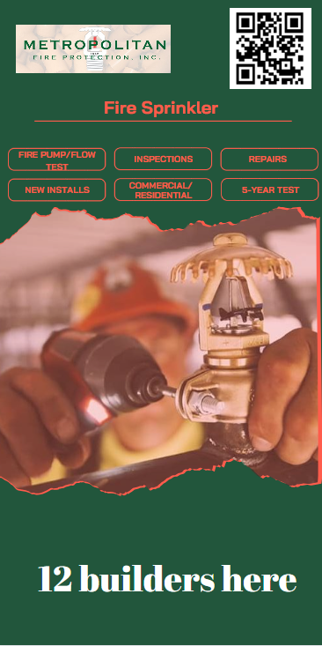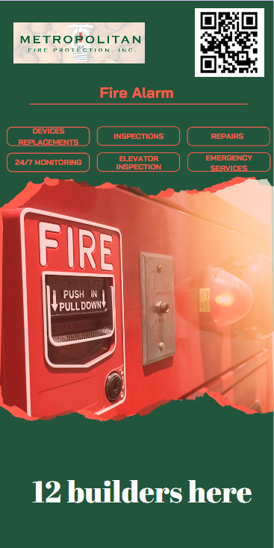
*We will get back to you with these*

