Big Banner Use banner picture 1
- Metropolitan’s logo without the white background
- Use banner 1 but the main picture of banner 2.
- Keep the grayed background but without the white lines that makes the division. (just merge them all)
- Try another layout for the bullets, we don’t like the green background on it. Maybe with the layout of pic 2. The position is fine tho.
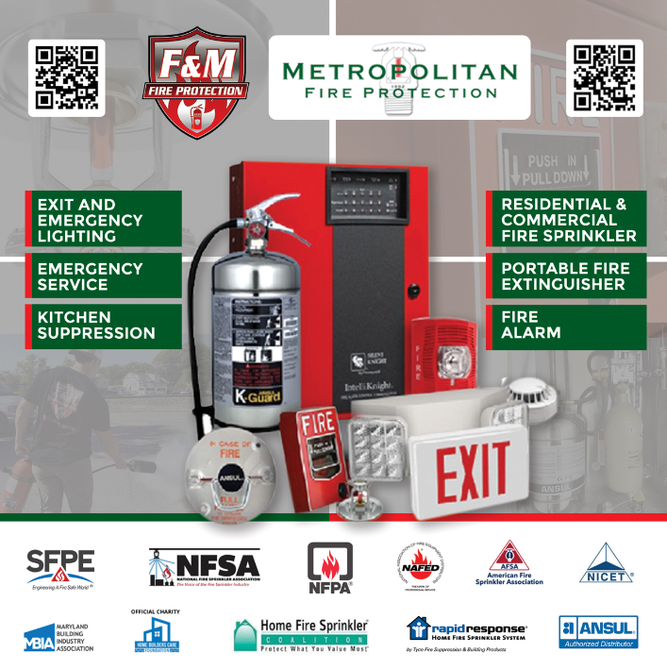
*Banner Picture 1

*Banner Picture 2
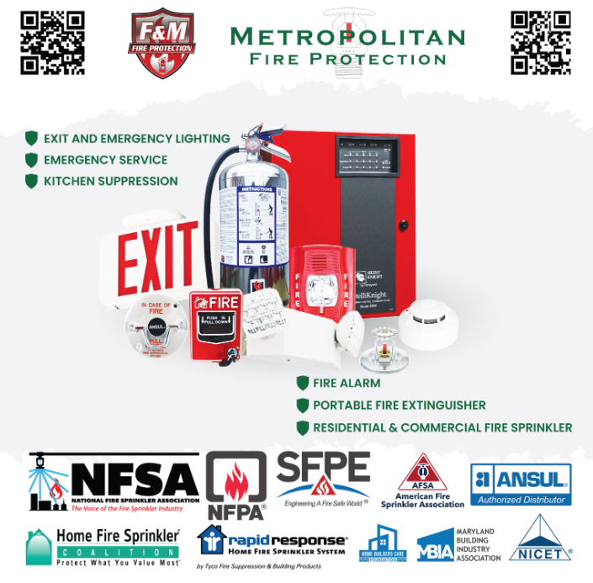

Pull up banners. (4 total, same layout)
- 2 for F&M same color (Fire Extinguisher/ Lights & Kitchen Suppression), 2 for Metropolitan same color (Fire Sprinkler & Fire Alarm)
- The layout of the first two pictures but get rid of the pinkish of the imagen and the bullets (use layout of the third pic). Make bigger the pics and play a little bit with it.
For F&M
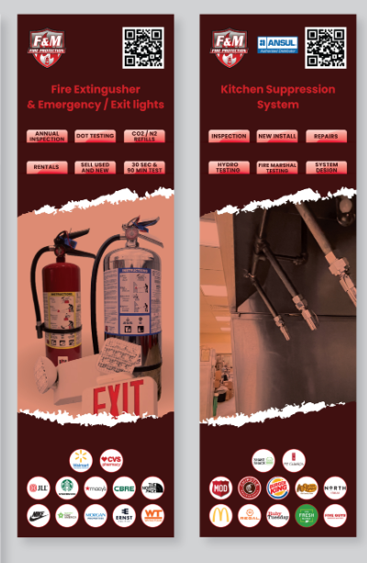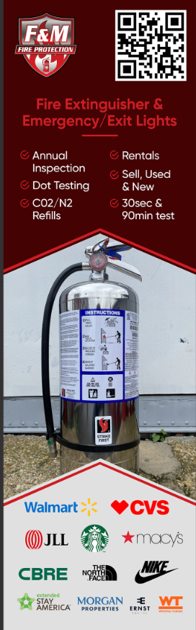
Kinda like this without the red/pink color on the letters
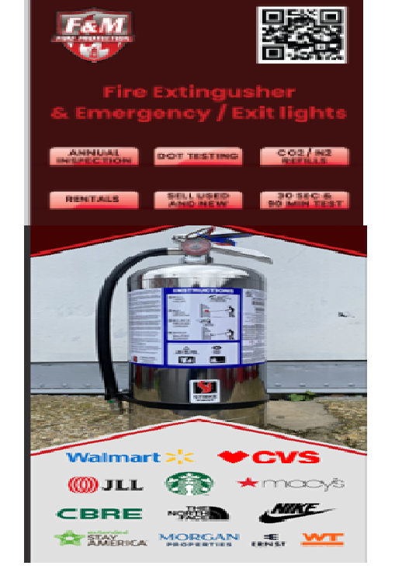
Final Logos for Extinguisher:
- Walmart
- JLL
- Starbucks
- Hilton
- North Face
- CBRE
- Costco
- Morgan Properties
- Ernst Equities
- Whiting-Turner
- USPS
- Curtis Properties
Final Logos for Kitchen Hood:
- Shake Shack
- MOD Pizza
- Chipotle
- Burger King
- Cracker Barrel
- Mc Donalds
- Regal Cinemas
- Ruby Tuesday
- The Fresh Market
- Five Guys
- Sams Club
- Fogo de Chao
For Metropolitan:
- White Background with green font
- Use the other Metropolitan logo
- Get rid of the red/pinkish on top of the pictures (same as F&M banners)
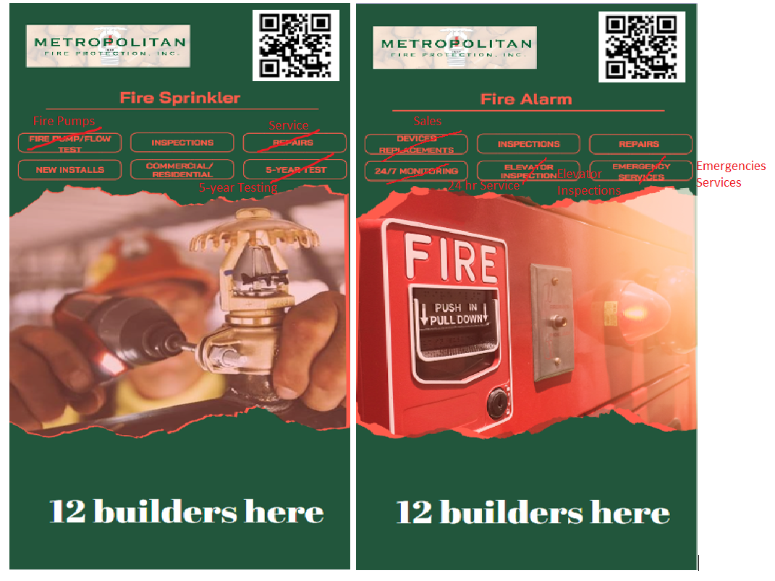
Logos for Sprinkler
- Pulte Homes
- K – Hovnanian Homes
- Ryan Homes
- DR Horton
- Lennar
- CVS
- Great Wolf Lodge
- Target
- Marshalls
- PF Chang’s
- Nike
- Carmax

Logos for Alarm
- Macy’s
- Navy Federal
- Nordstrom
- Blue Crab Stadium
- Dicks Sporting Goods
- Extended Stay America
- Amazon
- Cube Smart
- LA Fitness
- Petco
- H&M
- TD Bank

