Aviation Maintenance Company Logo Design

Creative Brief

Hi All – I recently purchased a business that repairs and upgrades small airplanes like Cessna’s, Pipers and Cirrus’. But we’re also getting into working on smaller jets and turboprops like below.

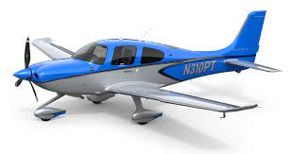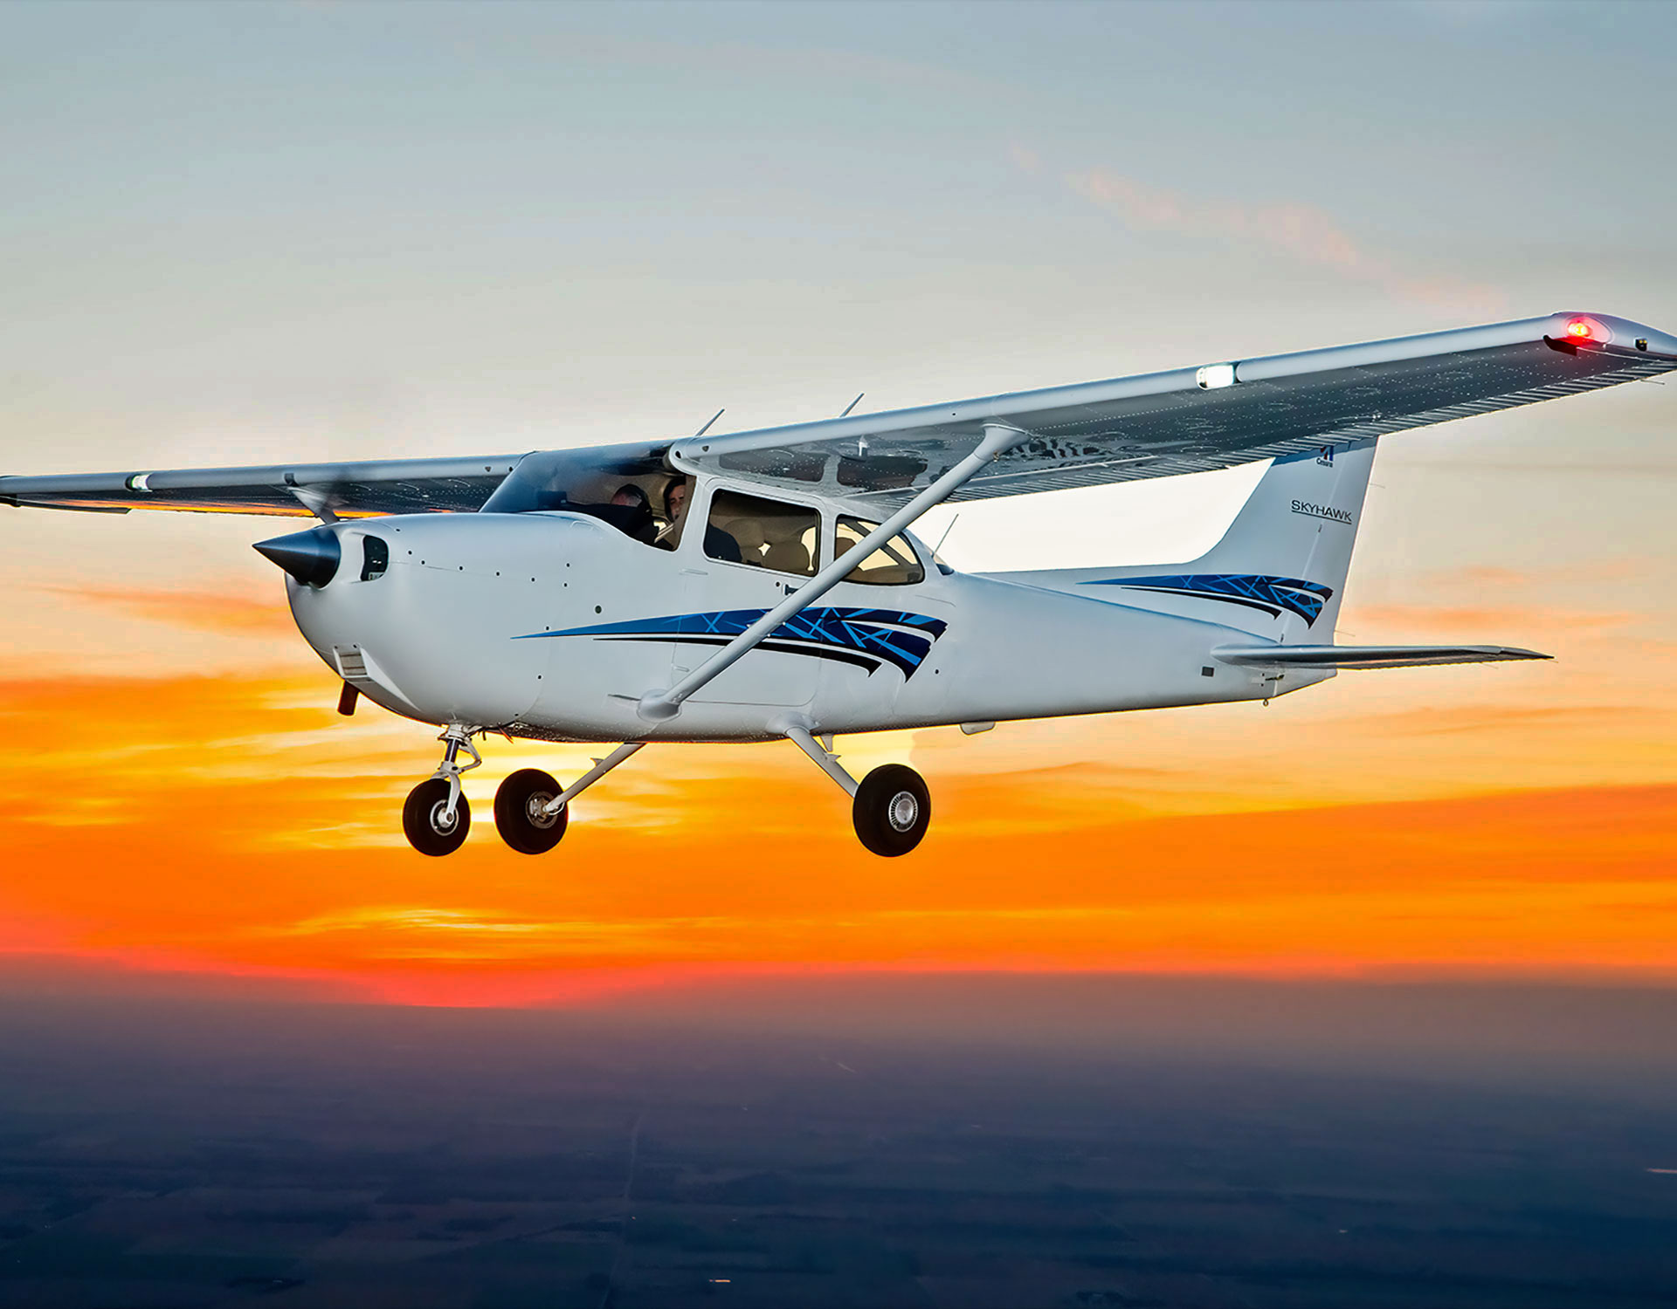

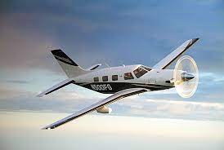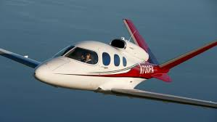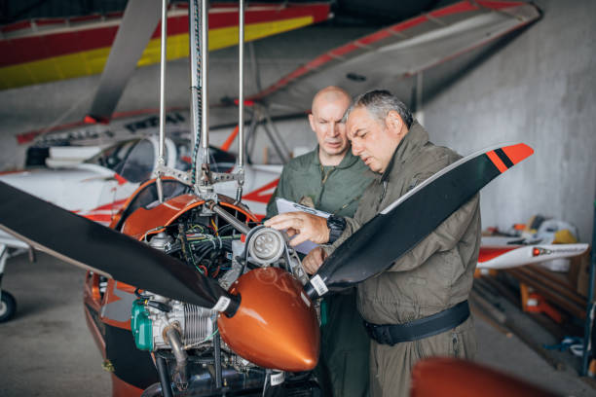

We’re looking for a new logo that projects the following:

- Innovation/technology
- The fun and fantasy of flying
- Smart and sophisticated like our customers
- Visually unique and interesting

We think we like the name “Avias” because it’s short and simple and is a made-up word that we can create a brand personality around over time. So that is the main job here. One thought that came to me is using an artistic representation of the V-tail jet (bottom center) for the ‘V’ in Avias. But that could get messy and busy so be careful and keep it simple and elegant.

But if you are so inclined you could also offer designs on the name:

5 x 5
5 by 5
Five by Five
Five X Five

This is an old aviation radio communication phrase between airplanes or between an airplane and the ground meaning that they can hear the other person clearly. It’s a phrase that generally means everything is good – which is a positive sentiment that a brand could leverage. This phrase can be represented any of the four ways you see here so pick one or two that you think lend themselves to an interesting design. This part is voluntary of course.

Or you could even offer your own suggestions for a different name. I don’t know how DesignCrowd would handle it but we will pay a $250 bonus (plus DesignCrowd’s fee) for a new name that we end up using.

Thanks in advance for your time and talents.

Doug Warner
doug@dlkaviation.com

