Brief – Logo

Logo Communication Take-Aways
- We are modern experts and craftsmen
  - We’re not generic nor corporate.
  - We're professional and respectful but not friendly or nice.
  - We are serious, know the answer to your question, and will get the job done without fanfare.
  - Our customers are direct, gruff, with no-bull style interactions – we need to replicate.
- We manufacture HVAC Spiral Ductwork
  - Tagline: HVAC Spiral Mfg.
  - We’d also like to see a variation with contact info:
    - See spec section below, but we’d like some versions to contain contact info
    - sales@metaltecdirect.com, (208) 362-0702
Current Logo & Creative Direction
Don’t like about current logo | Want from new logo
Phallic – no bueno | Not phallic
Tagline in general is not that helpful – the word “custom” can lead people to believe we do any metal project under the sun, which we don’t. | Updated tagline: “HVAC Spiral Mfg.”
Style doesn’t look modern like we want – a little bit 90’s-PowerPoint-ish and generic. A bit cheesy. Italics remind me of Microsoft word formatting. | Font and design that says we’re modern, professional, and expert. More direction below.
Does not lend itself to a symbol-only logo. We want to have a logo that could stand alone as a symbol, but can also pair with the name of the company. | Needs to have a symbol that can stand alone AND pair with the full company name.

Notes:
- Logo design can communicate that we work with metal, but the name already does that, so it is not required.
  - Nor is it not a requirement to visually incorporate a visual of what we do or make in the logo (like the current logo does).
  - IMO, logos that try to be clever can miss and come across as cheesy.
Examples of elements we like
Like | Don’t like
***like***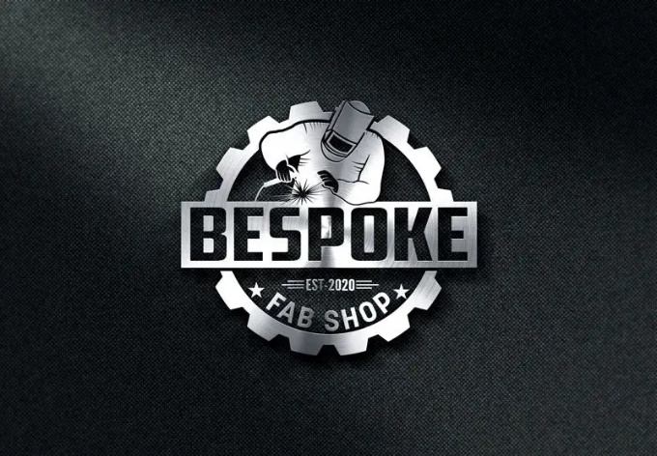 Love the lighting, depth, and shadow here. It elevates this logo. Looks like it could have been cut with a plasma cutter.  We don’t like people characters in the logo.  We don’t want a gear in the logo. | 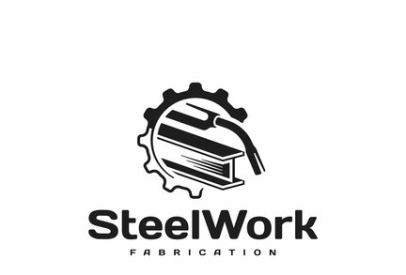Generic. Looks like this company does whatever every other steel company does. Nothing special.
***like alot***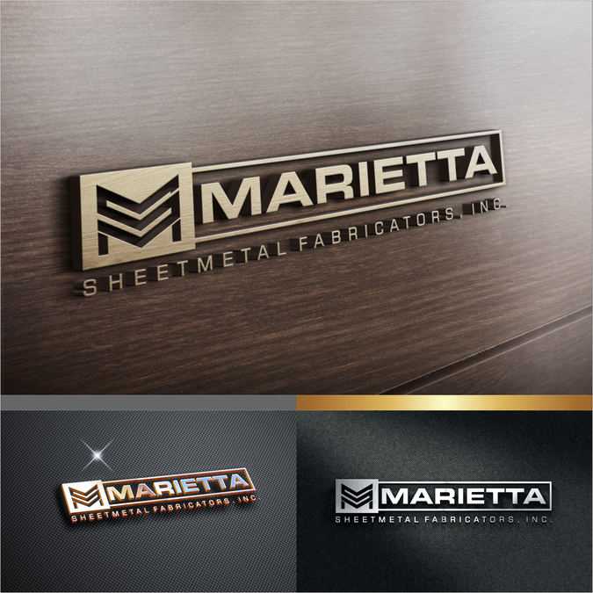I like this one a lot. Not only do I like the actual metal logo, but I like the digital metal-looking logo. The metal communicates permanence and craftsmanship.  Again, I like the lighting that gives depth, it makes the logo look like it was crafted by an expert, and that it is tangible.  I like metallic colors/design, and I wouldn’t mind looking at gold as an option, as it communicates excellence.  I’m open to metal shine as long as it doesn’t look bedazzled or like Jewlery. | 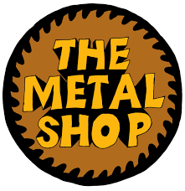  Too playful and organic (hand drawn)
***like a lot***  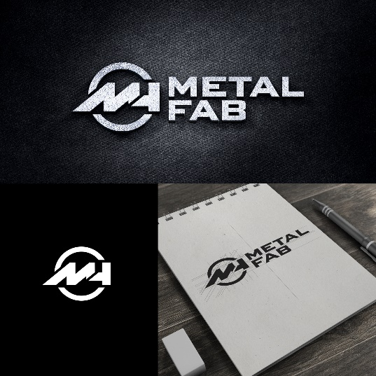  Modern look and feel. This is a good example of a logo that can stand alone as a symbol, but also can be paired with its name. | 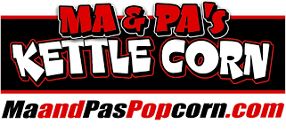  To silly, not serious.  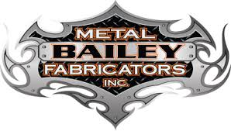Trying too hard to be cool. This is extra fanfare.  Thinking: We’re not sales bros, we’re serious experts who are the best and get your job done without the extra fluff.
***Like a lot***  Another good example of the elements we’re looking for, mentioned above. | 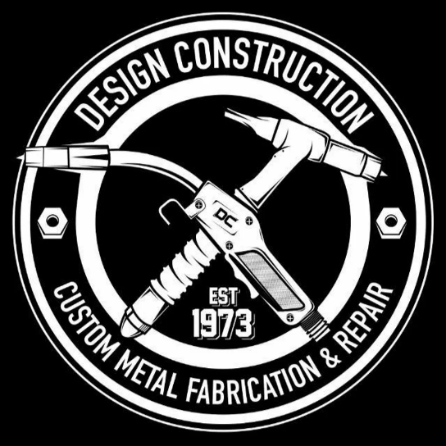  This is a good example of where the fine details matter (in this case the type is hard to see) – which is not good, because it means if the details matter, and you can’t see the details, then you’re missing a core part of the message.
Spec/Format:
- Various formats to suit an array of uses – Your team may know better than I what may be needed. Here are some thought starters I can think of:
  - Logo without tagline
  - Logo with tagline
  - Logo with tagline and contact information – phone and email
    - Sales@metaltecdirect.com
    - (208) 362-0702
  - Logo with tagline and contact information – phone only
  - Favicon logo
  - Should be able to stand alone with symbol or have symbol and name together.
  - Logo with chosen backdrop color and design
  - Logo with transparent background for placement on light backdrops
  - Logo with transparent background for placement dark backdrops
  - Format appropriate to be placed on a billboard or side of truck with vinyl

--------------END OF BRIEF-------------

