Leadership Placemat - 2023

Purpose | Leadership | Feedback | Culture | Teams
Purpose  (insert the What?, How?, Why? Diagram)  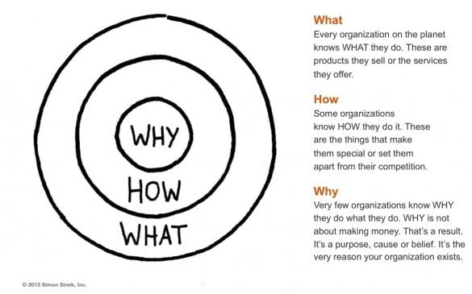  Key concepts of a performance, planning and development culture:  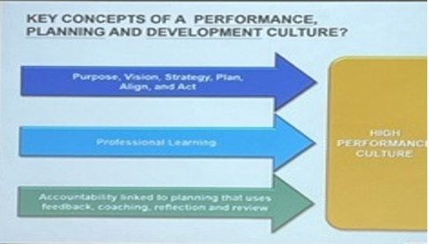 | Leading and managing  Everyone needs to know when to lead and when to manage  Teachers need to be the leader of learning – in and out of the classroom!  When do you need to step in and manage, direct and/or take charge?  (Include the 80% and 20% diagram)  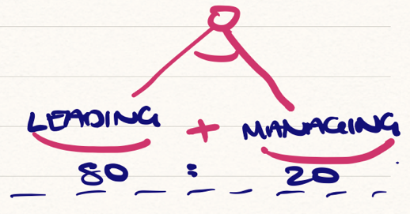  How do we make strategic decisions?  But, don’t get analysis paralysis. Move around all phases of the diagram.  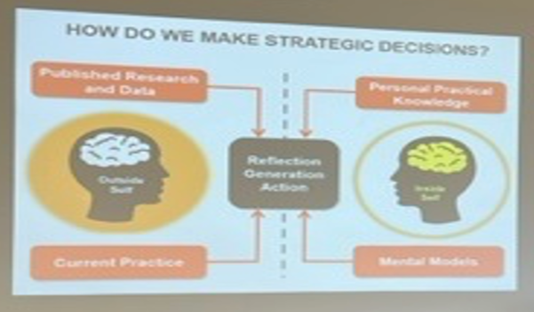 | Model an effective feedback culture  All levels of feedback  - Teams  - At level  - Above level  What will we - Start, stop, continue develop?  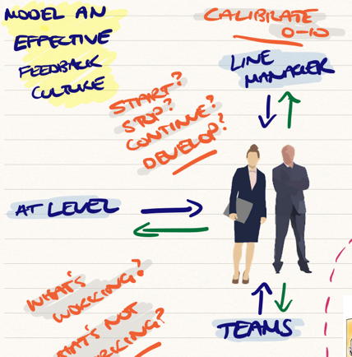 | Culture and strategy  Culture doesn’t eat strategy for breakfast – Culture needs to sit down with strategy for breakfast!  (Include diagram of chicken and the egg)  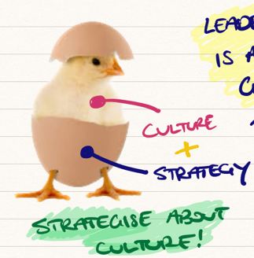  We need a culture where people can disagree without being disagreeable  Resisters are not bad people or enemies – enemies are people who are actively out to get you! | Supporting teams to thrive  We will work to ensure that we are seeing the multiplication effect with our teams. We’ll be mindful of burnout and ensure that we are looking after our team members.  (Include diagram of multiplication effect)  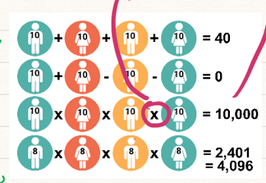
The infinite game  (insert the diagram for the infinite game)  1 – Live and lead to further a just cause  1 – Build trust in teams  3 – Find worthy rivals  4 – Display existential flexibility to make extreme strategic shifts  5 – Find the courage to lead with an infinite mindset  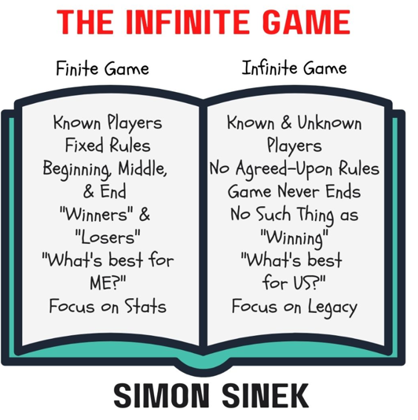 | Levels of perspective  Perception is your reality. Understand how you and others make meaning.  You keep your mental models if you are operating as mostly a manager.  - Purpose – Why?  - Vision – What you want to see  - Mental model – Values and beliefs  - Systemic structures – Systems and processes  - Patterns of behaviour – Habist and routines – rituals and celebrations  - Events – Outcomes and outputs  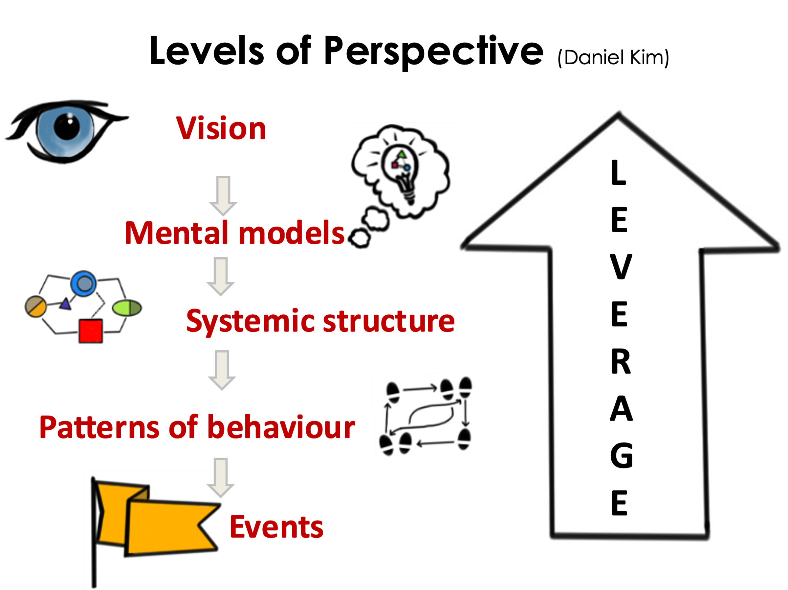  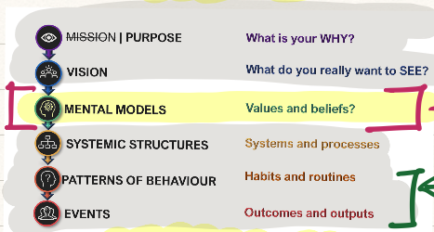  Self-Belief and Self awareness  (Include the diagram about the balance between self belief and self awareness)  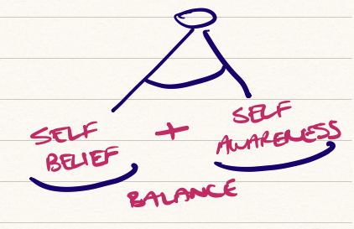  The Ladder of Inference  - You select different data depending on your mental model  - Reflexive loop should be a reflexive loop, or it is a delicious loop of self delusion  - You need to come back down the ladder  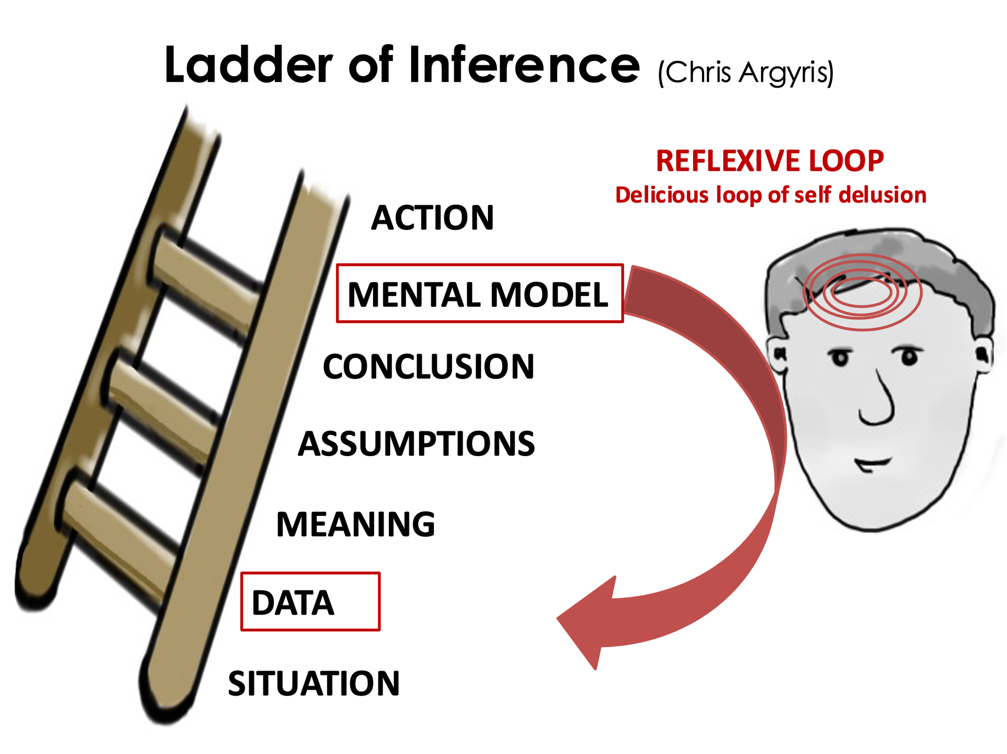 | Deep listening  Am I:  - Conversing or convincing?  - Waiting to speak?  - Thinking what to say?  - Evaluating what is being said?  Skilled questions to ask:  - How long has this been an issue?  - What action have you taken?  - What is the outcome that you are looking for?  - What is the best way to move this forward?  - How would you like me to be involved here? | People to work with  (include diagram with Get stuff done, dream big and Know how to have fun)  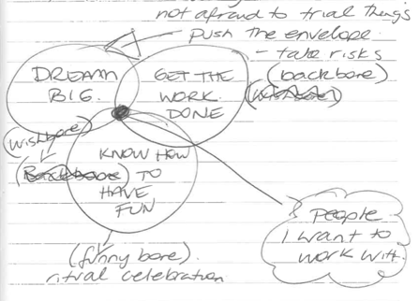  - Dream Big – The wishbone  - Get work done – The backbone  - Know how to have fun – The funny bone | Aiming for alignment  Be frank and rally  (include diagram for the alignment)  Be wary of agreement!  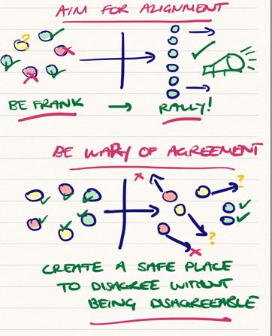
 | The Pit – Change Takes Time  We must become expert learners and promote struggle as normal.  (Include diagram of the learning pit)  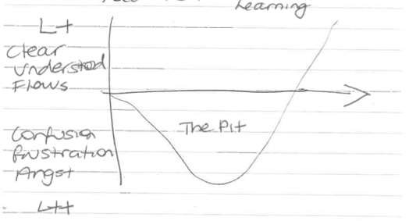  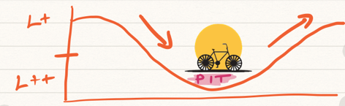 | After deep listening, follow up questions may help:  - How will you know if you have reached a point where you are pleased with the situation?; describe what is happening.  - Who else do you need to consult, and what additional date do you need to gather?  - What decisions can you make now and action immediately?  - What do you really want?  - What are all the options available to you?  - What are the priorities for you?  - How would XXXX describe the situation?  - How do you think XXXX feels about the situation?  - What do you need to do differently to move this forward? | Chief Affirmation Officer | Make informed decisions  You need the courage to look outside yourself  (Include diagram of outside self and inside self)  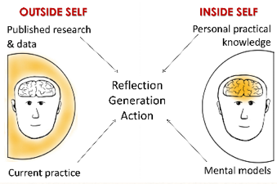
 | Leaders have a big impact  (Insert diagram from Hattie about influencing factors)  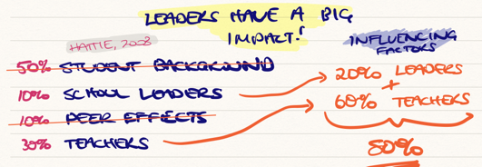 | Check for understanding - foldback  Don’t presume it’s a will issue!  (Insert will and skill diagram)  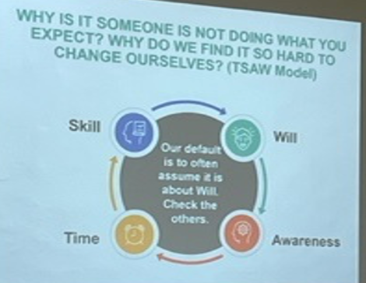
Promote scholarly teaching

Teachers must be scholarly – must consult the research

- Scholarly
- Consult literature.
- Select and apply appropriate interventions.
- Conduct systematic observations.
- Analyse outcomes
- Obtain peer evaluation of their classroom performance

Scholarly teaching involves both informal and formal traditions. Research on teaching and learning and in-depth understanding of literature, critical reflection and sharing through publication.

Life balance | Self-worth | Two expectations that kill performances
How many summers do you have left?  (Include diagram of Health, Career, Relationships, Physical Environment, Finance and Intrapersonal)  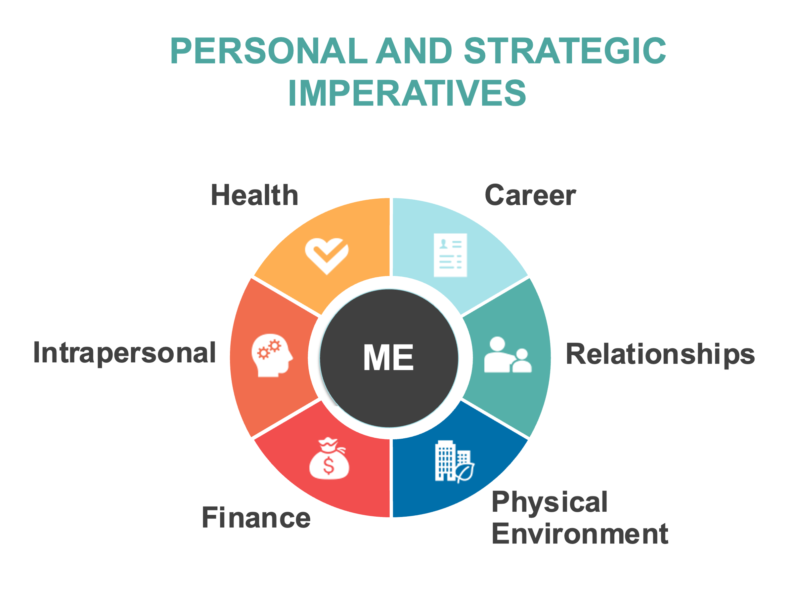 | Find self-worth independent of what you do, or you will never be satisfied!  Don’t get caught up in the narratives of others!  I don’t care about what you think about me, but I still care about you | - Expectation of outcome  - Expectation of what people can’t control  Focus on the things you can control.

