Background:
- We have an AI chatbot webpage for a real estate agent, and we’re are going to start sending traffic to that webpage (primarily from Google)
- We want to maximize the percentage of visitors who start conversations with the chatbot.
- We have a specific area of the webpage where we can include any HTML.
- We need the design and HTML for both desktop and mobile version.
- We’re looking for the best designs that help convert visitors into people who engage the chatbot.

Additional important information:
- Here is an example of the current chatbot webpage: https://heylibby.ai/erica
- The designs can include any content about Erica (for design purposes, doesn’t have to be real information.) This can include:
  - Biographical info
  - Reviews/testimonials
  - Related pictures
  - And anything else you think would help the page convert.
- Below are the areas we want designs and HTML for. Note the width and height of the mobile version will be smaller than the desktop version. (It can be separate designs though - it doesn’t have to be responsive.)

Desktop:
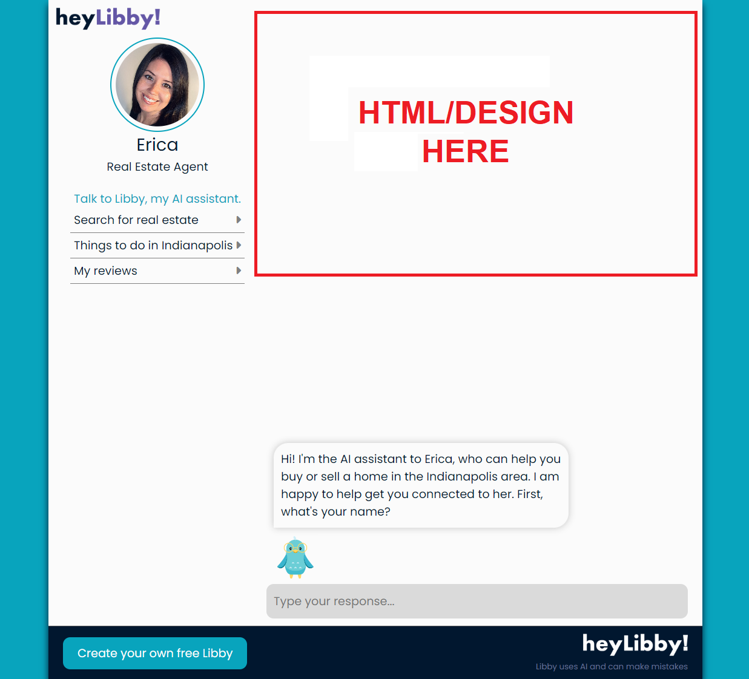

Mobile:
