 | 

Earn an additional £60,000+ per year, part-time.
Sign up to our Distressed Assets Property Investment, Sourcing and Packaging Course
Marble Arch, London, W1
Saturday 18th November 2023 9.30am - 6pm
__________________________________________________
Property Investor Show Special Offer £695
(usual price £995) _____________________________________
This course is suitable for property investors, sourcing agents, deal packagers and other property professionals.
Learn to source below-market-value distressed assets like a professional. We will teach you to source property for yourself and how to become an agent and source property for your clients. Add £60k to your annual income by doing as little as one deal per month. This course will allow you to source properties at rock-bottom prices ANYWHERE in the UK, whether Liverpool, Leeds, Leicester, Luton, or London.
Trainers
Dominic Farrell – A BSc (Hons) in economics, MBA (Defence), property investor/developer and author of the Amazon No.1 bestseller Property Auctions: Repossessions, Bankruptcies and Bargain Properties

Claire Farrell – Former Director of Legal Balfour Beatty Construction, property and construction solicitor with 23 years’ experience, property investor

Joshua Lee CeMap – mortgage and bridging finance specialist – the UK Adviser.

PROPERTY INVESTORS:
We will show you how to source deals like this:  Apartment for £5,000 (purchased 2023)  In 2017, this property sold for £59,950. It could be resold now, in 2023, for up to as much as £85,000. It was purchased by us for £5,000 cash plus debt – an asset for debt swap. No refurbishment was required. Market rent is £550 pcm or £6,600.  Equity c. £60,000 Yield 44% | 

PROPERTY SOURCING AGENTS & INVESTORS:
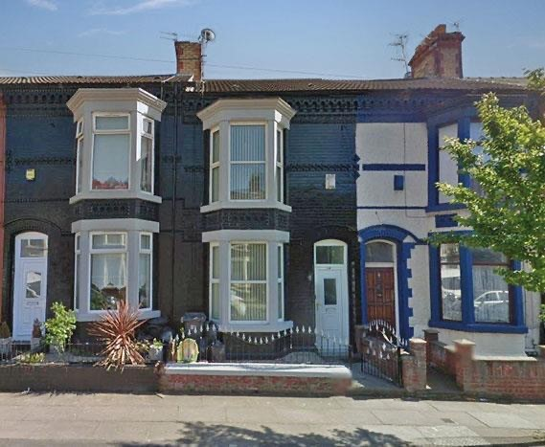 | We will show you how to source deals like this:  House - £90,000 (purchased 2023)  28% below market value. Yield 10% or 17% net as a HMO.  Fee earned £4,000 plus add-ons.  The same client has purchased 5 properties this year, a minimum fee income of £20,000 before add-ons from just one client.
You can do this!
Be a property investor AND property sourcing agent. The deals you have spent time researching and do not want, sell to others for a fee and also JV with agents to sell to their clients.
Learn how to buy property and flip, using NO CASH!
The Property Investment and Sourcing Intensive Course:
Core objectives
1. Distressed Property Investment – Source property substantially below market value (BMV)
- What is a distressed asset, and why now is the best time to invest since 2008/2009.
- How to source BMV distressed assets for personal investment purposes or to sell on to others, either for a fee or profit (flip).
- Buy properties with NO CASH and flip for profit using a professional legal technique.
- What’s a property Call Option?
- Creating a viable property strategy, whether for investment, development, or sourcing.
- Houses v HMOs v Leasehold Flats – what’s the best strategy in the current market?
- Learn to value a property like a professional.
- Understand the key investment ratios and numbers which make a potentially good investment, OUTSTANDING.
2. Property Auctions – Repossessions, Bankruptcies and Bargain Properties LIVE
- 50% below market value (BMV) is achievable – illustrated with real-world examples.
- Property Auctions – Not all properties at auction offer value. How to sort the outstanding opportunities from the duds.
- Property auction strategies and tactics that work in 2023.
- Navigate the legal pack – fix issues for a huge uplift in value – real-world examples.
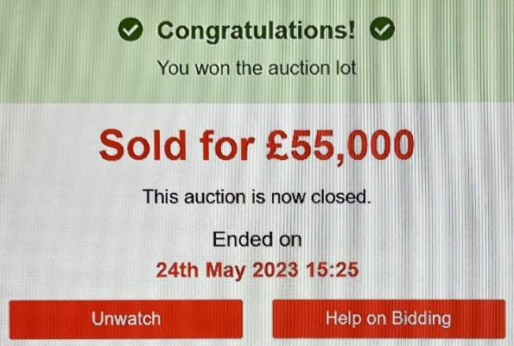
3. Off-market
- How to source off-market opportunities. 100% or more below market value (BMV} is achievable. Illustrated with real-world examples.
- Sources of Intelligence – Where do you find off-market bargains like this?
Purchased 2023 - £17,500
Sold in 2017 for £59.950
Potential value £85,000
2-bed garden flat - £5,000 refurbishment
Yield 28%

4. Law - how to fix problems for an instant uplift in equity
- The legal pitfalls to avoid and the legal challenges to embrace.
- Do you buy in a limited company or as an individual?
- How to manage risk. The risk management matrix.
5. Finance – the latest bridging and mortgage advice
- Discover the best and most up-to-date sources of finance available. Get the latest mortgage and bridging advice from an expert, and also learn how to qualify.

6. Buy, Refurb, Refinance and Rent (BRRR)
- How to use a small deposit, bridging and mortgage finance as part of a Buy, Refurbish, Refinance and Rent (BRRR) strategy.
7. Property Sourcing and Deal Packaging
- Deal packaging – How to source properties for investors. How to source investors for properties. The legal considerations of becoming a property sourcer.
- Partnering with an established property sourcing company, such as Tuna Fish Property and Distressed Assets.
8. Starting Your Property Business
- Setting realistic and achievable goals.
- Investor profiling.
- Project manage refurbs.
- Branding and marketing
- Establish a lettings and property management business.
- The law, property sourcing, client money and lettings.
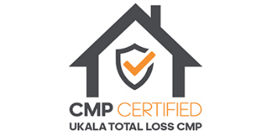
9. Networking with speakers and delegates after the course.
Join fellow delegates and trainers in the bar for a coffee or drink afterwards. This is an opportunity to share ideas, thoughts, and experiences.
After the Course
Community
Delegates will have a range of property experience. You will have an opportunity to share your experiences with others. Whatever the question, how trivial you think, someone will have an answer. All delegates, if they wish, will have access to a private Facebook group where you can bounce ideas off each other and be involved in networking events.

Zoom Meeting
As part of this course, all attendees are entitled to a free 30-minute 1-2-1 Zoom with Dominic Farrell after the event to discuss their strategy, goals, and aspirations and how to get started or increase growth.
Contact:
Distressed Assets – www.distressedassets.co.uk Tuna Fish Property – www.tunafishproperty.co.uk
Telephone 0151 705 9055 or 020 8638 6271
Tuna Fish Property 20 Chapel Street Liverpool L3 9AG
Distressed Assets 27 Old Gloucester Street London WC1N 3AX
LOGOS HERE PLEASE

