Module 1: Leadership Responsibilities
“Before you are a leader, success is all about growing yourself. When you become a leader, success is all about growing others.” – Jack Welch (CEO of General Electric from 1981-2001)

Leaning Objectives:
- AVK Mission, Vision & Values
- Eight Customer Promises
- Understanding our Strategic Goals
- Creating & Communicating Your Vision
- Introduction to Managerial Leadership
- Understanding the Role of a Manager

Exercise 1: EXPECTATIONS
List the five most important expectations to be considered successful in your role.
five most important expectations of my role
1
2
3
4
5

Exercise 2: Do Our Strategic Goals Align with our Values & Promises?
Review the Strategy Deployment Initiatives and connect them to corresponding Values and Promises. Are there any values or promises that are not aligned to our goals?
 | Department | Level 1 Initiative | AVK VALUES | Customer Promises
1 | HR | Succession Planning
2 | HR | Reach IKTVA Saudization of 47%
3 | HR | Increase Technical Competences of Commercial
4 | Quality | Redefine All Processes & Establish Training Schedule
5 | GM | Improve the Follow up Process of Payment Collection
6 | Commercial | Market Share of GV - BFV - HYD - Control Val.
7 | Commercial | Enhance Project Management
8 | Commercial | Define Service Offer
9 | Commercial | Enhancing Relationship with Aramco Depts.
10 | Commercial | Define Sales & Marketing Strategies
11 | Commercial | Utilize CRM in measuring and Improving Response Time to Customers
12 | Supply Chain | Supply Sustainability
13 | Production | Capacity Improvement
14 |  | Increase Factory 2 Ability to Produce Larger Sizes BFV

AVK VALUES:

Quality – Sustainability – Reliability - Innovation – Customer Service

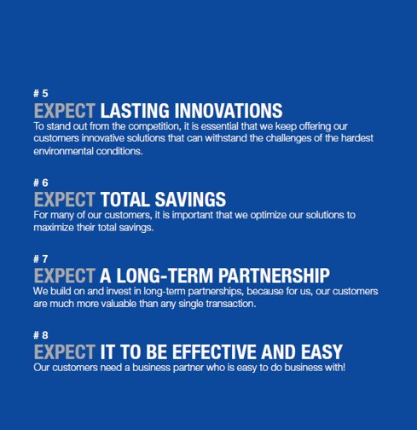
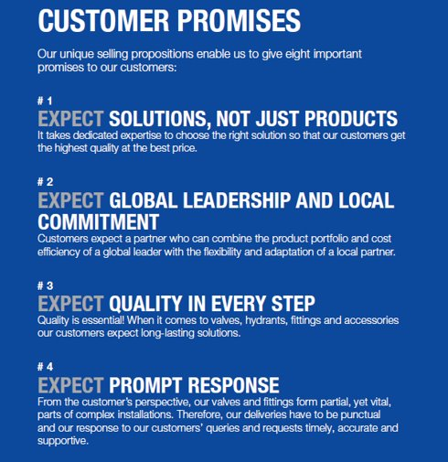
Exercise 3: Reflection Exercise
This exercise has 2 parts: First reflect on the past year and then get clarity on the upcoming year’s goals.
1 | What was our most significant accomplishment last year?
2 | How did we get the result?
3 | What could we have done better?
4 | What do we need to accomplish next year?
5 | What is your performance goal?

Exercise 4: Creating Your Vision
Developing and communicating a vision is an important skill for leaders. The following checklists are designed to help you cover the key issues associated with the effective communication of a compelling vision.

Part 1 – Identifying Key Components
A vision communicates answers to the basic questions: Who are we, where are we going and why are we going there? For individual leaders the root questions include what do I care most about and how do I want to spend my life in pursuit of what is important to me? A vision is a statement that provides us with a destination, a desired future. To be inspired by a vision, three components need to be identified:
- A Strong Vision Makes a Case for Change – First, the vision should justify changing from the status quo. The case for change can be based on various factors such as changing economic conditions, market changes, new customer demands, the threat of rival products, or advances in technology. Regardless of the reason, people are more inclined to support the idea of changes that they helped create otherwise they need to be convinced that change is needed.

- A Strong Vision Identifies Ideal Strategic Goals – Second, ideal goals need to be identified to show how the future will be different from the past. Ideal goals establish a standard of excellence and invite people to be intrinsically motivated to achieve the goals but they don’t have to be so specific to define final end-states. A powerful vision invites followers to think for themselves about the ideal goals toward which they should strive.

- A Strong Vision Includes a Focus on People – Third, the vison needs to recognize the people whose actions are necessary. Who will benefit if the vision is achieved? Whose actions are necessary to make the vision a reality?

Part 2 – Communicating a Vision
Leaders are constantly communicating – everything they say and do (as well as how they say and do it) is closely examined by employees. Likewise, people are paying attention to what is not said and done. Given this level of scrutiny, leaders need to choose carefully what to communicate and how to communicate it effectively. Your vision will be communicated through your words and your actions so your message must be authentic and consistent. Your words and actions take three forms: strategic, tactical and personal – they must address the heads, hands and hearts of followers.
- Heads – Strategic Communication of the Vision: Developing a clear philosophy centered on the strategic objectives helps employees make decisions and act autonomously to meet the goals. For example, Johnson & Johnson has a long standing credo which was created in 1943: “to put the needs and well-being of the people we serve first”. Over the years, this credo has helped align employee actions to the company values and served as a reminder of what they needed to do in order to live the values.
- Hands – Tactical Policies & Practices: Your vision should also have tactical policies and practices that can be implemented to support the vision. The heads and hands must work together – employees should know what they need to do to make the vision a reality. Southwest Airlines, for example, created 10 organizational practices to support their company’s vision. These practices help create an environment of coordination that is characterized by shared goals, shared knowledge, and mutual respect that is focused on problem solving.

- Hearts – Communicating at a Personal Level: The most critical and challenging aspect of communicating your vision is touching the hearts and connecting with the personal values and aspirations of employees. Your vision should inspire employees to want to pursue it, even if it is challenging.

 | When making suggestions for taking action, I need to…
1 | Explain how my idea fits in with the “big” picture of what we want to accomplish.
2 | Justify and explain why it would be the right thing to do.
3 | Emphasize the rational arguments for taking that action.
4 | Try to connect the needs & interests of others to the action.
5 | Talk in terms of what we would ideally like to accomplish.
6 | Try to make my suggestion as vivid as possible.
7 | Offer examples of how my approach will make a difference to people.
8 | Avoid getting into too many details until people have agreed to my basic idea.
9 | Try to explain how my suggestion will benefit us in the future.
10 | Look for ways to connect what I want to do with what others want to do.

Exercise 5: Communicating Your Vision
Describe your goal below and then list the tasks the team needs to accomplish to meet the goal. Determine who is best suited to be responsible for the task and describe in detail what it will look like when they complete it.

 | Task | Responsible | What does success look like?

1

2

3

4

5

6
Performance Goal: ___________________________________________________________________

Exercise 6: Delegating Effectively

After describing the goals in detail and outlining what will be required to achieve them, use the checklist below to ensure that you covered every aspect. This will help you communicate the goal clearly and ensure that the person responsible has the necessary information, authority, and tools to accomplish the tasks required.

Overview of Leadership Styles

Term | Definition | Outcome
Autocratic | A leadership style that is boss-centered and authoritarian | Produces short term productivity but in the long run it reduces responsibility as employees delegate upwards
Charismatic leadership | A leadership style in which the leader uses the power of their influence and appeal, as well as inspiration and empowerment, to achieve change | Useful for short term initiatives that require selling a new idea & fostering adoption
Democratic | A leadership style in which the leader relies heavily on input from others, especially if they are impacted by the decisions being made | Creates consistency in results as employees feel involved in decision making
Laissez-fair | Translates to “let do” or “let them do it,” which reflects a leadership style that is very hands-off and a belief that the subordinates will self-regulate | Effective for teams of experts who do not require hands-on management
Servant leadership | A leadership style in which the leader consistently looks for better ways to provide and support followers | Employees are highly productive and engaged because manager acts to remove obstacles and supports them to achieve goals
Situational Leadership Model | Focuses on the belief that no one leadership style works best in all cases and that the leader needs to adapt to fit the situation | Difficult to execute as it requires leader to be skilled in many styles

Introduction to Managerial Leadership
Understanding your organization’s culture and your leadership styles will help you know what influences employee behaviors and outcomes. Then you need to decide what is working and what needs to change.
Control
Compete
Create
Stability & Control
Future State
Current State
Collaborate
10
Flexibility & Discretion

Representation of SVMC Organizational Culture
20
30
40
50
External Focus & Differentiation
Internal Focus & Integration
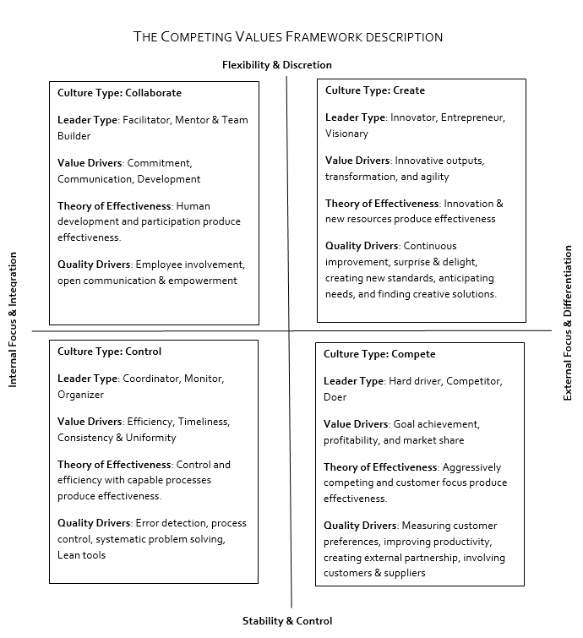

Compete Skills
- Manage Competitiveness – Foster an orientation towards exceeding competitors’ performance
- Energize Employees - Motivate and inspire people to be proactive and put forth extra effort
- Manage Customer Service – Foster a focus on serving customers, communicating promptly with them and exceeding their expectations
Create Skills
- Manage Innovation – Encourage creativity, facilitate mew idea generation and exploring alternatives
- Manage the Future: Communicate a clear vision for the future and facilitate its accomplishment
- Manage Continuous Improvement: Foster a focus on continuous improvement, flexibility and productive change
Control Skills
- Manage the Culture – Help people understand what is expected of them, what the standards of the team are and how they can best contribute to the team
- Manage the Systems: Ensure that procedures, measurements, and monitoring systems are in place to keep processes and performance under control
- Manage Coordination: Foster information sharing across the organization and with external units
Collaborate Skills
- Manage Teams- Facilitate high performance teamwork
- Manage Relationships- Listening, supportive feedback and resolving problems
- Develop Others – Help people improve performance, expand competencies, and obtain development opportunities.

External Focus & Differentiation
Internal Focus & Integration
Stability & Control
Flexibility & Discretion

Critical Managerial Responsibilities

Real Life Scenario - Leadership Values in Action

Varco Human Resources Conference

By Walter Beni Reinhold
  - May 8, 1996
Human beings can adapt, and work around the most unfavorable, psychological environments. However, if an environment of trust, understanding, working together, caring, sharing, and respect is fostered, human beings will be motivated to achieve performance levels unknown in the great majority of companies. Everybody, at every stage of their life continues to seek this kind of climate, even though they may have had only very little psychological nourishment in their past working experiences. It is the Varco way to try to create a healthy atmosphere in which the individual will grow and flourish, have a sense of creating, and take pride in accomplishments. We should always help people to achieve possible things in life. This will give them inner confidence, a sense of purpose and involvement, meaningful, constructive relationships of others, and most of all - happiness.
We must do everything we can to promote and foster self-esteem, high self-esteem, in all our people.
What is self-esteem? It is how a person feels about himself. It is his overall judgment of himself - how much he likes his particular person. High self-esteem is not a noisy conceit. It is a quiet sense of self-respect, a feeling of self-worth. When you have it deep inside, you’re glad you’re you. Conceit and arrogance is only whitewash to cover low self-esteem. With high self-esteem you don’t waste time and energy impressing others; you already know you have value.
Remember, a happy employee is true to himself; this gives him personal integrity. He does what he can with what he has and is at peace within. The unhappy one lives by borrowed standards. At odds with himself, he masks his unacceptable parts and judges himself and others accordingly. Aristotle knew the truth of psychology verifies today. Over 2000 years ago, he said: “Happiness is self-contentedness.”
So, how we treat our people becomes one of our most important management objectives:
People like to feel that they belong
People like to feel that they are being involved
People like to feel that they are part of something important
People like to feel that others listen to what they have to say
People like to be recognized for their accomplishments
People like to be part of a successful team
People like to be proud of a company that is proud of them
All of these things can be done for all of our people and it doesn’t cost a nickel. However, the return on your investment to be a trusting, caring, understanding human being can be measured in millions upon millions of dollars. And I would like to say that it is also very important to treat our employees as well as our vendors or customers with the same caring, understanding and trust - for these relationships form the strong foundation necessary for the healthy growth of our company.
In every situation - always do what is right.

