DESIGN BRIEF FOR LOGO DESIGN Active Transport Partners

CLIENT
PROJECT TITLE | Active Transport Partners – Logo design
CLIENT NAME | J Posthoorn
BRAND
PRODUCT | Active Transport / Project Management / Civil Engineering Consultancy
POINT OF CONTACT NAME | Jean Posthoorn | PHONE | 0432439254
EMAIL | Jean.posthoorn@jpegroup.com.au | MAILING  ADDRESS

BUSINESS INFORMATION
BUSINESS OVERVIEW  what do you do? what is unique about your business? | Active Transport Partners (ATP) is a subsidiary of JPE Group and boutique project management company with a primary focus to deliver Active Transport initiatives and outcomes (i.e. bicycle, scooter, pedestrian initiatives). ATP manages all stages of the project lifecycle including strategy, consultation, and design through to delivery / construction.
TARGET AUDIENCE  who are you trying to reach? | Primary: Local councils and Transport for NSW (TfNSW) clients with active ‘Active Transport’ Requests for Tender (RFTs)  Secondary: Consultancies, schools and other entities with an interest in developing and fulfilling Active Transport initiatives.

CREATIVE
VERBIAGE  what name should be included in the logo? | Active Transport Partners
TAG LINE  if applicable | -
IMAGERY  what images, if any, should be included in the logo? | Active Transport symbols, e.g a bicycle, bicycle wheel, person walking, a road, bike lane, etc.
DESIRED DESIGN STYLE  include reference images, if applicable | Combination mark - with pictorial and word elements, but also have the ability to be used as a symbol-only logo.  The logo should have an ‘active/ green / eco’ feel and appear modern and cutting edge and incorporate all or some of the aforementioned active transport symbols.  Brand values: professional, modern, youthful, active / eco-focused.  Some similar style examples include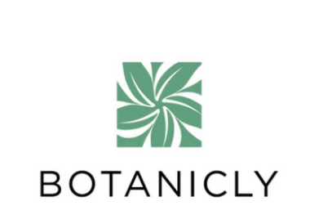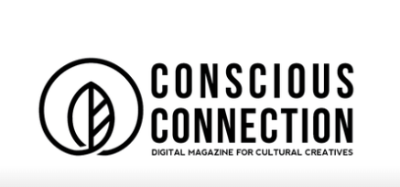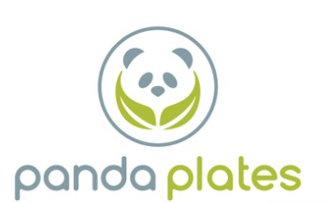
COLORS  & OTHER VISUAL CONSIDERATIONS | Prefer a green / blue colour palette, but open to others.
INTENDED USE  signage, business cards, etc. | Digital and Print including Websites, Business Cards, Tender documents, Letterhead, Branded Merchandise
FORMATS | Once the final logo is selected, we will require the following versions / file formats:  - Full Colour  - All Black  - All White  In:  - Symbol only  - Symbol and company name – vertical and horizontal configurations  InDesign / Photoshop / Illustrator files  JPEG High and Low Res files (online)
DELIVERABLES | logo conceps, including revisions and final files
BUDGET | $500 incl. GST

