Introduction: Somany this year is expanding its presence in “Long format” ceramic tiles refer to high-quality ceramic tiles that are manufactured in larger sizes compared to traditional ceramic tiles. These tiles typically come in rectangular or plank-like shapes and have dimensions that exceed the standard sizes commonly used in tile installations. The term "long format" is used to describe tiles that are longer and narrower, providing a sleek and modern aesthetic to the space. These tiles are often designed to mimic natural materials such as wood, stone, or concrete, offering a more luxurious and contemporary look. The sizes start from 1200x800 and goes above, they also come in different thickness from 9mm to 15mm. (Definition of LFT is “ any one side of the tile should be of minimum 1200 mm in dimension”).

LFT tiles are replacing Marbles, stones and granite as they are cost effective, easy to install and maintain, this is fuelling the demand. LFT’s are being now extensively used in commercial spaces, offices, and in civic infrastructure.

The term "premium" indicates that these tiles are of superior quality, often manufactured using advanced technologies and techniques. Premium large format ceramic tiles typically feature high-resolution printing, intricate designs, and realistic textures, creating a visually appealing and highly realistic surface – Digital glazing v/s Traditional glazing. They are also more durable, resistant to stains, scratches, and wear, making them suitable for high-traffic areas or areas that require heightened performance.

Due to their larger size, premium long format ceramic tiles can enhance the visual appeal of a room by reducing the number of joints, creating a seamless and sophisticated appearance. They are commonly used in residential and commercial settings, including living rooms, kitchens, bathrooms, and lobbies.

The New brand for this has been named as SOMANY MAX

Advantages of SOMANY MAX
- Diverse Design Palette imitating all possibilities of marble, wood etc
- Seamless Look
- Illusion of Space
- Fewer Grout Lines - Visual Continuity
- Versatility - Explore the World of Finishes
- Affordable
- Easy to maintain

Product features:
- Long life
- Maintenance free
- Hygienic Surface
- Impact resistance
- Low water absorption
- Easy Installation – less time required to install
- Scratch Resistant
- Fire Resistant
- Chemical Resistant
- Frost Resistant
- Thermal Resistant
- Crazing Resistant

What solution does SOMANY MAX provide to customers?
Somany Max is not just a large format tile, it’s about distinct finishes, sizes and designs which provides our customers infinite possibility to paint their dream canvas.

Brand Promise
SOMANY MAX large format tiles stand as a testament to intricate engineering, masterfully emulating the textures and finishes found in nature with astonishing authenticity. These tiles effortlessly establish a harmonious aesthetic, reducing the grout lines and introducing fresh outlooks and dimensions for applications like flooring, wall cladding, furniture elements, kitchen and countertops. Whether it's the opulent gleam of polished marble, the evocative charm of aged wood, or the earthy tactility of natural stone, these finishes not only ignite limitless creativity but also compels you to THINK BEYOND!

The New Brand
- The brand will have the name “MAX”
- MAX logo will also have the Somany logo integrated as a unit
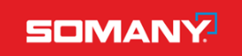
Just an example
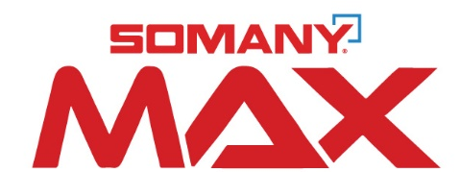

- The tagline of the logo will be “Think beyond”
- Will need the logo design in reverse version as well
- We all also need the logo to be vertically stacked and horizontally stacked, eg
