`

Søle

Nordic Wellness Spa
(Norwegian: mud)
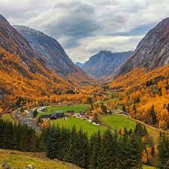

Connie Thompson
Owner/Director
c. 780.999.0745
Solewellnessspa@gmail.com

4807 48 Street
Leduc, AB T9E 7K2

Company Profile Summary

Company Overview
Søle Nordic Wellness Spa will be a unique wellness destination for healing, rest and relaxation with our Nordic Circuit and our Himalayan Salt Relaxation Haven. With our focus on the traditional Scandinavian wellness of the Sami people, we will be emulating the services and benefits of Swedish and Norwegian health spas. We will offer the healing therapies of hot/cold therapy, halotherapy, reiki, massage, yoga, meditation, and sound therapy. We also offer our signature lingonberry, birch bark, pine and spruce needle oils combined with healing salt and mineral muds for our bespoke skincare, facials, and body treatments.

Competition
There are seven spas in the Leduc area, Elements Day Spa, Relax & Renew Spa Inc, True Esthetics, Prestige Studio, SΛLT Day Spa, Refresh Wellness Centre, and Beauty Forward Medi-Spa. Each has similar basic spa services with Elements Day Spa providing the most comprehensive list of services and SΛLT Day Spa housing a small salt room with loose salt on the floor.
In Edmonton, there are many massage studios, approximately twenty-eight day spas, and approximately fourteen wellness spas. All provide similar services such as facials, manicures, pedicures, reiki, massage. Notable exceptions are Synergy Sauna & Spa and Hot Stones Spa. Both on the north side and provide a sauna experience. Hot Stones Spa also houses a small halotherapy room without salt walls or floor. None of the above provide a destination experience.
There are seven Scandinavian destination spas in Canada and only one in Alberta, the Kananaskis Nordic Spa located 45 minutes southwest of Calgary. Scandinav has four locations in Whistler BC, Blue Mountains ON, Mont Tremblant QC and Vieux Montreal QC. The last two are the Nordik Spa-Nature in Chelsea QC, and the Siberia Station in Quebec City QC.

Strategy and Marketing Plan
To turn around the existing business we will undertake the following:
- Branding
- Renovations
  - New exterior and signage
  - Addition of sauna, showers and additional treatment room
  - Bathroom renovation
  - Complete interior flooring, paint, and new trim
- Lease quality spa equipment
- Marketing Plan
  - Comprehensive online presence: A user-friendly website, optimized for search engines to engage and support our target audience
  - Local advertising: Partner with local health and wellness publications, partner with local motels and hotels, leverage influencer collaborations, and implement a targeted online advertising campaign
  - Loyalty program: Offer loyalty programs to ensure the loyalty of our customers and increases their lifetime value. Provide reduced pricing, exclusive events, and exclusive access to new treatments for members
  - Online booking: Using Milano, a robust booking management system, to increase bookings and reduce no-shows
  - Off-time promotions: Promotions for slow days to ensure a steady flow of customers
  - Cross-sell and upsell: Offer add-on, high-profit services to customers to increase client satisfaction
  - Gift cards: Provides additional services to friends and family
  - Social media: Utilize social media platforms to communicate with our clients on a personal level
  - PPC ads: Social media and search engine PPC ads to gain visibility and reach our relevant target audience
  - Google listing: Listing on Google My Business to ensure that people can quickly find our business during local online searches
  - Referral program: Encourage existing clients to refer friends and family by offering discounted services as incentives

Our Vision
A warm and welcoming hygge spa with a focus on Nordic wellness, healing and relaxation in a northern climate.

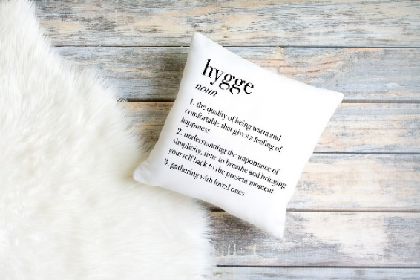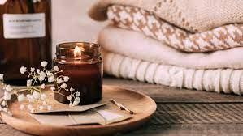
Let me introduce you to our proposed new space.

New signage and logo
Walking up to our spa, picture a backlight “halo” logo on the existing exterior stonework and simple black lettering above the front windows on the white background.
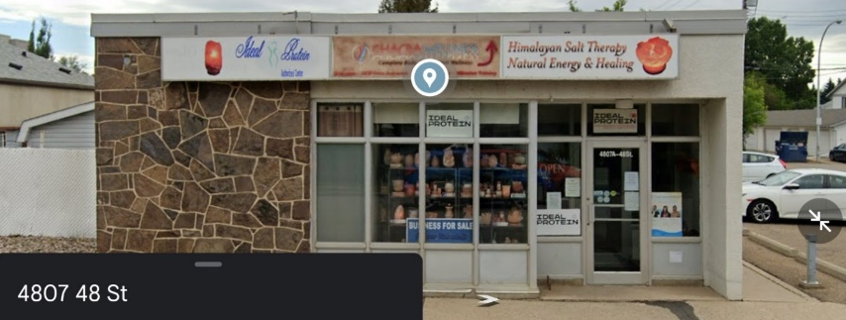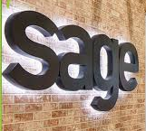

Reception & Waiting Area
The warm, welcoming colours of Himalayan salt envelope you as you step into our foyer. Clean and simple you are welcomed by our friendly, uniformed staff from our simple cream and white reception desk with natural elements and lower portion for client accessibility.
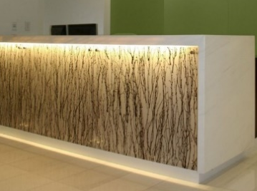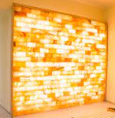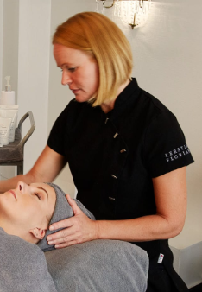
Behind the desk is a striking backlite Himalayan salt wall which hints at the relaxation ahead. Comfortable chairs welcome you to sit while you wait for your relaxation guide to start your journey.

Our Signature Nordic Circuit
Your journey begins with our signature Nordic Circuit through our traditional sauna with your choice of our signature essential oils infused into snowballs to bring healing aromatherapy to your first step.
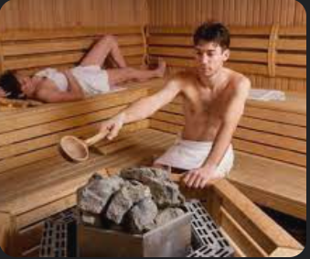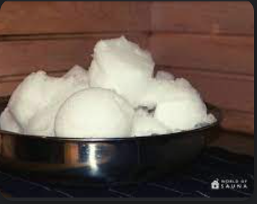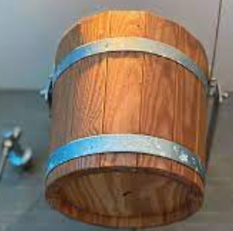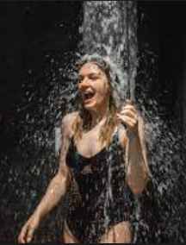
Step two is a our unique nordic bucket shower. Step three is relaxation in our healing Salt Room.

Halotherapy Salt Room
Our unique halotherapy salt room with the walls and floor of quality Himalayan salt bricks, provides an enveloping comfort where you can relax in silence, with meditation or sound therapy.
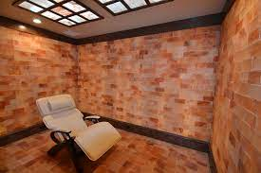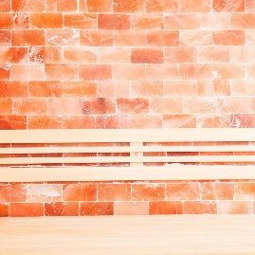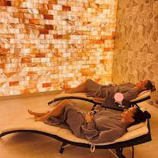

Relaxation Wellness Spa
Next to our circuit are our relaxation and wellness spa rooms, our yoga suite, change rooms and bathrooms.
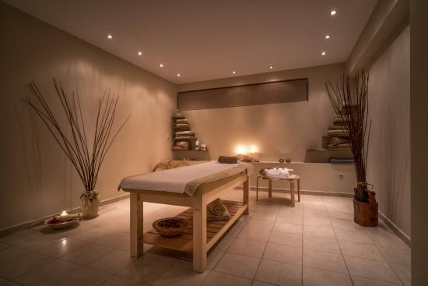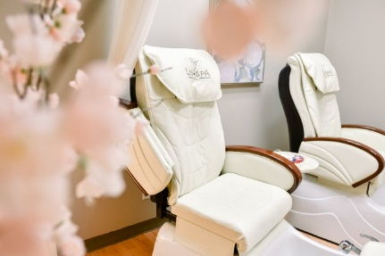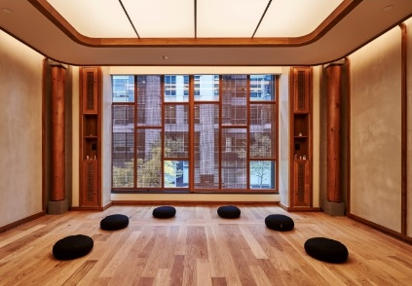
Warm colours, modern fixtures, vessel sinks, and a walk-in shower in spa changeroom.

