CAPABILITY STATEMENT

Page 1

Add IN Imagery – of Logo/Building/Signs or a project – must relate to us in someway – encapture who we are in a photo

ADD in our address, Link to Website, ABN and Builder Reg # etc

Page 2
Table of Contents

Page 3 and Page 4

COMPANY PROFILE Utlise the below BUT flesh out a LOT more
With IMAGERY PLUS TEXT – also utilising the “ Why Orixon”
Utlise the below BUT flesh out a LOT more - Our History si essential BUT get to the point of who we are and what we can do
Established in 2007, Orixon is a family business that has grown to become a trusted partner for a diverse range of businesses and government agencies across metropolitan, regional and remote areas of Western Australia.
We partner with our clients to assist them in achieving their goals through the provision of high-quality work that is delivered on-time and on-budget.
Our Managing director, Mark Kelly, is a registered builder with over 24 years' experience in the industry. Mark oversees all projects and is supported by a competent team of experienced administrative professionals, qualified tradespeople and preapproved subcontractors.

Delivering quality outcomes on construction projects and providing reliable and timely maintenance work has cemented Orixon's position with our clients as a preferred supplier with a reputation for safety, quality, and reliability.
Long-term contracts and partnerships with companies such as Western Power and The Department of Finance, who hold Orixon in high regard, are a testimony to the quality of our team and the services we provide

ADD CLIENT LOGOS – or LIST THEM ALL
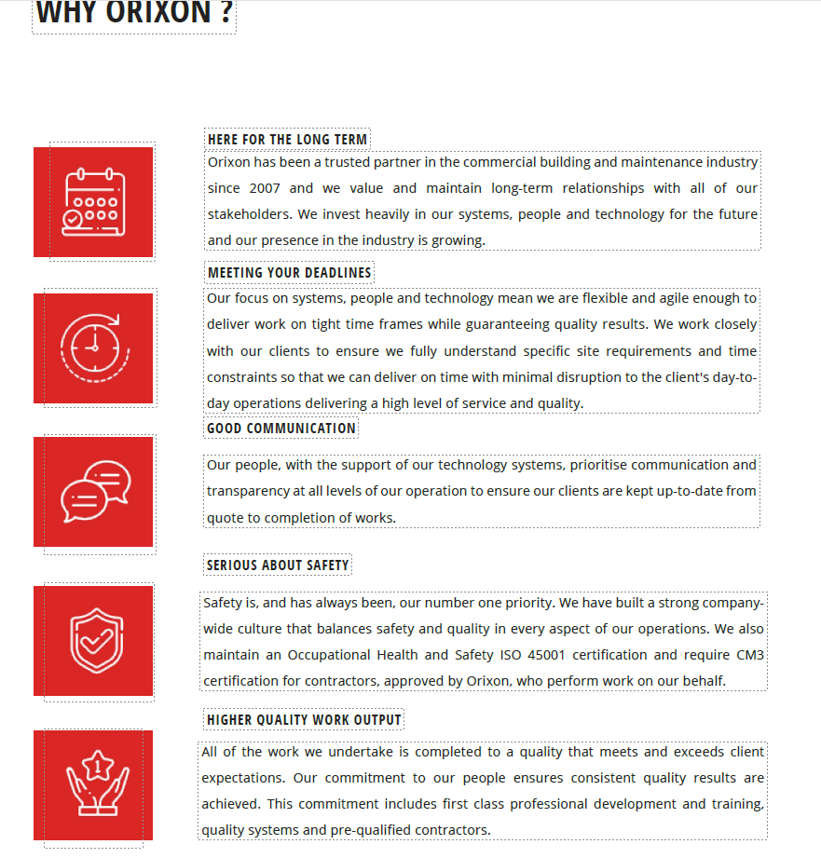

PAGE 5 and 6
Our Services ( they will be based over 4 Pillars ) Maintenance, Minor Works, Major Works and Modular
Maintenance
Overall at least 1 page text – spread over 2/3 pages with Imagery of some of our works
High Level: We can service Maintenance for Reactive, Priority or Planned
Talk stats, Volume of works, Our IT Systems and App’s that allow us to action works direct to trade
A lot MORE DETAIL
SPECIFICALY WHAT DO WE DO - TALK ON PJ's - TECHNOLOGY Supporting the Business PRIORITY/REACTIVE/PLANNED - VOLUME OF WORK WE MANANGE - HOW IT IS REPEATABLE FOR ANY CLIENT AS WE HAVE the FOUNDATION and PROCESSES in PLACE
STATS, SUCCESS, KPI ACHEIVEMENTS

PLUS IMAGERY

PAGE 7

An artistic placed statement – something along the lines of ….
Our priority is to
provide a service to
our clients, our staff
& the community,
built on the strongest
of relationships.
Or similar

PAGE 8 and P 9

High Level: We can service MINOR WORKS Do and Charge – Minor Maintenance, Quoted works, Small projects – agile to service quickly –

Overall at least 1 page text – spread over 2/3 pages with Imagery of some of our works
Could group examples in to ?
Education
Law and Order
Shopping Centres
Aged Care Facilities
Industrial Projects
Recreational

Logos of clients

PAGE 10

IMAGERY – COMPANY SPECIFIC

PAGE 11, Page 12

MAJOR Works
High Level: We can service MAJOR WORKS what service we can offer – full service, Tendering , D +C,
Overall at least 1 page text – spread over 2/3 pages with Imagery of some of our works
Could group in to Project examples for

Education
Law and Order
Shopping Centres
Aged Care Facilities
Industrial Projects

Logos of clients

P 13 – 2 Page only
MODULAR
High Level: We can service Supply and installation 0 what service we can offer – full service, Tendering , D +C,
Project examples

P13 P 14 OUR PEOPLE

BIO’s – with Photos – Who will you be working with ?
Mark, Liane, Lyn, Joe, Jose, Paul and 2 New PM’s
Ability to have – Photo and 1 paragraph per person – in an artistic way

P15
Quality Management – Pre Qualifications and Certifications

Nominate all Certs (triple Certified) and What they mean to our services and our clients

P16
Company Resources
Our ability to resource up to suit clients and contracts and projects – based on solid foundation, willingness to invest in resources to service our clients
TEXT Plus some imagery- EXAMPLE
Naturally Hutchinson Builder’s resources are not limited
to our people. We have many other available resources
which help to add value to our project.
Hutchinson Builders is structured into more than 22
teams, each specialising in certain areas within the
construction industry including but not limited to
refurbishments, schools, commercial, industrial and
highrise, tourism, clubs/hotels and resorts.
In addition to these construction teams we also have
teams devoted to providing cranes and hoists, and
scaffold to our projects.
These two divisions allow us to provide very competitive
pricing for these elements of the works, which quite
often form a significant portion of any large project.
Headquartered at our Ormeau facility, Hutchies’ Crane
and Hoist division boasts a young fleet of the highest
quality cranes and hoists diverse enough to cater for the
wide range of projects undertaken by the company. The
fleet includes both electric and diesel cranes in both the
hammerhead and luffing variety along side both Alimak
and Pega hoists.
In addition to the above, we also have an internal
training team which provides training to 180 apprentices
within Hutchinson Builders and closest subcontractors.
This team works hard to ensure we are producing and
maintaining the highest quality workers within the
industry.

P17 – P20
FOLLOW UP With PROJECT OVERVIEW’s

Project Overview – Like we put in Tenders –
Value, Client, Type of Project – list successes or challenges or Added value ( see below examples)
Imagery – NOT std photos – see their example
If no photo available we can state – due to Contractual and Confidential/Sensitive requirements we are unable to share Photographic evidence

See below example from others website –
Need at least 4 – 6 examples ( 3 Minor, 3 Major)
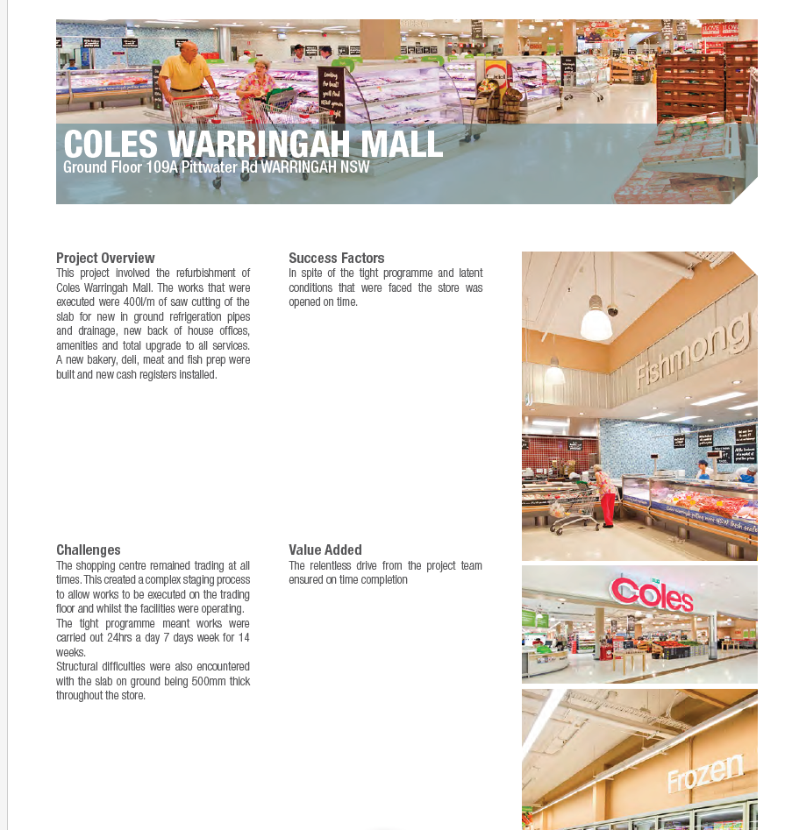

1`