Purpose: video game jacket

I would like the pictures below put in a cartoon drawing style (not childish) ;
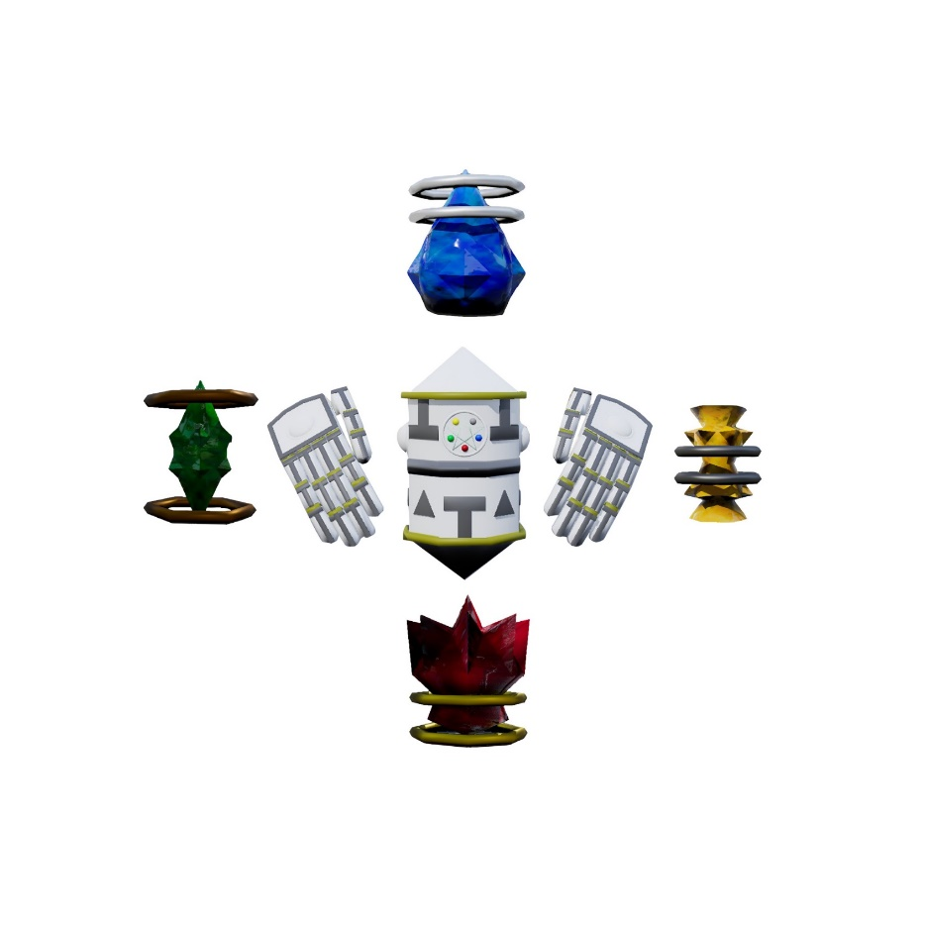
robot in the middle surrounded by a circle depicting all four elements (see example). Water (above) , fire (below), earth (left) and air (right)

In the background,a space-like sky in shades of grey.

