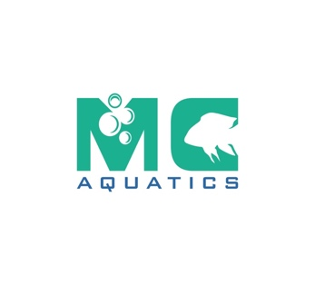
New Tropical Fish Store Englewood, Colorado
MC Aquatics specialize in rare and community species of tropical, cold and marine fish together with inverts and plants. We feature one of the largest Aquarium and Aquatics accessories ranges in the state.




