Bethesda Metro Area Village
Friendship Fun Caring Connection
OR
Friendship Fun Caring Community
OR some other combination

Suggestions:
Clean and clear
Must work in color or black and white
Navy and marine blues. Some yellow or green or red ok.
Not a fan of representations of people and especially not buildings. Possible but would have to see. Don’t want stylized people who look like they are running or jumping, or restroom-like depictions
Avoid common image 2 hands interlocked)
Portray supporting each other, connecting

Current: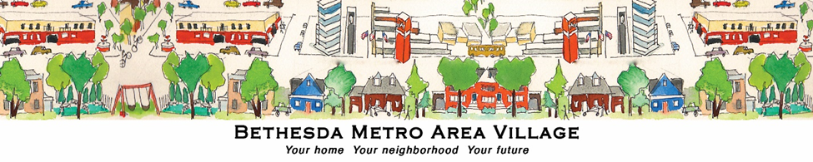

Others we like:
