We need to create an advertisement that is part of a newsletter that needs to conform to the following standard

Specs & Requirements
Image Dimensions: 580x150
File Type: JPEG
Max File Size: 40 kb
Resolution: 72 dpi
Clickthrough Link: One standard URL to a safe and secure (https) page on the client’s website

We need 2 options

Option 1: Need the caption and logo to be embedded in the image



Do you have a rapid response plan for this?

Option 2: Need the caption and Skyline logo to be embedded in the image so that when the reader clicks on the logo they are taken to our website-specific page here:

https://callskyline.com/emergency-response-planning/

The newsletter reader will then click on the url from the logo (see below) and then be taken to our website link to learn more and then fill out a form to schedule an appointment.



Do you have a rapid response plan for this?

Here is the Skyline Restoration logo that needs to be an overlay where if someone clicks on it and it takes them to our website to this URL: https://callskyline.com/emergency-response-planning/

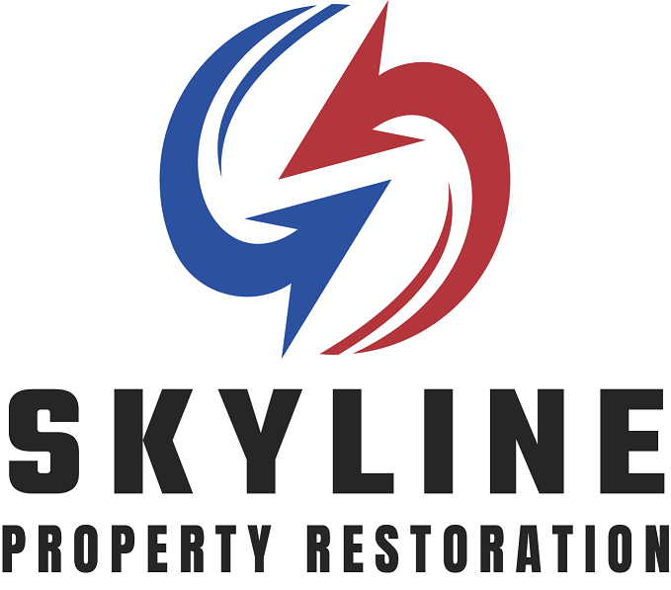

Here is what the typical email newsletter looks like with the old law firm logo - ERWIN LAW (we’re replacing Erwin Law) effective 9/8

The way we see this working is that the newsletter reader sees our banner ad, clicks on it, and is taken to our website URL to learn more

