- Below is team emblam with logo font. This font should be used to say HAMMARBEER on the can/bottle. We must not also say FOTBOLL. Team colors are white and green and those should be used for the can. Yellow can be an accent color on can or. Circular wheat concept without flag can also be used as decoration on bottle and can.
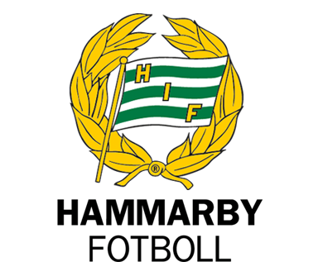

- The center two jerseys below show a green/white pattern the team has been using lately. Something similar could be used for decoration on the bottle and can. It cannot be used all over because the logo “Hammarbeer” would be hard to read against it.
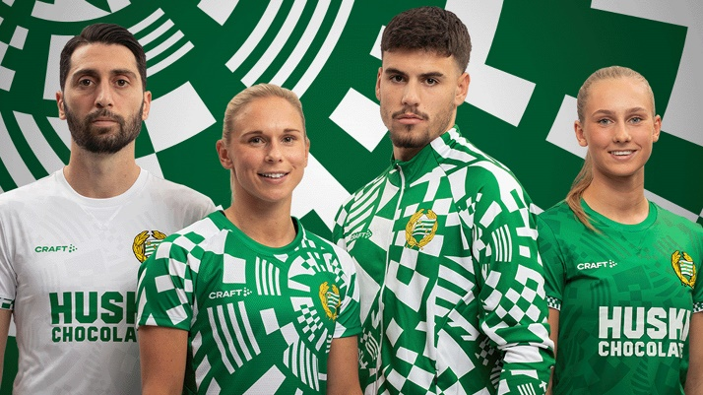
- Away jersey – possible basis for can/bottle design with white text (do not use Huski Chocolate anywhere on bottle or can)
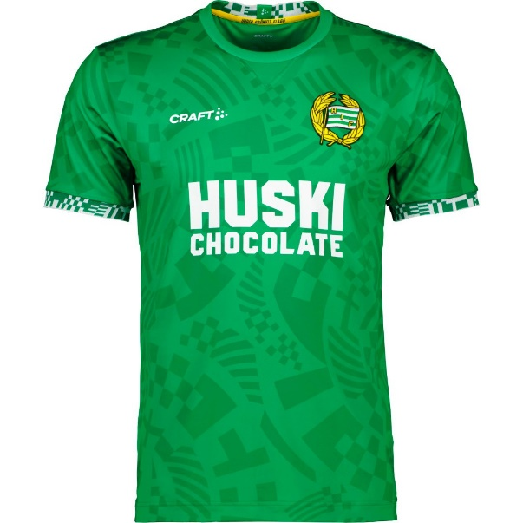
- Possible inspiration – another use of green and white
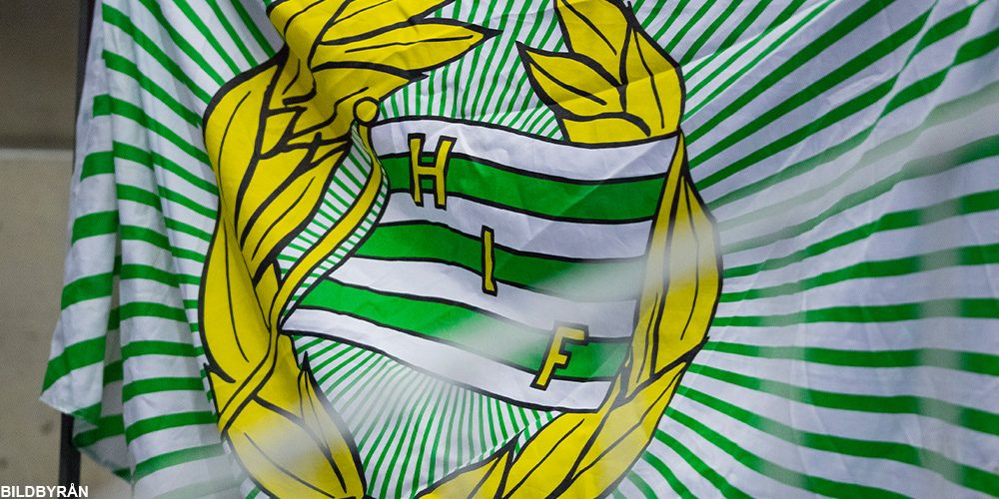

- Somewhere on the can version should appear all of the following three text items. On the bottle it need not appear or it could appear on the neck ring. They could appear quite subtlely so they are barely noticed. They need not be obvious:
- Bajen
- Just idag är jag stark öl (this could be in a script font)
- Heja heja heja Hammarbeer

- Can for shape and dimension:
