Fuel Up
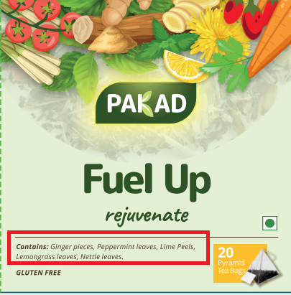 | Contains – All words will start with upper case (like below)  Contains: Ginger Pieces, Peppermint Leaves, Lime Peels, Lemongrass Leaves, Nettle Leaves
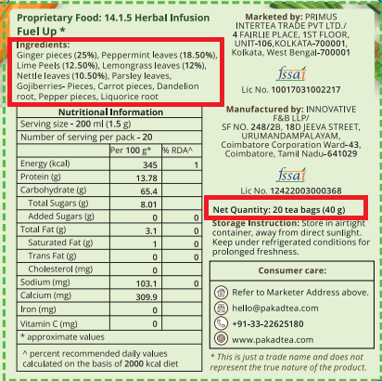 | 1. Ingredients – All words will start with upper case (like below)  Ingredients:  Ginger Pieces (25%), Peppermint Leaves (18.50%), Lime Peels (12.50%), Lemongrass Leaves (12%), Nettle Leaves (10.50%), Parsley Leaves, Goji Berry- Pieces, Carrot Pieces, Dandelion Root, Pepper Pieces, Liquorice Root  2. Quantity will be  Net Quantity: 20 tea bags (30 g)

