Beautea
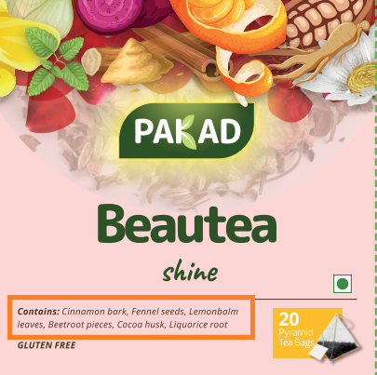 | Contains – All words will start with upper case (like below)  Contains: Cinnamon Bark, Fennel Seeds, Lemon Balm Leaves, Beetroot Pieces, Cocoa Husk, Liquorice Root
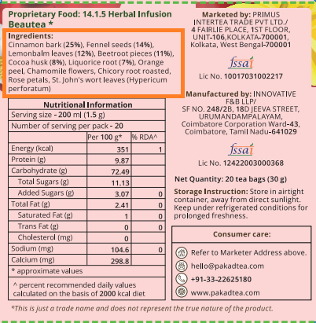 | Ingredients – All words will start with upper case (like below)  Ingredients:  Cinnamon Bark (25%), Fennel Seeds (14%), Lemon Balm leaves (12%), Beetroot Pieces (11%), Cocoa Husk (8%), Liquorice Root (7%), Orange Peel, Chamomile Flowers, Chicory Root Roasted, Rose Petals, St. John's Wort Leaves (Hypericum Perforatum)

