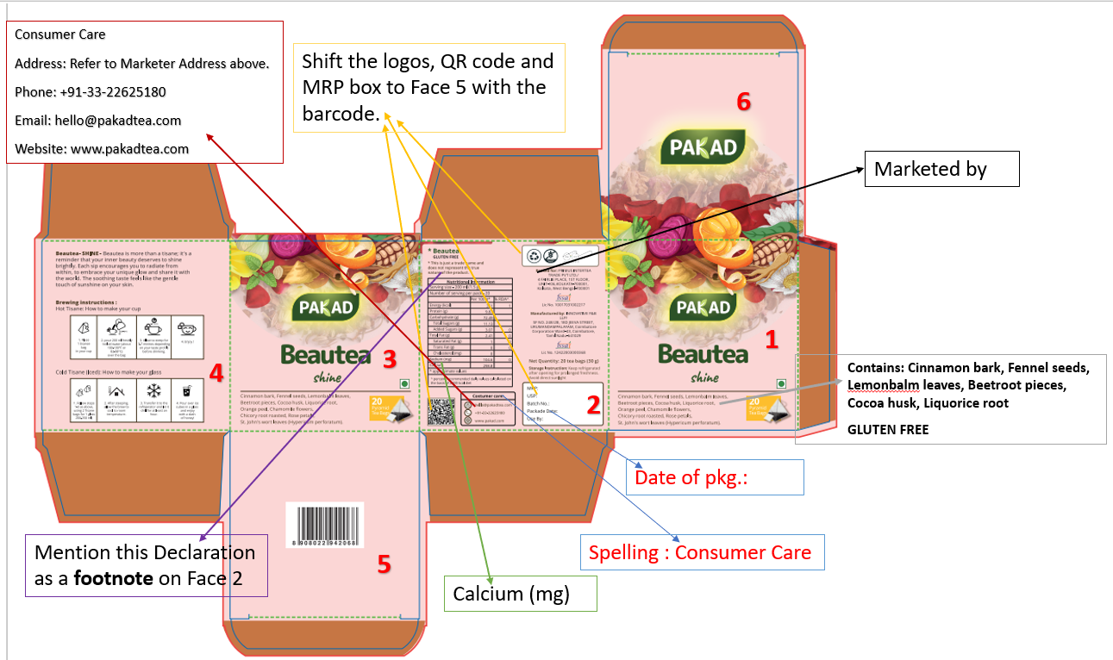
- Font size should be minimum 2mm
- GLUTEN FREE – put as a foot note on Face 1 and 3 in capital letters.
- Shift Logos, MRP panel and QR code to Face 6.
In the MRP box replace Packed Date with Date of Pkg.:
- Mention this Declaration as a foot note on Face 2 – *This is just a trade name and does not represent the true nature of the product.
- Mention- Herbal Infusion on Face 2 above the ingredients.
- Star mark will come after Beautea on Face 2.
- In the Nutritional Table for this blend – add (mg) near Calcium.
- Bring back the ingredients on Face 2 like below
Ingredients:
Cinnamon bark (25%), Fennel seeds (14%), Lemonbalm leaves (12%), Beetroot pieces (11%), Cocoa husk (8%), Liquorice root (7%), Orange peel, Chamomile flowers, Chicory root roasted, Rose petals, St. John's wort leaves (Hypericum perforatum)

See below for point nos. 5,6,7 and 8
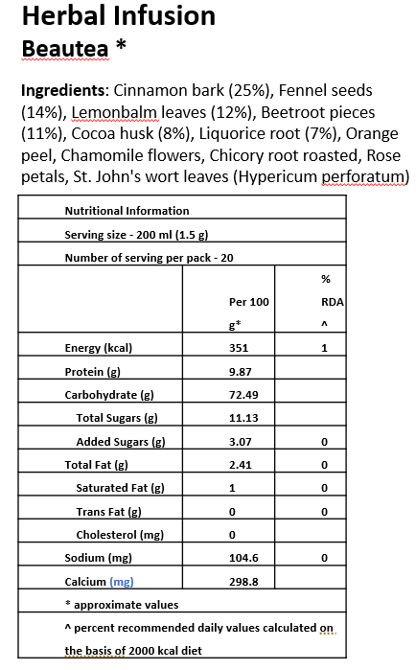
- On Face 1 and 3 where ingredients are mentioned put as below:
Contains: Cinnamon bark, Fennel seeds, Lemonbalm leaves, Beetroot pieces, Cocoa husk, Liquorice root
GLUTEN FREE (as footnote)
- Face 2 replace Packed for with Marketed by
- Consumer Care (Correct the spelling)– make the following changes
Consumer Care
Address: Refer to Marketer Address above.
Phone: +91-33-22625180
Email: hello@pakadtea.com
Website: www.pakadtea.com

- Storage Instruction: Store in airtight container, away from direct sunlight. Keep under refrigerated conditions for prolonged freshness.

- Nutritional Table for this blend – Beautea- add (mg) near Calcium.
Nutritional Information
Serving size - 200 ml (1.5 g)
Number of serving per pack - 20
 | Per 100 g* | % RDA^
Energy (kcal) | 351 | 1
Protein (g) | 9.87
Carbohydrate (g) | 72.49
Total Sugars (g) | 11.13
Added Sugars (g) | 3.07 | 0
Total Fat (g) | 2.41 | 0
Saturated Fat (g) | 1 | 0
Trans Fat (g) | 0 | 0
Cholesterol (mg) | 0
Sodium (mg) | 104.6 | 0
Calcium (mg) | 298.8
* approximate values
^ percent recommended daily values calculated on the basis of 2000 kcal diet

Barcode_Beautea_8908022942068   | QR_Beautea_8908022942068  

Beautea- SHINE

Beautea is more than a tisane; it’s a reminder that your inner beauty deserves to shine brightly. Each sip encourages you to radiate from within, to embrace your unique glow and share it with the world. The soothing taste feels like the gentle touch of sunshine on your skin.
Logos:
Gluten Free   | Swachh Bharat  
Ingredients List for all: Please check this while making the design for all
Ingredients:
Cinnamon bark (25%), Fennel seeds (14%), Lemonbalm leaves (12%), Beetroot pieces (11%), Cocoa husk (8%), Liquorice root (7%), Orange peel, Chamomile flowers, Chicory root roasted, Rose petals, St. John's wort leaves (Hypericum perforatum)

